Nazarbayev Intellectual School 

of Physics and Mathematics

in Almaty

Theme: "Website of the beauty salon" Aigolek ""

Completed: Nargiz Isina

**Almaty 2018**

**Table of contents**

System Definition 3

(b) Description, study and analysis 4

(i) Description – features of task 4

Study and analysis: 10

Study : 10

Analysis: 17

(c) Simulation 24

(i) Features of the solution 24

(Ii) Estimated Benefits 36

(iii) The scope of the solution range 37

(d) Software Development, Programming, Testing and Installation 38

(i) Development: 38

(ii) Programming: 45

(iii) Testing: 63

(iv) Installation 75

(e) Documentation 79

(i) Operating system documentation: 79

(ii) User Manual 83

(f) Evaluation 90

(i) Examining the likelihood of a successful outcome for compliance with the original goals: 90

(ii) System evaluation by the client and user 92

## 

## System defenition

**Introduction**

➢ This report contains details of the website, which was created to facilitate the work and provide convenience for the clients of the Aigolek beauty salon. With the help of the new system, customers will sign up for services via the Internet and order goods without leaving home. This system also stores data about customers, products and services that were provided to them.

**Training**

➢ The Aigolek Beauty Salon, like all service centers, has a very large customer base. As a result, employees do not have time to serve all customers in a day, and sometimes they have to work during change. Typically, customers come to the administrator, specify their data and get a card to a particular master. With each new client, the administrator works individually, which causes inconvenience to other clients. The salon has a working cosmetics shop, where saleswomen do not have time to serve all customers. In connection with these problems, the salon has a very long line, and the worst thing is that they lose their regular customers.

➢ This project aims to create a website that will be used by the administrator and clients of the salon. The new system will contain information about the products of the salon, news about promotions, a database in which information about the clients of the salon, purchases made by the client, etc. will be stored. Also in the system will be provided for registration, online ordering of products and a record to the master. The site will perform the following functions online:

❖ Registration of users and customers of the new system (login and password);

❖ Registration of orders;

❖ Record customers to the master;

❖ Communication between client and administrator (questions and answers);

❖ Product update;

❖ The administrator’s personal page, where all information about customers who made an appointment or ordered goods is stored.

**Task statement**

➢ Whenever customers come to the salon, they are built in a queue in order to sign up for services. At this time, the administrator writes the client data in the notebook and sends the client to the right employee. All this time, the rest of the customers are waiting for their queues, which leads to some problems in the cabin. The store, which is located on the second floor has a lot of customers and does not have time to serve everyone.

➢ To solve this problem, I proposed to create a website that will greatly facilitate and speed up the work of the center, and also provide Almaty residents with quality service.

### (b) Description, study and analysis

**(i) Description – features of the problem**

**Description of the organization:**

**The organization is the largest beauty salon "Aigolek". The salon is located in the South Kazakhstan region, in the city of Almaty, at 189 Abay Street. The salon is engaged in the service of high-quality and affordable service of the population of the city of Almaty. The Aigolek Beauty Center is open from 8.00 am to 9.00 pm, 7 days a week, receiving various clients of Almaty. The salon is located in the center of Almaty, next to a huge shopping center, which has a lot of visitors. Given this fact, the Aigolek Beauty Center has a huge customer base. The building of this organization consists of two floors. In the ground floor there is a reception room, where the administrator sits, and offices where hairdressers, manicurists, massage therapists and other employees of this organization work. On the second floor there is a shop that sells and takes orders for cosmetics. Before the salon every day there are a lot of cars, both the clients and the clients of the shopping center located near the salon.**

**Methods that are used now:**

At the present time, the salon accepts customers every day. First, the client comes to the administrator, specifies his data and receives a card to a specific service provider. Upon registration, a new page is opened for the client on which his data are written (Name, surname, phone number, reason for his arrival, to which personnel the date is sent). It takes a lot of time to fill up, and the rest of the customers have to wait, thus forming a whole number of queues. As for the store, the client rises to the second floor and searches for the necessary cosmetics, or turns to the staff. The saleswoman must answer all customer questions, at the same time take orders from other customers and record all the information. This information is recorded in paper form, in the usual 12-sheet notebook. Usually in this "database" write the name of the goods, prices, name and surname, address and telephone number of the client. (Fig. No. 3).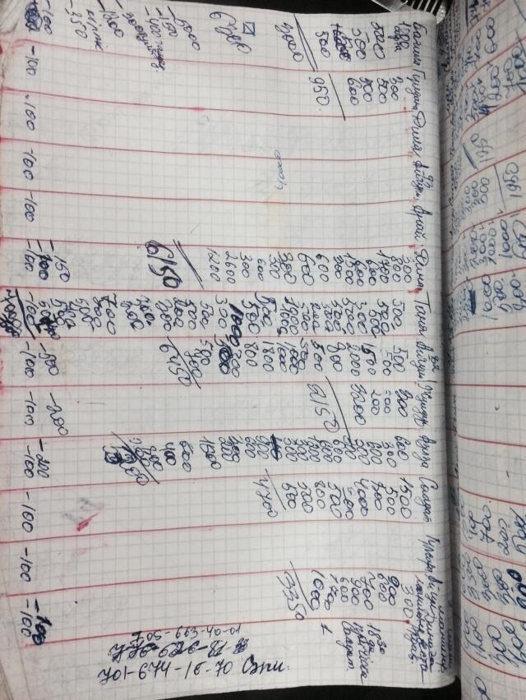

Fig. №1

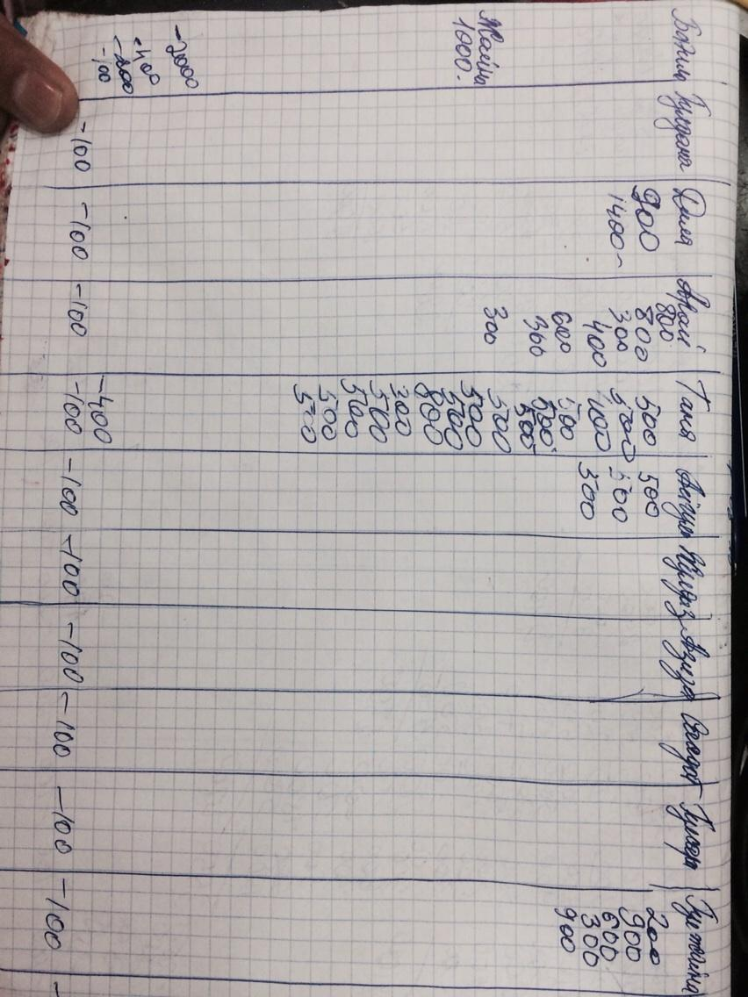

Fig. №2

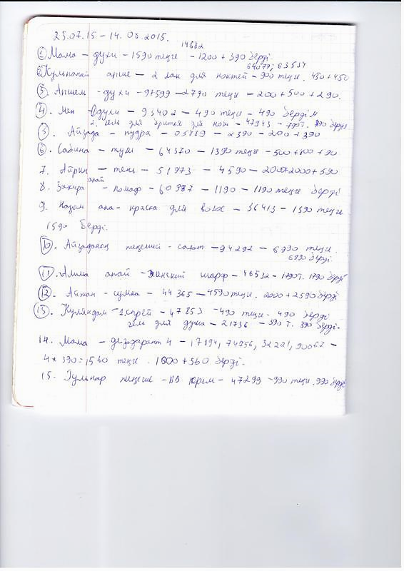

Fig. №3

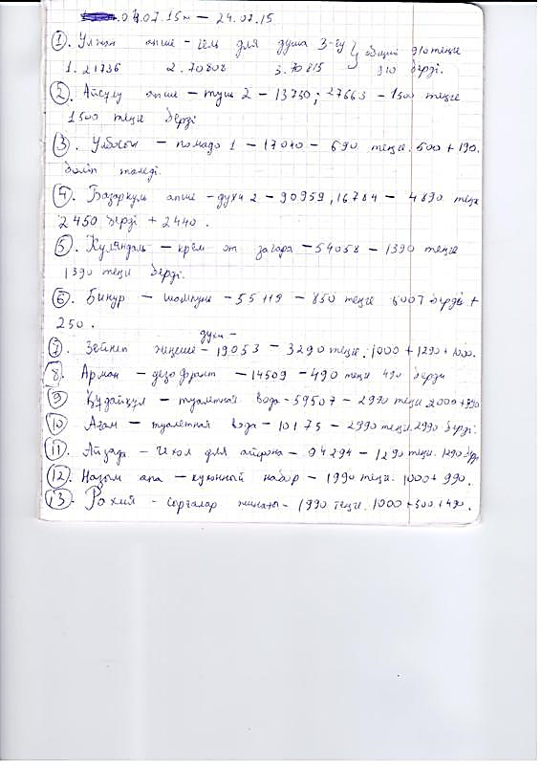

Fig. №4

Origin of data:

Employee information is stored only in special files and is not used for customer service.

     Data about buyers and customers come from themselves and are recorded in a regular notebook. The administrator records which employee the client goes to, and the employee records the name of the clients he served. In the second floor, where the store is located, manual recording is also being made in a 12-sheet notebook (Fig. No. 3).

Types that accept data:

After the client has been registered, service personnel create their own “database”. Saleswomen write down the name, description and price of the goods. (Fig. № 4). Also, in the second notebook they record data about customers, which include: First Name, Last Name, Address, Telephone Number and email. The wizard records the client’s name and the amount of money he earned per day in the “database” (Fig. No. 1).

|  |  |  |  |  |
| --- | --- | --- | --- | --- |
| Name | Surname | Address | Telephone number | E-mail |
|  |  |  |  |  |

### Study and analysis:

**Study of:**

**Interview:**

Before you start programming and creating a website, you need to gather information on the system you are using, find out how the output and data entry work. It is also necessary to find out exactly what functions the new system should perform. To obtain this information, interviews and discussions will be held with the client, the owner of the Prestige beauty salon. Questions will be asked about the future operation of the system, about the existing problems that the system will have to solve, about the data used and any useful information regarding the system (Fig. No. 5, Fig. No. 6). In order to learn the opinions of customers, a survey will be conducted among customers.

Interview number 1

Questions to interview:

❖ What does your organization specialize in?

❖ How long does this institution conduct its work?

❖ What is the purpose of your organization and your employees?

How do you collect data about your customers and customers?

❖ Are there any problems with the recording and registration system?

❖ How do you keep customer records?

❖ Do you manage to serve all customers per working day?

❖ What do you expect from the new system?

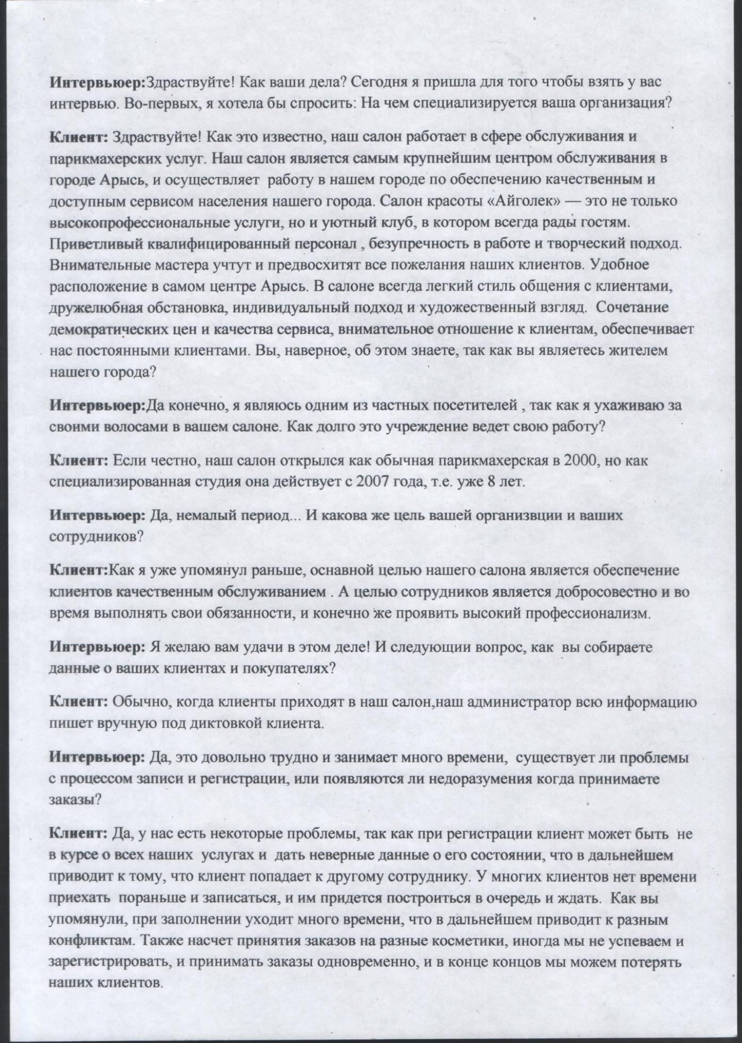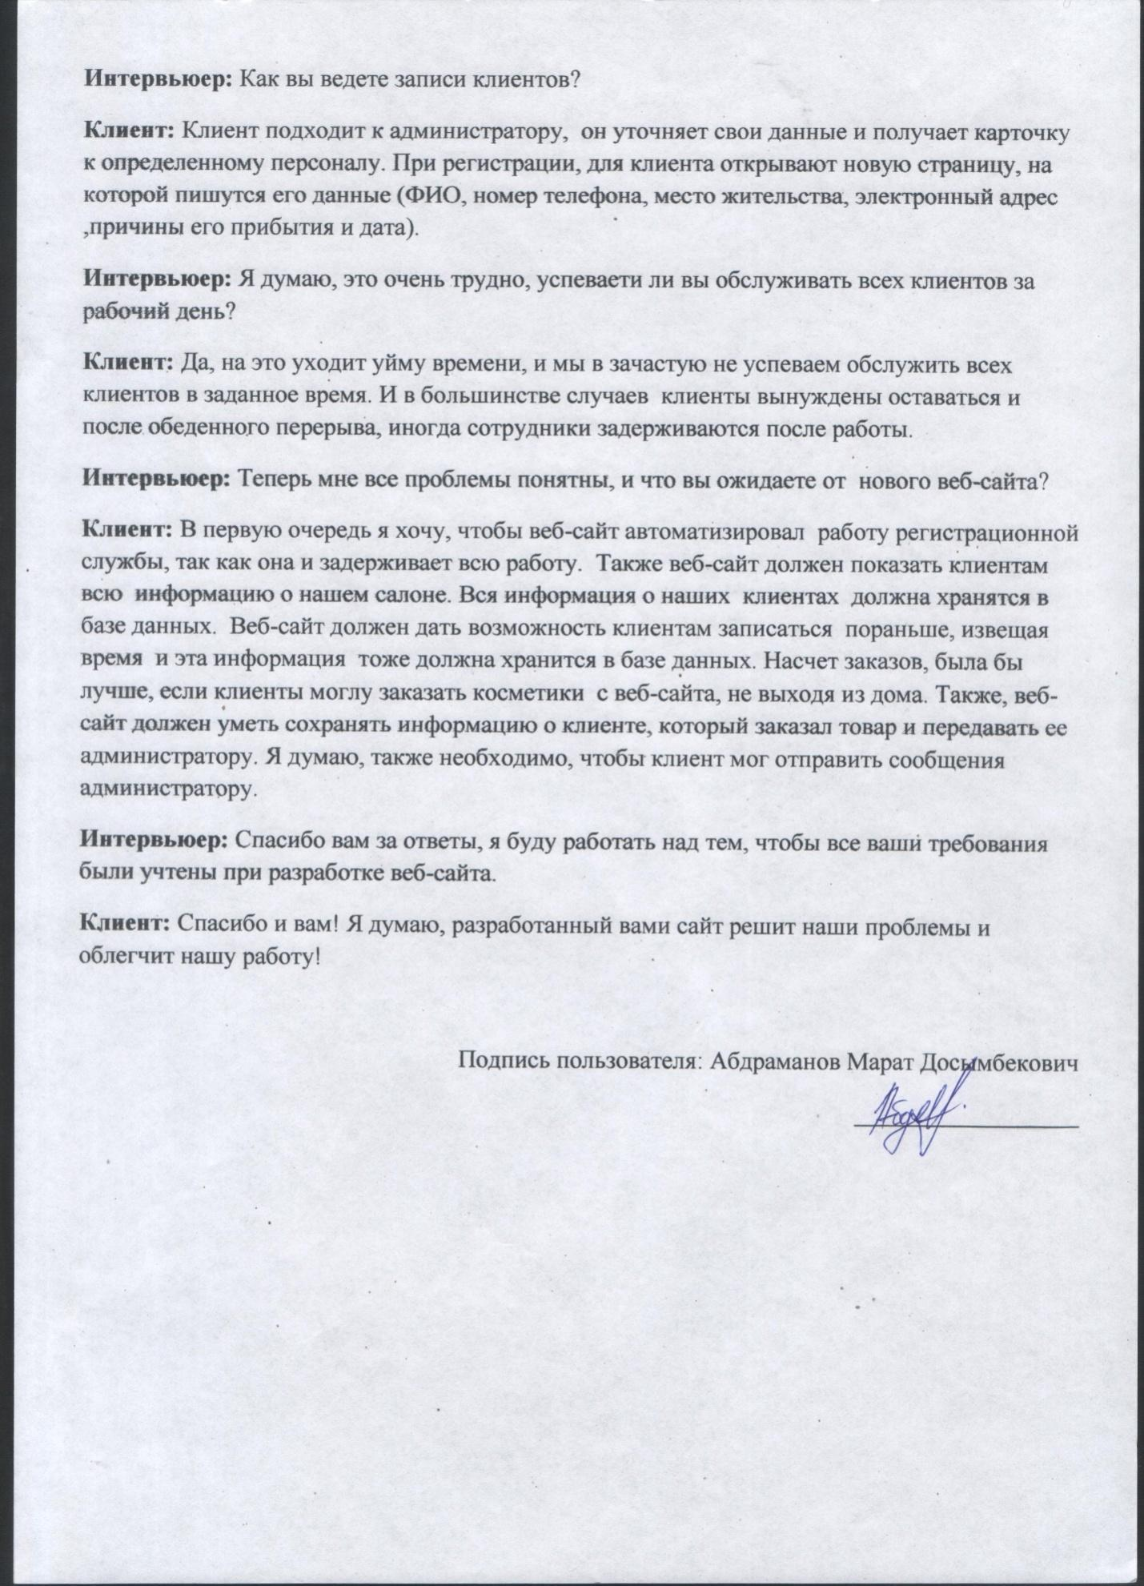



**Interview №2**

**Questions to interview:**

**1. How often do you visit a beauty salon?**

**2. Are there any problems in the cabin? If so, which ones?**

**3. Would you like to sign up for the salon early through the website?**

**4. How do you prefer, buy products in the store or order them online?**

**5. Do you think the website will make your life and salon work easier?**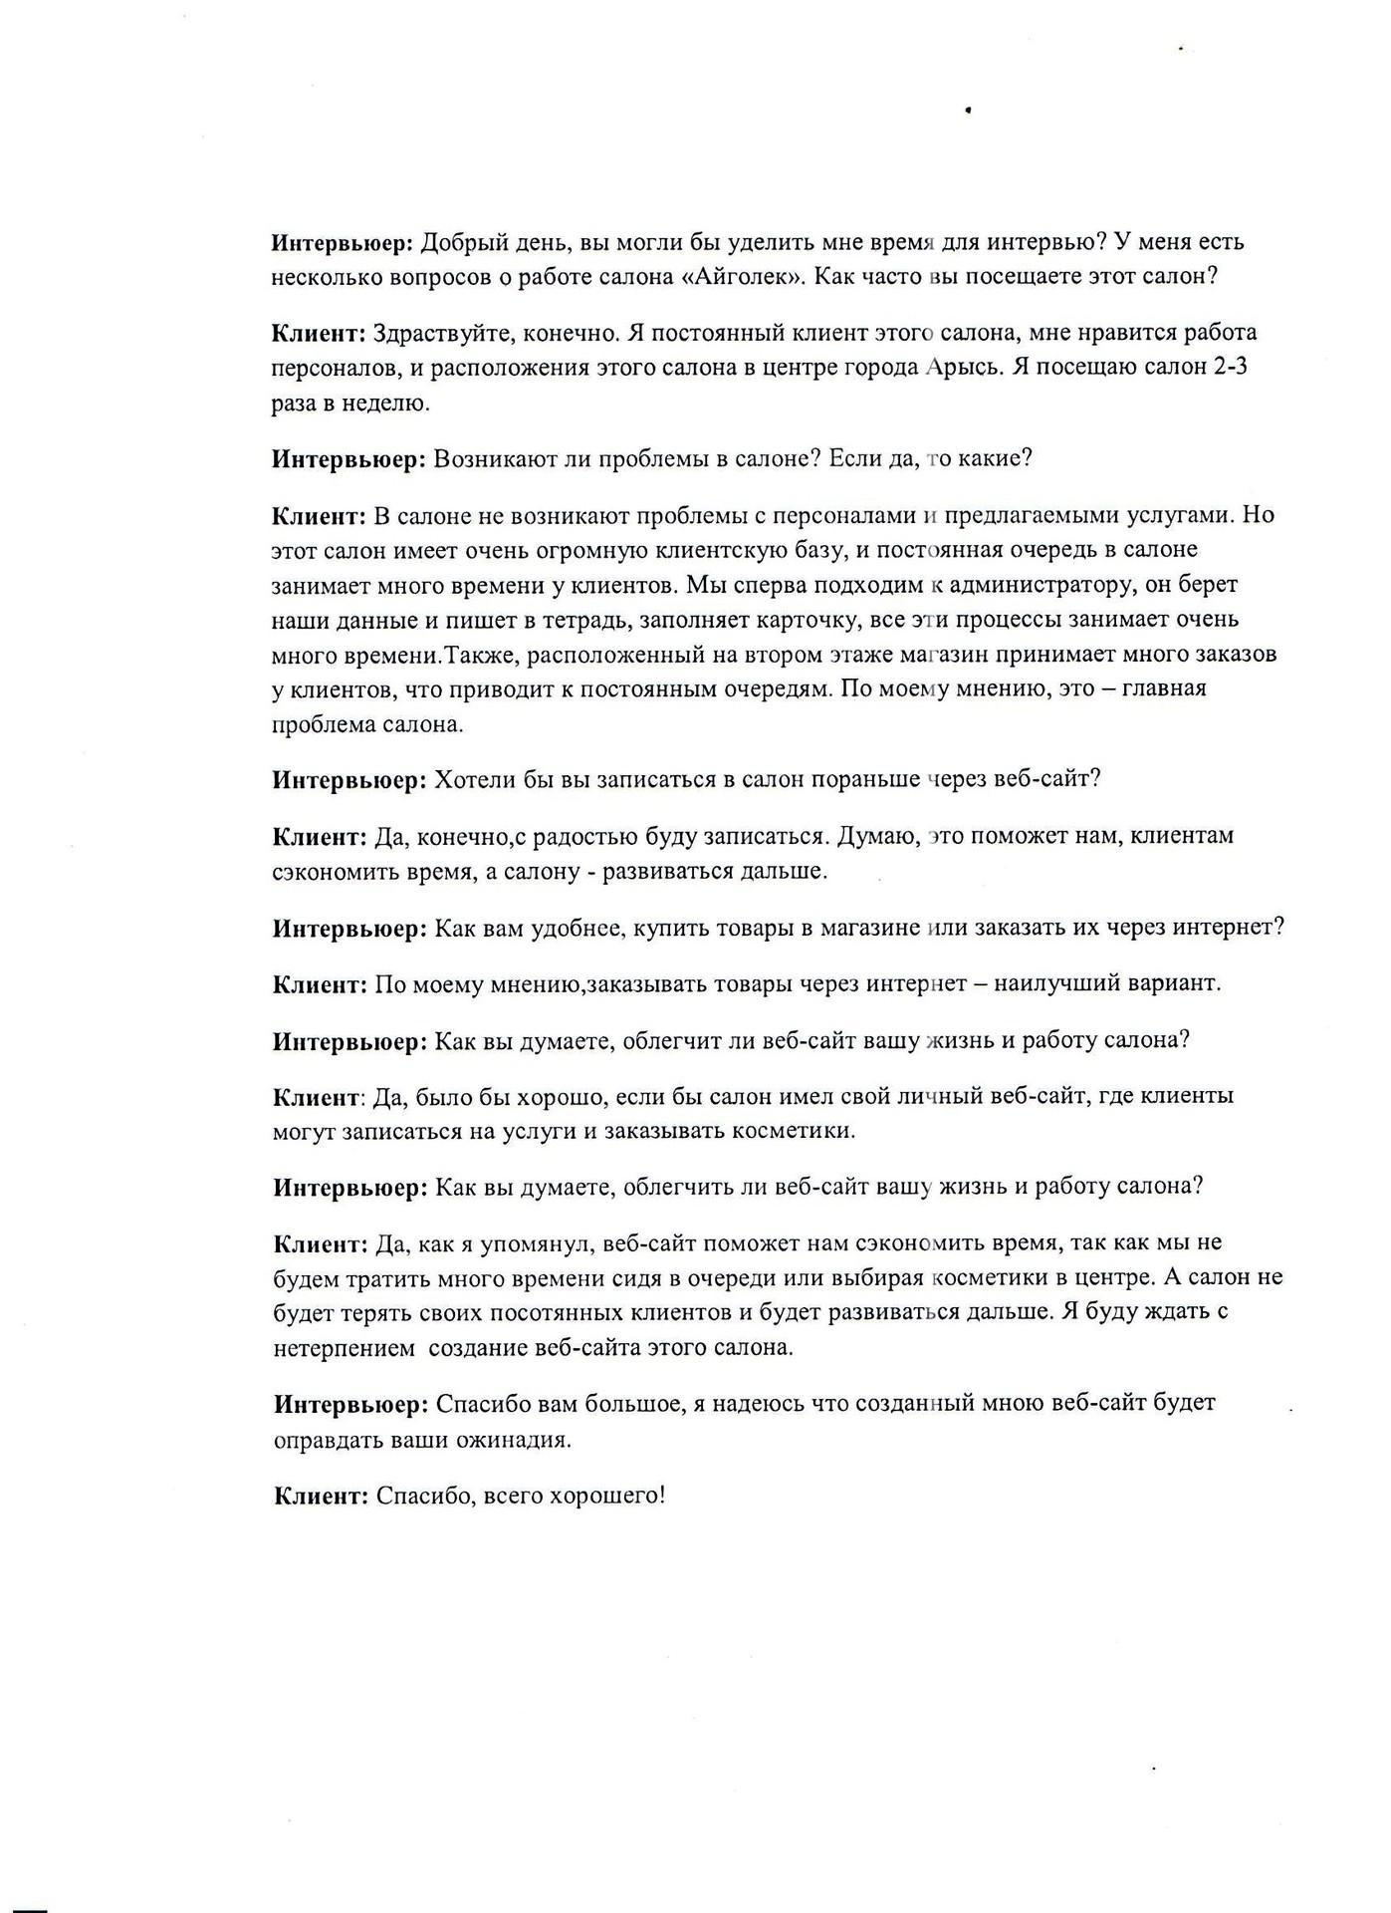

Fig. №7

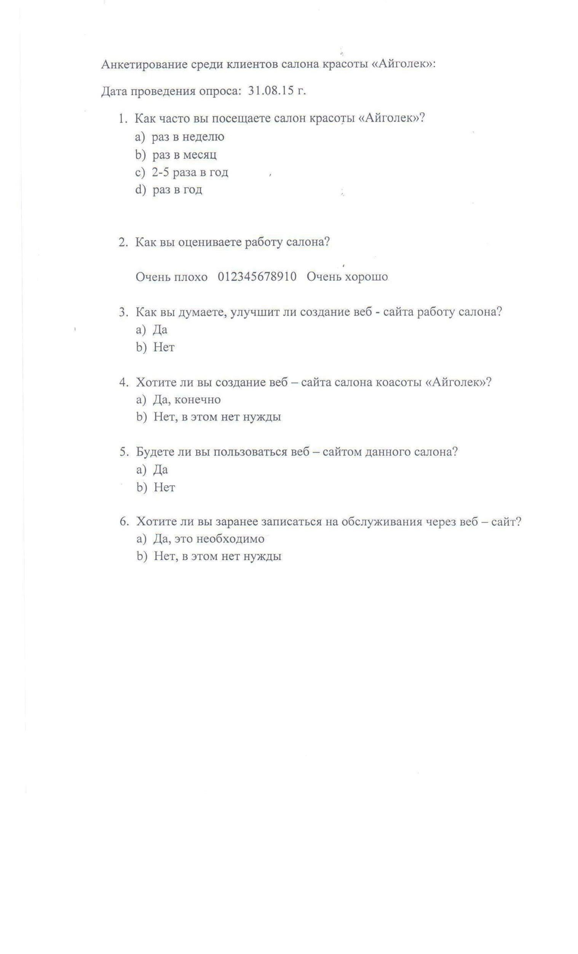

Fig. №8

The results of the survey (Fig. No. 8):

      I interviewed 30 clients: 20 of them were women, and the remaining 10 were men. Age - between 15 and 35. The following charts represent the analysis and the results of the survey:

Chart №1

How often do you visit the beauty salon "Aigolek"?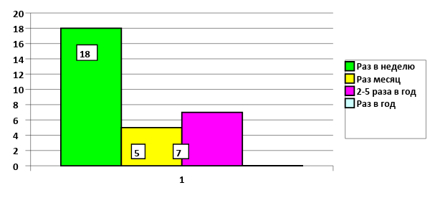

As can be seen from this chart, about 18 people visit the beauty salon once a week, that is, 60% of all surveyed clients. This means a beauty salon has a very large customer base.

Chart 2

How do you rate the work of the salon?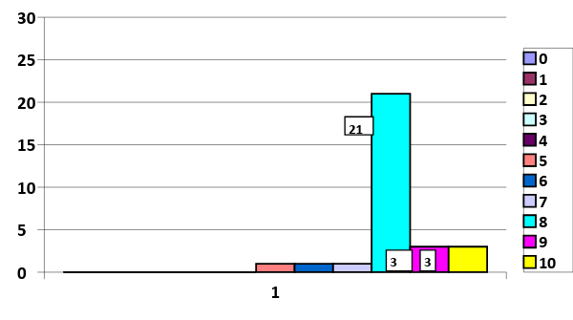

Most of the clients, 28 out of 30 rated the work of the salon at 8. It follows from this that some qualities for 10 are missing here. In my opinion, customers did not rate at 10 due to long queues.

Chart number 3

Do you think that website creation will improve the work of the salon?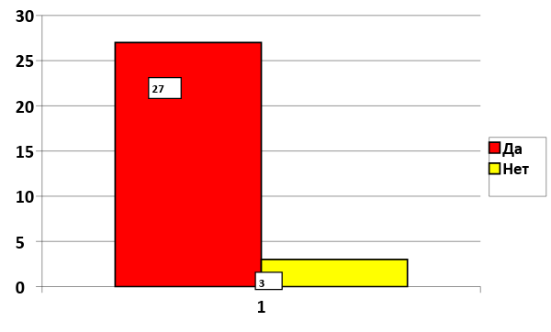

As can be seen from the diagram, 90% of respondents think that the website will improve the work of the salon.

Chart 4

Do you want to create a web site salon "Aigolek"?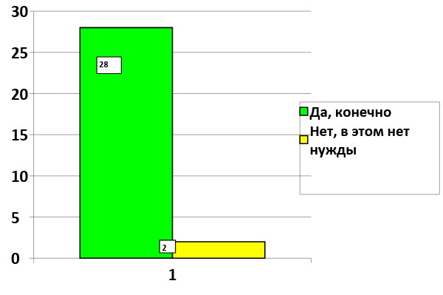

This diagram shows that 93% (28 people) of the surveyed customers stated that they want the website of this beauty salon.

Chart 5

Will you use the website of this salon?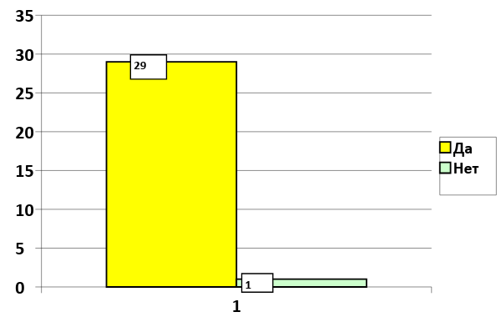

96% of the people surveyed will use the future system, so this will be useful.

Diagram №6

Do you want to pre-register for service through the website?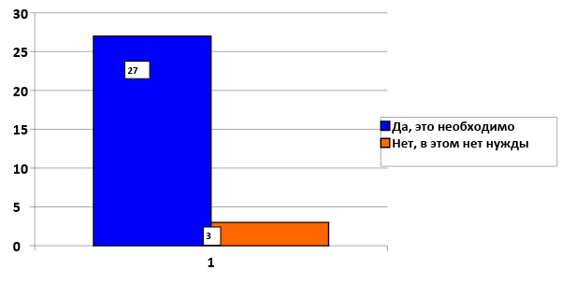

### 90% of respondents want to sign up for services in advance through the website. This means the future system will facilitate and speed up the work of the cabin.

**Analysis:**

Flow Chart:

(Figure 9) The following block diagram shows the algorithm of the Aigolek beauty salon: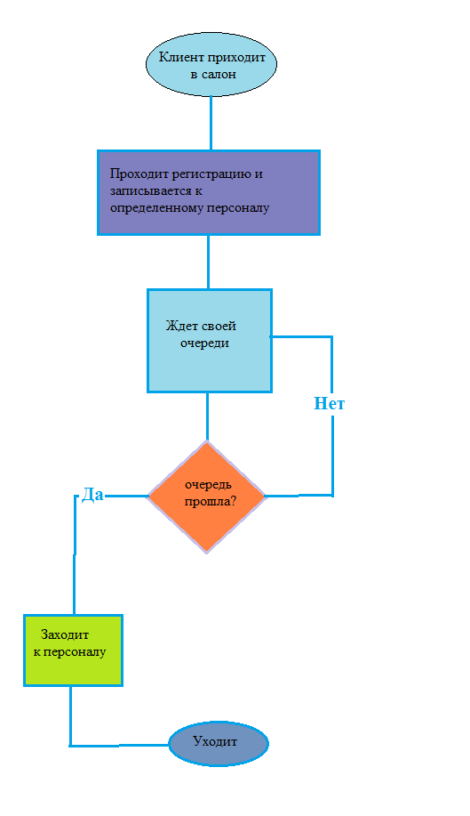

Fig №9

DFD:

This diagram illustrates the data flows in the existing system (Master, Seller and Deliveryman are service personnel and are included in the “Services” system)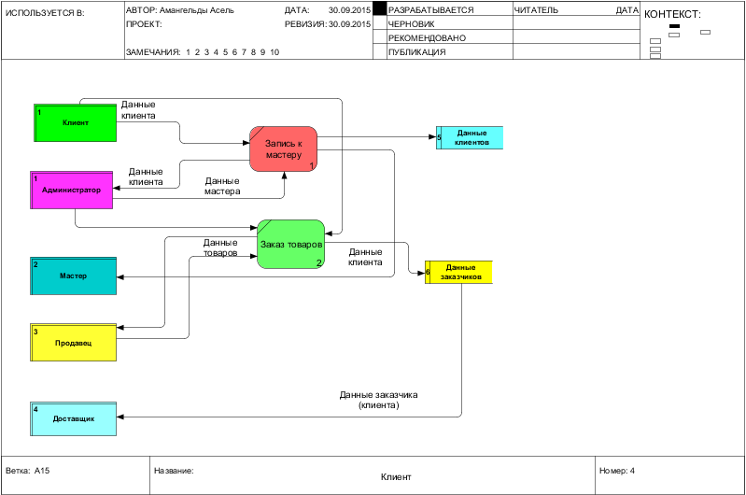

Fig. # 10Data Flow Chart

**Data collection methods:**

**Data collection is performed orally and briefly. The customer data is filled in place, i.e. the client himself gives all the information (Fig. No. 10). If the client's data is already in the database, that is, if he has already visited the salon before, then his data is taken from this database (12 sheet notebooks). But these pages (cards) during maintenance are issued to the client, which leads to its loss. Data on the masters come from the salon database, that is, this information is provided by the administrator, and their work schedule is updated from the daily schedule of employees.**

**Data processing:**

**Data processing takes place according to the information received, i.e. Depending on the input information, the administrator (expert) analyzes and directs the client to a specific master. However, the analysis takes place in a very simple manner and in many cases this leads to errors.**

**What works well, what is not very?**

**Customer data collection is successful when there are few visitors in the cabin, and when there are a lot of them, the queue becomes large, which leads to a misunderstanding of the administrator's visitors. Also, orders for goods are carried out in detail, all data is recorded. But the work requires the last part, where a notebook is used to record all the data.**

**Information entered:**

**✓ Name - text, field size 50**

**✓ City- text, field size 10**

**✓ Phone number– digital data**

**✓ Email address - strings**

**✓ Name of the product that is ordered - text, field size-50**

**✓ Total price - digital data**

**✓ Customer address-text, field size 60**

**Displayed information:**

**✓ Services offered, text field size 10**

**✓ Total amount of goods - digital data**

**✓ The time when the master will accept the client- date and time**

**Storage: Figure№3-4**

**The data is stored in notebooks, which are stored on the shelves in the registration office. Information about the masters is presented in the form of a table, with the specification of their data. For the store, also, a 12-sheet notebook is used, where data on customers and products are recorded.**

**Alternative approaches:**

**We considered the following approaches with the client:**

**1. Purchase of the finished program:**

**To this salon you can create an expert system or mobile programs. But for this you will need specialized systems and each client will have to install this program in order to be ordered and booked for services. The purchase of this system will be very expensive, especially since there are no ready-made ES for each situation, they are created by special order.**

**2. Creating a website:**

**You can create a personal website for the salon. Web sites are a system of electronic documents of an individual or organization in a computer network under a common address. The connection to the website does not require special operating systems or programs, just a computer’s Internet connection is enough. The site helps clients and the administrator to make informed decisions. Also, the website will satisfy all customer and end user requirements.**

**As a result, the client and I came to the conclusion - to create a website for the organization. The site will contain all the processes being processed in the cabin.**

**Requirements:**

**The new system must comply with the requirements below, which were agreed with the client and the end user (Fig. No. 11):**

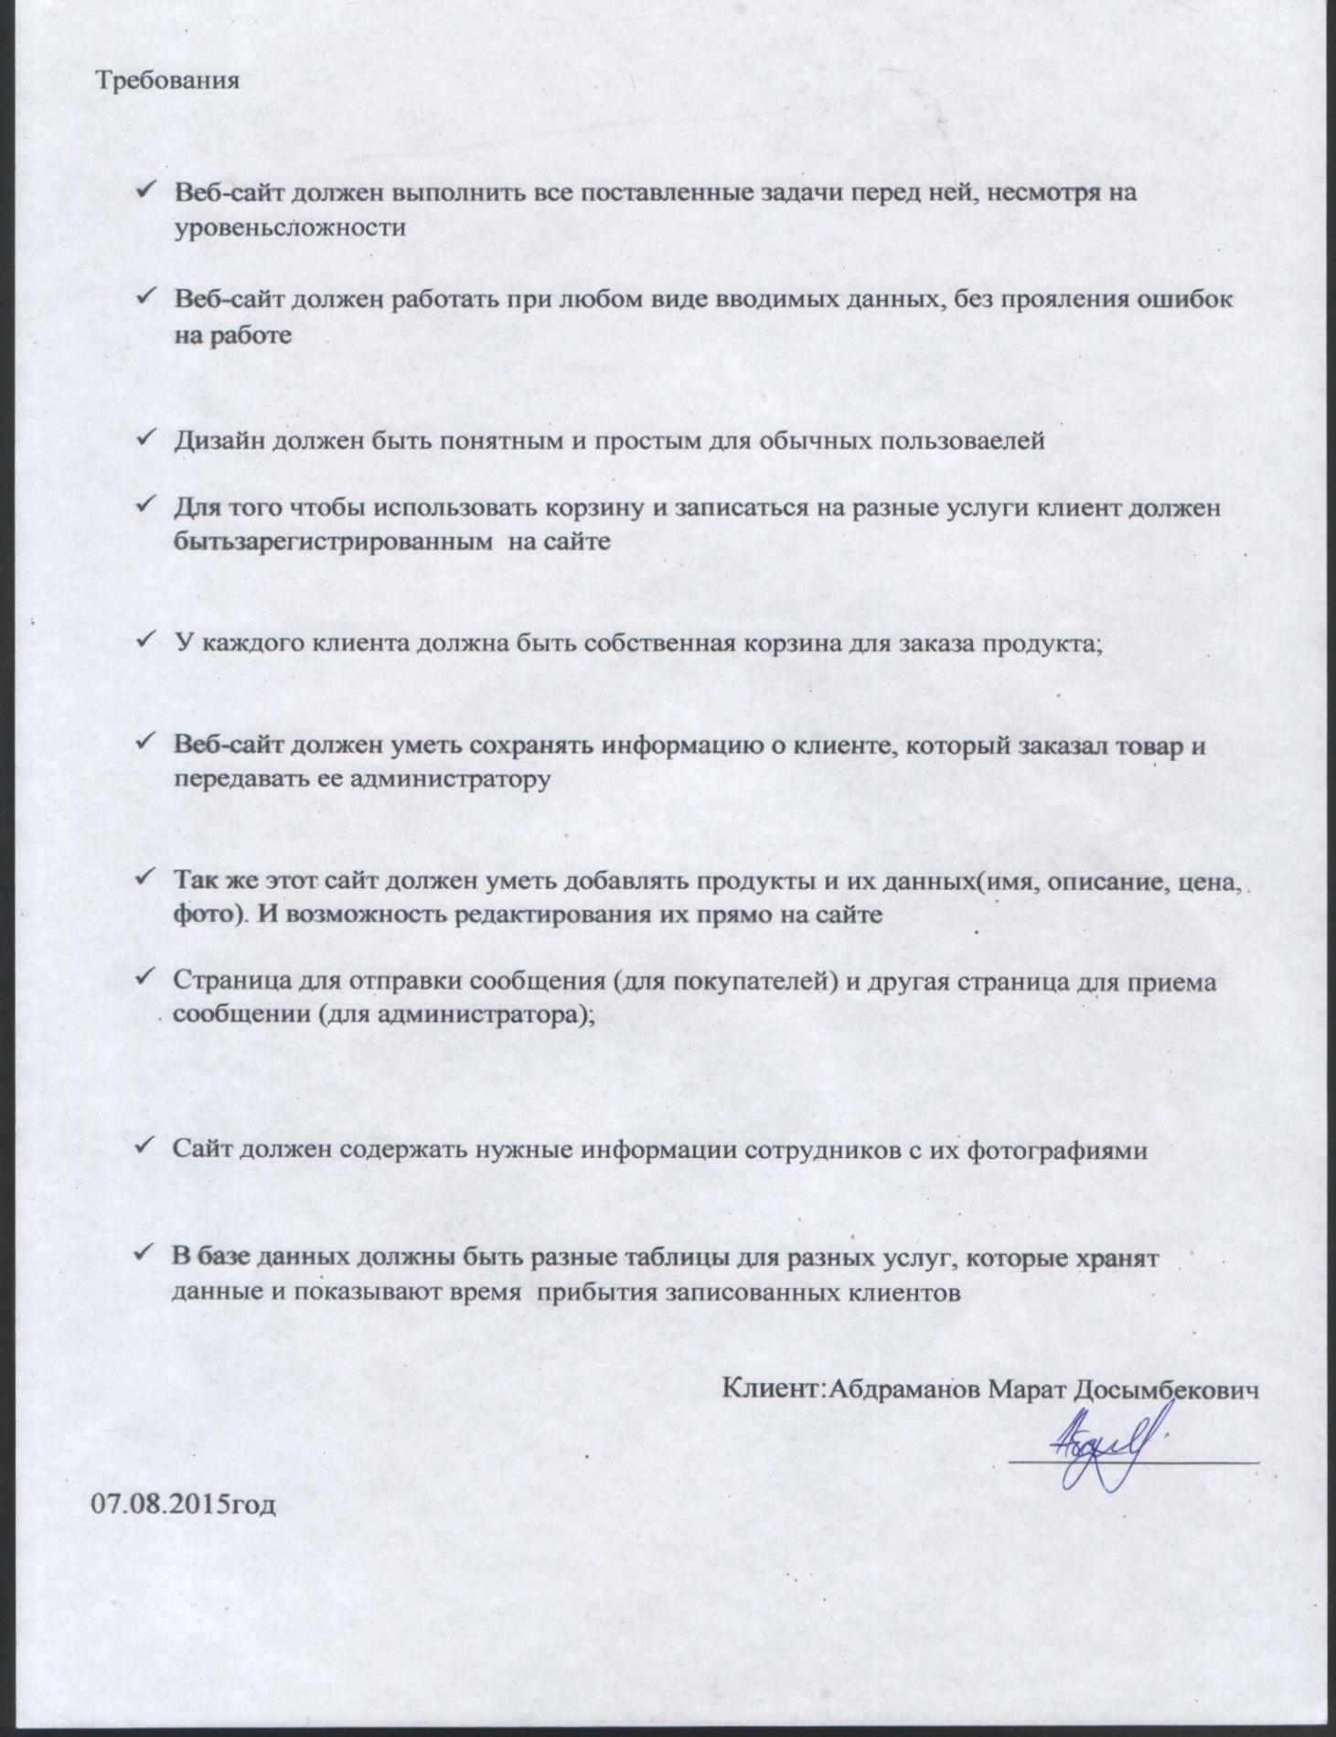

Fig. №11

**-Requirements for software:**

|  |  |
| --- | --- |
| Requirements for software | Cause |
| Any operating system | The program can be created on any operating system. Since my project will be about creating a site, only access to the Internet is required to view the site. |
| Local Xampp server with Apache (free web server), Mysql (free relational database management system) | This server is required because the program will connect to the database and I needed apache to view the site. |

**-Requirements for technical support:**

|  |  |  |
| --- | --- | --- |
|  | Device | Function |
| Input device | Laser mouse | It is necessary for the graphic interface of the program, there will be command buttons on it, by clicking on which you can see the information. |
|  | Camera | For photo masters who will be in the database |
| Output device | A laptop | This is an absolute effective device. Every job I will do on it. I will use this instead of a PC, because the laptop has the same functions, but is convenient and easy to use. Also, the laptop has its own keyboard, which will be used to enter data as numeric and text in the database. |
|  | Laser printer | Need for print |
| Storage | External hard drive | It is also convenient to use. Needed to store backups and the program of the site itself. |
|  | Flash drive | Need to transfer programs to remote computers |
| Treatment | CPU | Processes information and all processes. |

Table №1

### (c) Modeling

**(i) Solution features**

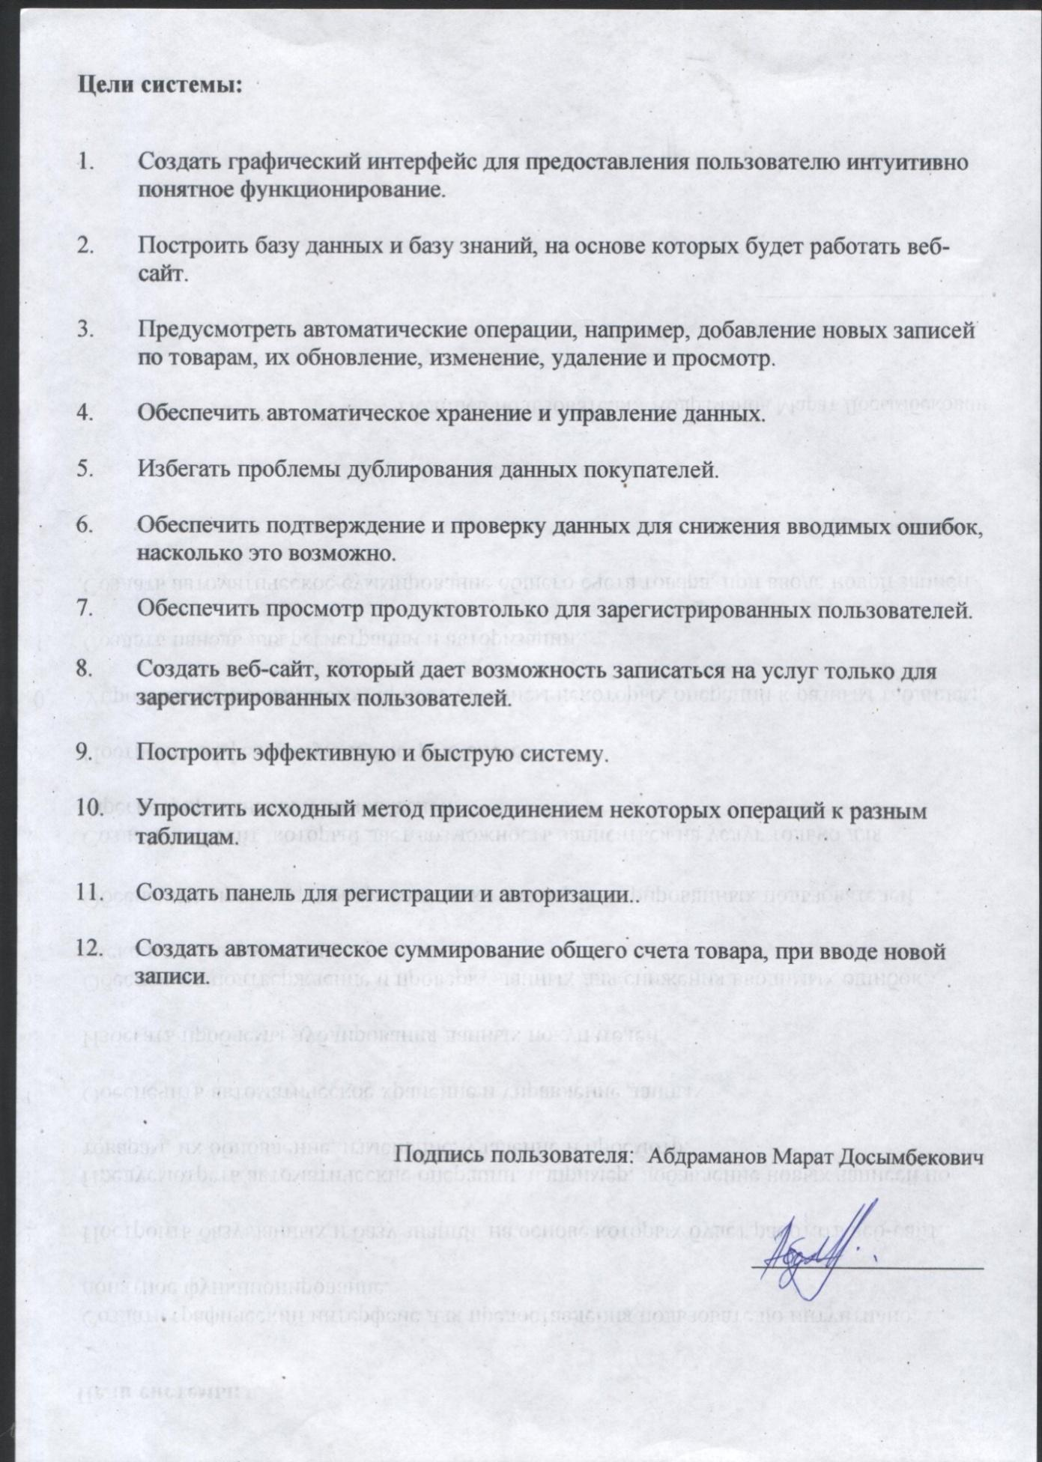

Fig. №12

These goals were based on the interview (Figure # 5, 6, 7) and my suggestions, after viewing the current system. My client, Abdramanov Marat and I were able to reach agreement on these goals. With these goals in mind, I was able to define a clear direction for developing a new system using my abilities in programming.

**Relationship Object Diagram:**

According to my research of the system used in the Aigolek beauty salon, I began to design a new system using the following diagram of relationship objects. According to my observations, the administrator can provide many clients and one client can sign up for more than one service and the administrator can add several products (cosmetics) and the buyer can buy more than one cosmetics, therefore the relationship between buyers and the product, therefore the relationship between administrator and the salon is a one-set relationship and the relationship between the salon and the customer is a many-one type. Therefore, this relationship object diagram is already ordered.

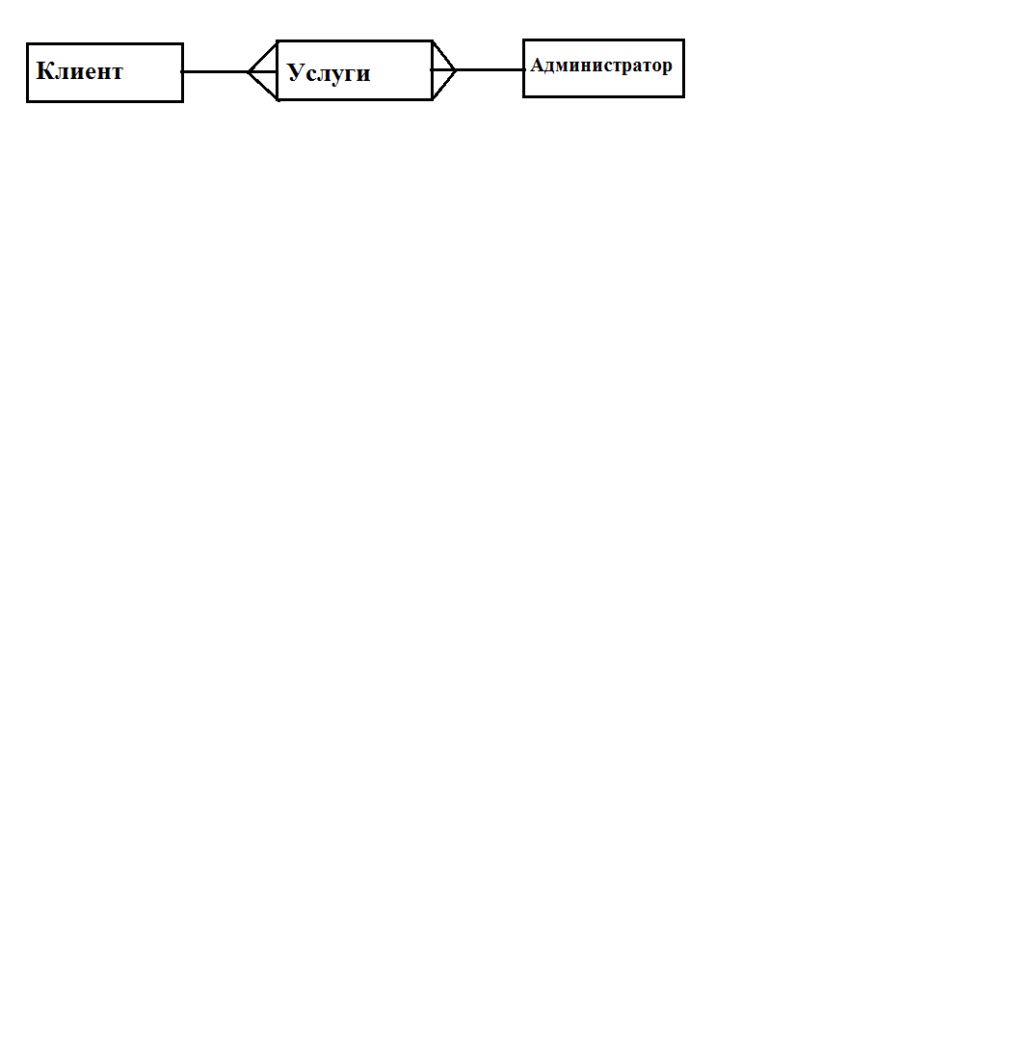

Below is a streaming data diagram that shows how the new system will work. (Fig. №14)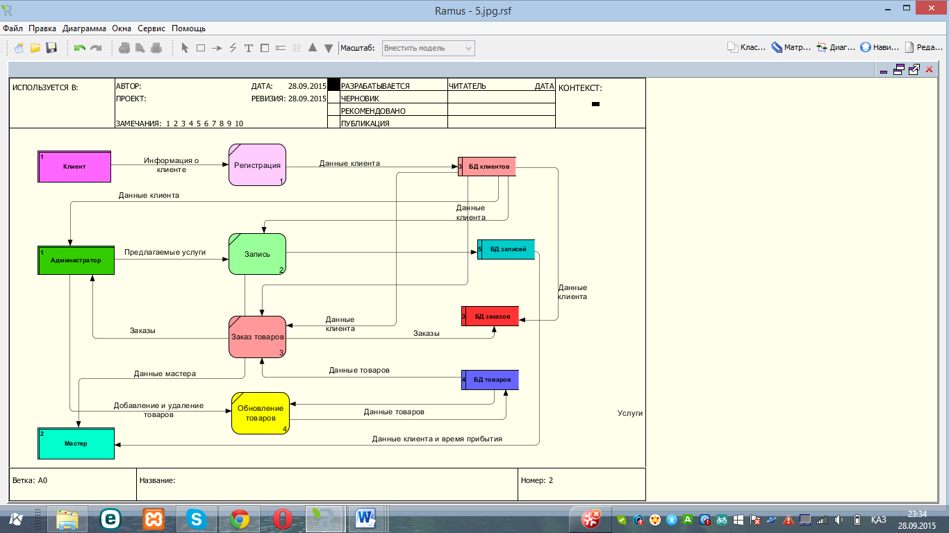

Fig. №13

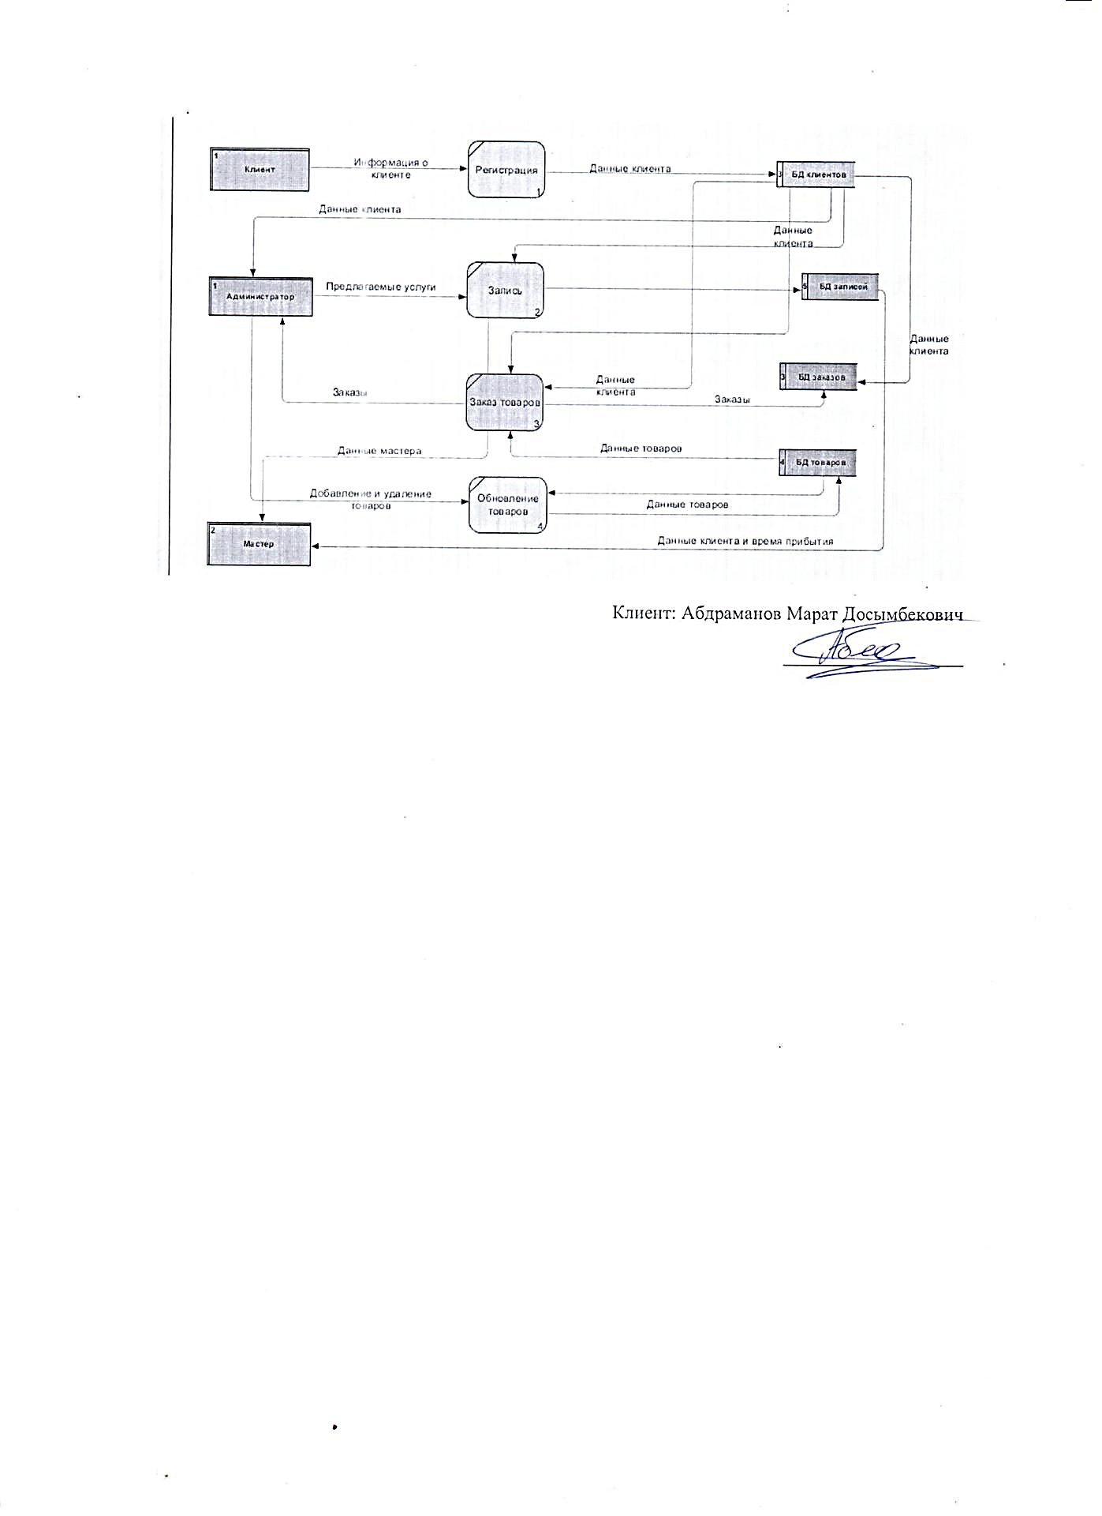

(Fig. №14)

**Menu and modular design.**

**It is recommended that I use the following system modules. Each module has its own specific functions. It is also necessary to access the different modules. The following modules are my designs.**

**❖ Service Module**

**❖ Sales module**

**❖ Editing module**

**❖ Removal module**

**❖ Control Module**

**❖ Module for viewing records**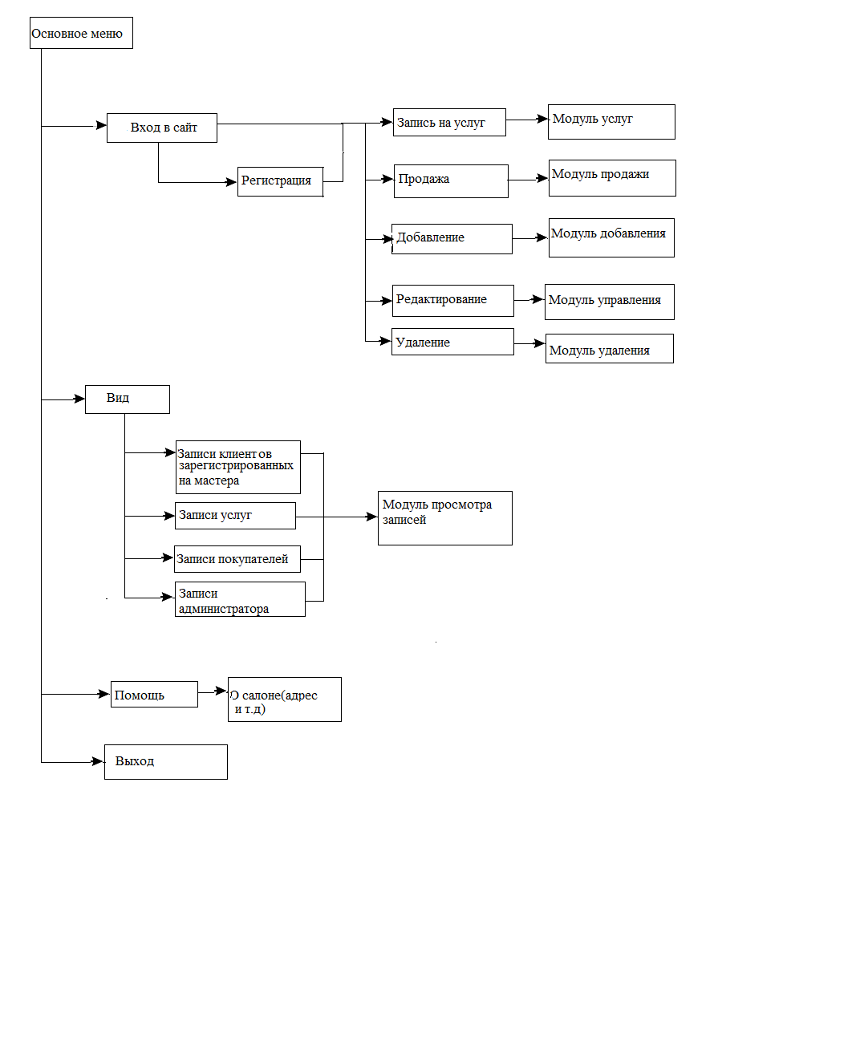

(Fig. №15)

**Block diagram for different modules**

**Order item:**

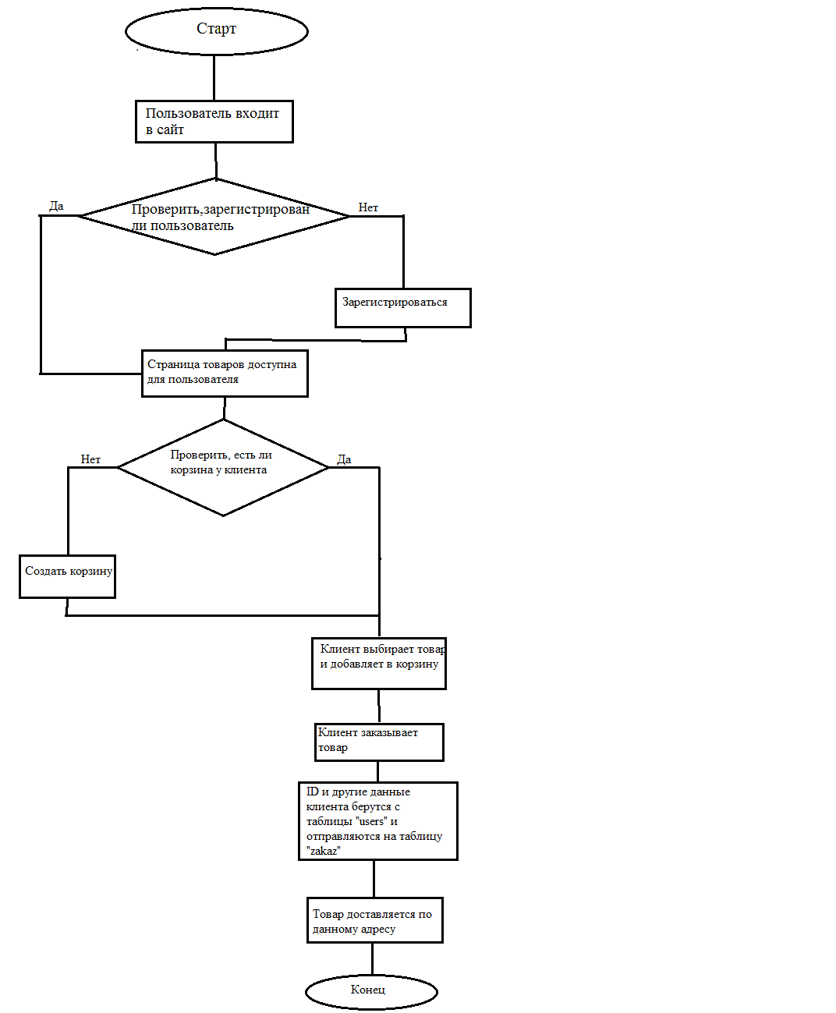

Fig. №16

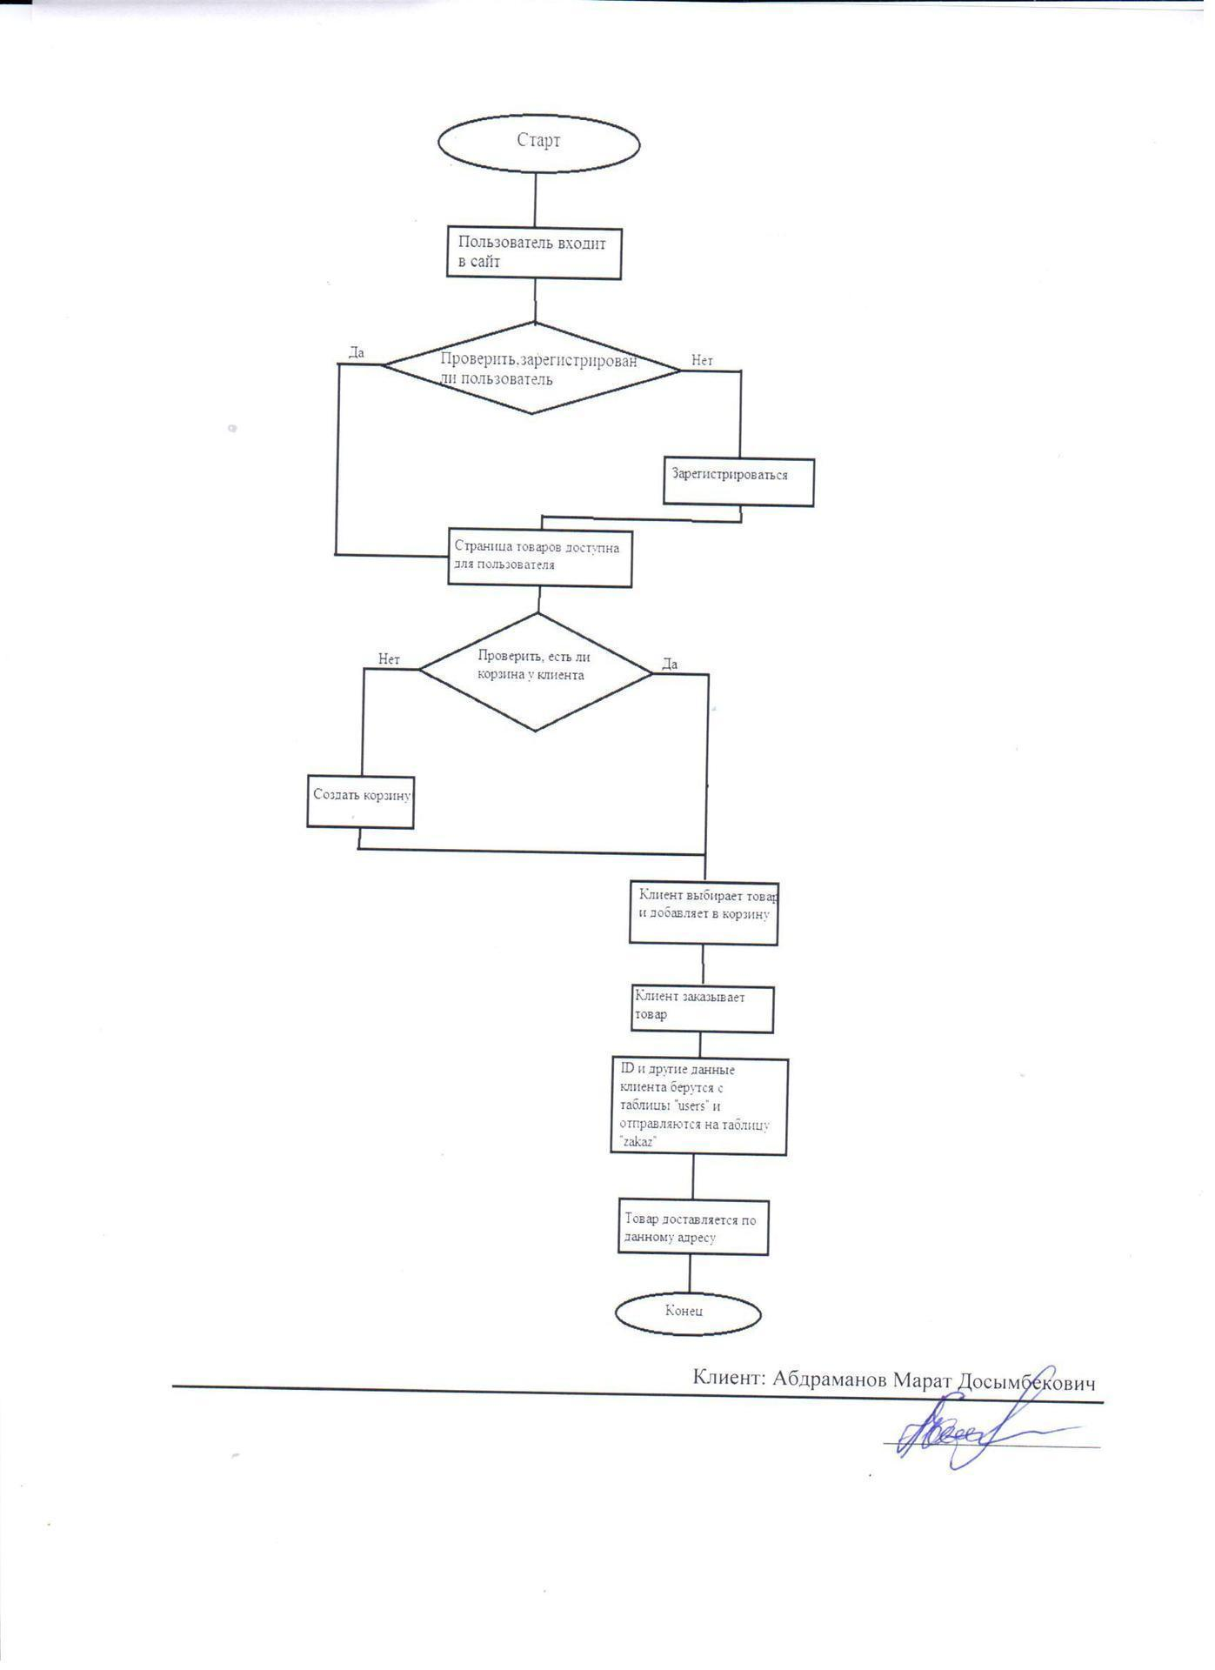

Fig. №17

Запись на услуг:

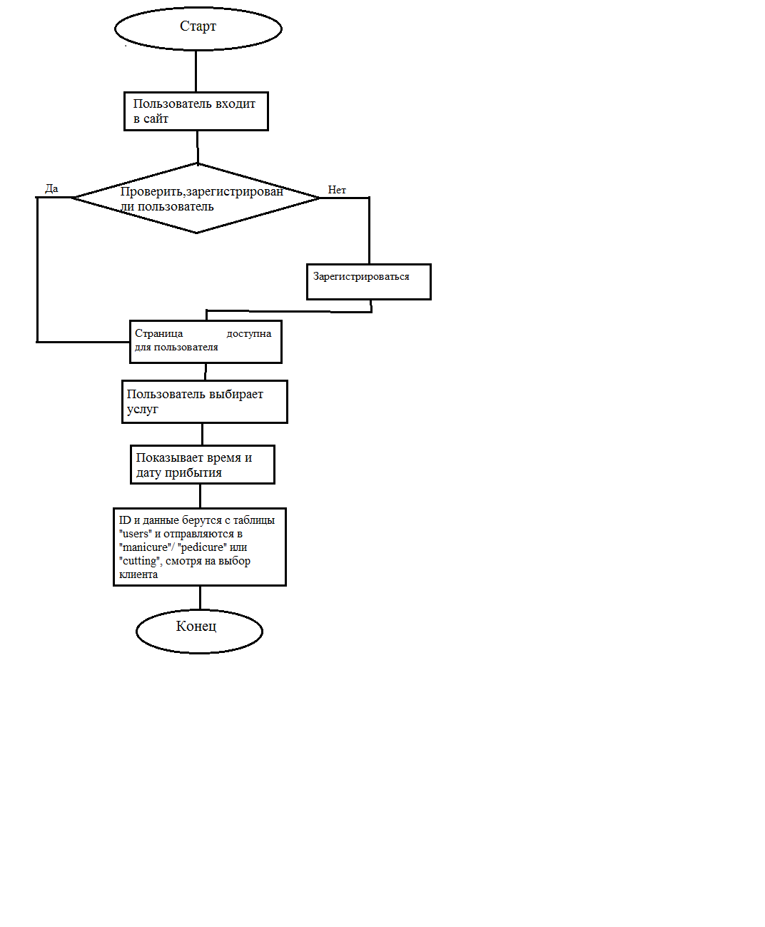

Fig. №18

Fig. №19

**Recommended File, Data and Record Structure:**

**The following three tables will be applied in the new system, the following details of the information in the form of data are as follows:**

**Data dictionary**

**Customer table**

|  |  |  |  |  |  |
| --- | --- | --- | --- | --- | --- |
| Field name | View | Length | Certification | Description | Examples |
| lD buyer (Primary Key) | Numerical | 18 | Check availability | Number identifying a specific customer | 1 |
| Full name | Lowercase | 60 | Availability check | Text identifying the last name, first name and patronymic of the client | Nargiz Isin |
| City | List | 8 | Availability check | Selection from the list identifying the client's city | Almaty |
| Telephone number | Numerical | 12 | Availability check | A unique set of numbers representing the phone number of an individual. | 87782377798 |
| E-mail | Lowercase | 30 | Availability check | Text identifying the e-mail of the client, with the encouragement of which the client can register and enter the site. | nargiz.isina@gmail.com |
| Password | Lowercase | 8 | Availability check | Hidden text indicating the password of the client, which is the registration and login key. | ****** (qwerty) |
| Address | Numeric and lowercase | 20 | Availability check | Presents data about the place of residence of customers | Md Nursat, Ibragimova Street, No. 167 |
| last visit | date and time | 3 | Availability check | The number indicating the last visit to the site by the client | 2018-08-09 00:08:41 |
| Registration time | date |  | Availability check | The time when the client registered on the site | 2018-08-05 |
| Number of site visits | Numerical |  | Availability check | Number identifying the number of times a client visits a site. | 3 |

Table number 2

**Product table (cosmetics)**

|  |  |  |  |  |  |
| --- | --- | --- | --- | --- | --- |
| Field name | View | Length | Certification | Description | Examples |
| lD Buyer (Primary Key) | Lowercase | 18 | Availability check | The number to recognize each client is unique. |  |
| Title | Lowercase | 50 | Availability check | Identifying text, product name | Lipstick "Avon" |
| Category | Numerical | 4 |  | Text identifying the last name, first name and patronymic of the client | 2 |
| Description | Lowercase | 100 |  | Selection from the list identifying the client's city | Red with a touch of pink |
| Price | Numerical | 6 |  | A unique set of numbers representing the phone number of an individual. | 1500 kzt |
| Status | Logical | 1 |  |  | 1 |
| Date added | date and time | 25 |  |  | 2018-09-15 00:09:22 |

**Table №3**

**Table recorded on manicure**

|  |  |  |  |  |
| --- | --- | --- | --- | --- |
| Field name | View | Length | Description | Examples |
| Full name | Lowercase | 50 | Text identifying the customer’s last name and name | Lipstick "Avon" |
| E-mail | Numerical | 4 | Text identifying the customer’s last name and name | 2 |
| Telephone number | Lowercase | 100 | A unique set of numbers representing the phone number of an individual. | Red with a touch of pink |
| Date | Date | 6 | Date showing the day, month and year of the client’s arrival | 1500 kzt |
| Time | Time |  | Time showing the exact time (hour, minutes) of the client’s arrival |  |

**Table №4**

Other tables for recorded hair care, pedicure and makeup (cutting the table, pedicure,) look the same as this table. All tables recorded will be visible on the admin page. (Figure 26)

**Varieties of data entry**

**All data is entered into the system through the following types of input, so the user does not have access to the database directly when saving data. All forms include input fields and buttons that have a clear and simple interface. Based on my observations and interviews, the following model (Fig. No. 21) will meet the requirements imposed on the system, as well as the agreement reached with users. (Goal 1, Fig. №13)**

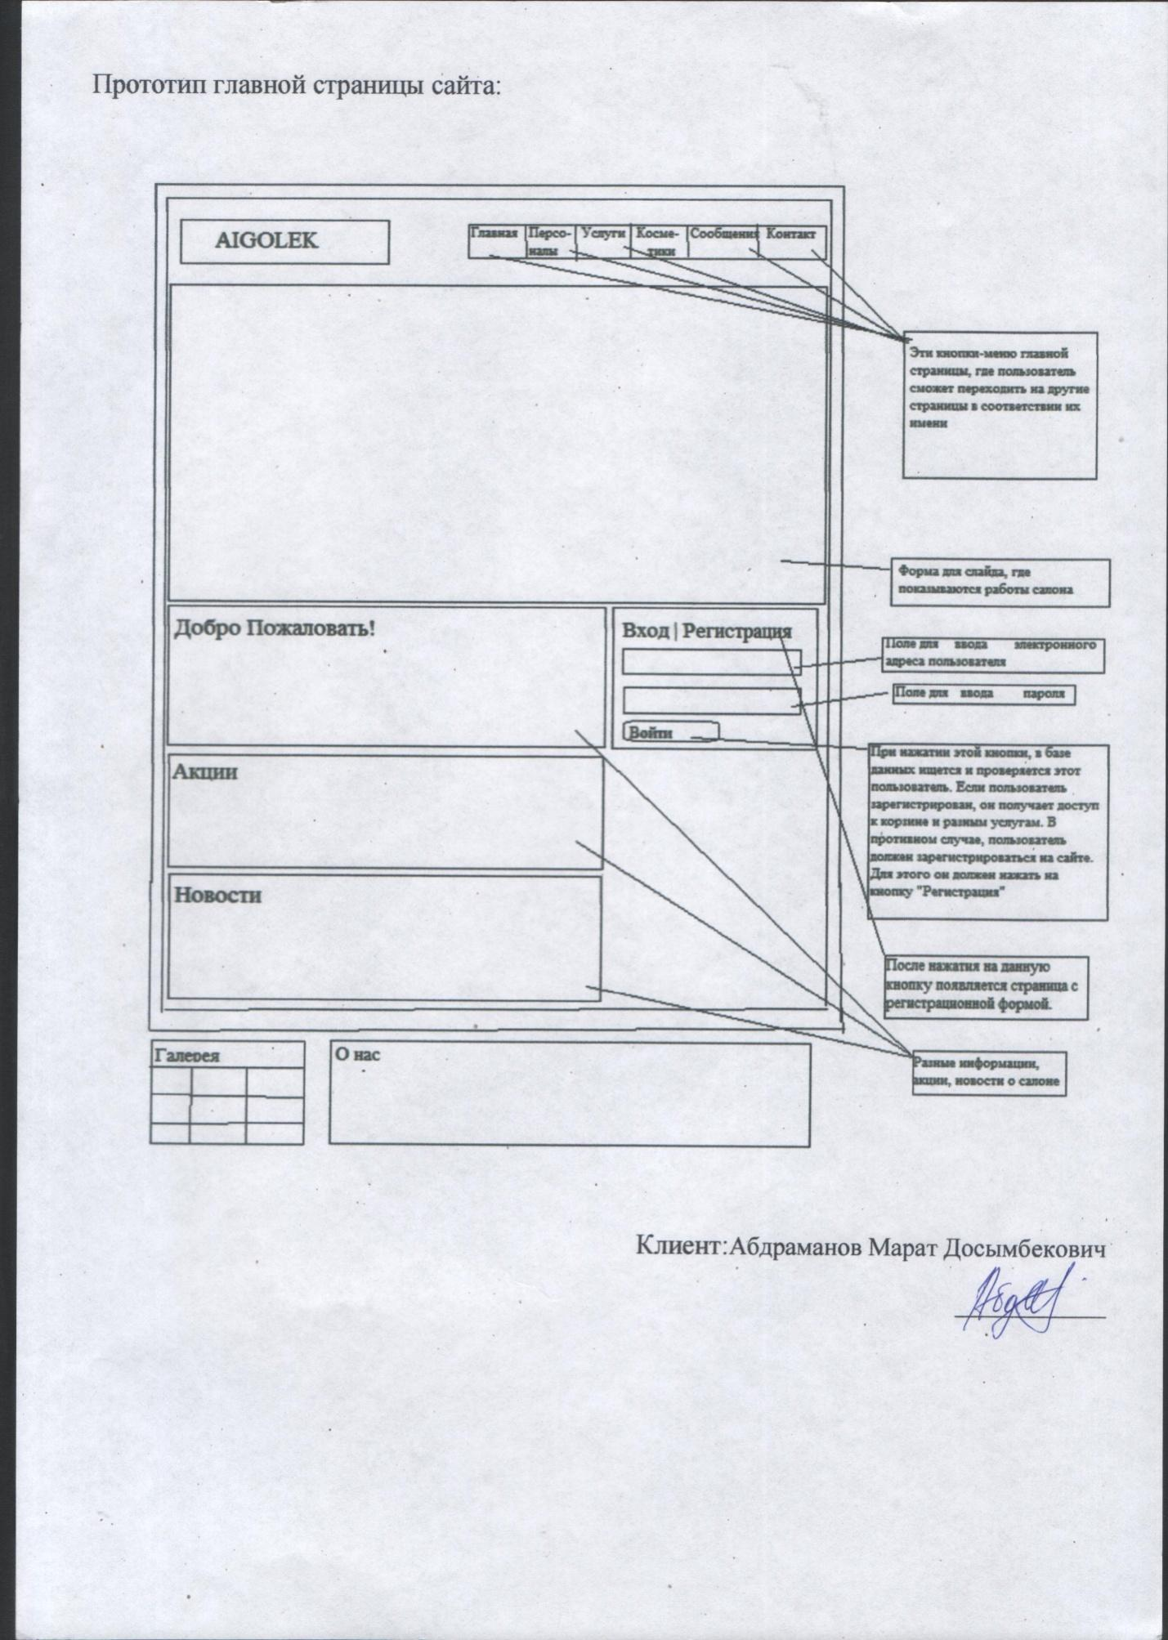

Fig. №20 (Goal-1 Fig. №49)

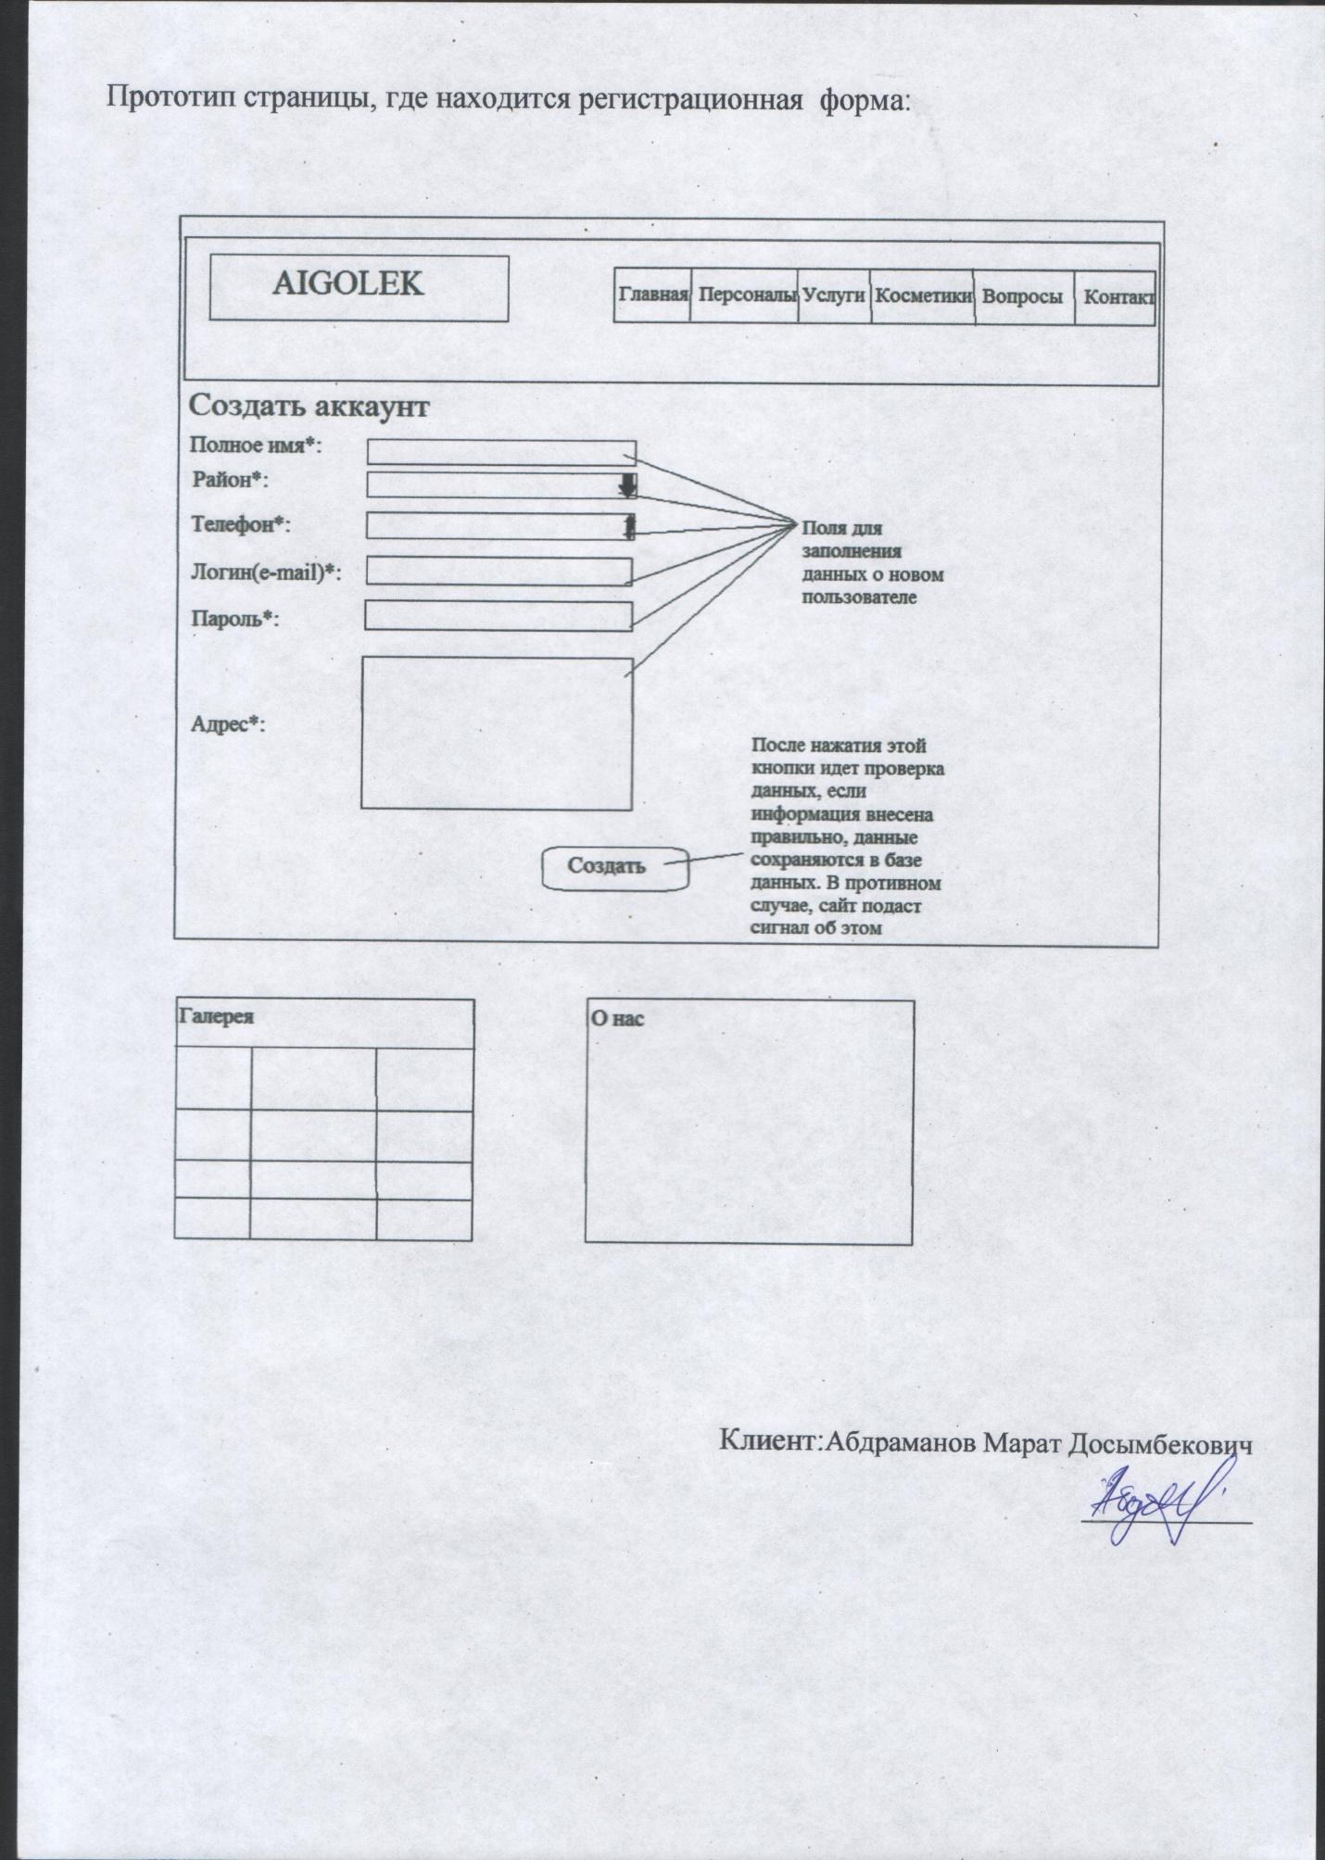

Fig. №21 registration form

This page is intended for the introduction of new users who will have the right to sign up for various services, and have their own baskets for ordering. Also, each user will have their own login and password, which should not be similar to the usernames of another user. (Fig. №14) The user can enter data and click the "Create" button. If there is no corresponding login in the database, the user will not be able to register with this login. In addition, the user must enter all the data in the correct form. After the “Create” button is pressed, the data is saved in the database.

**Page to add products**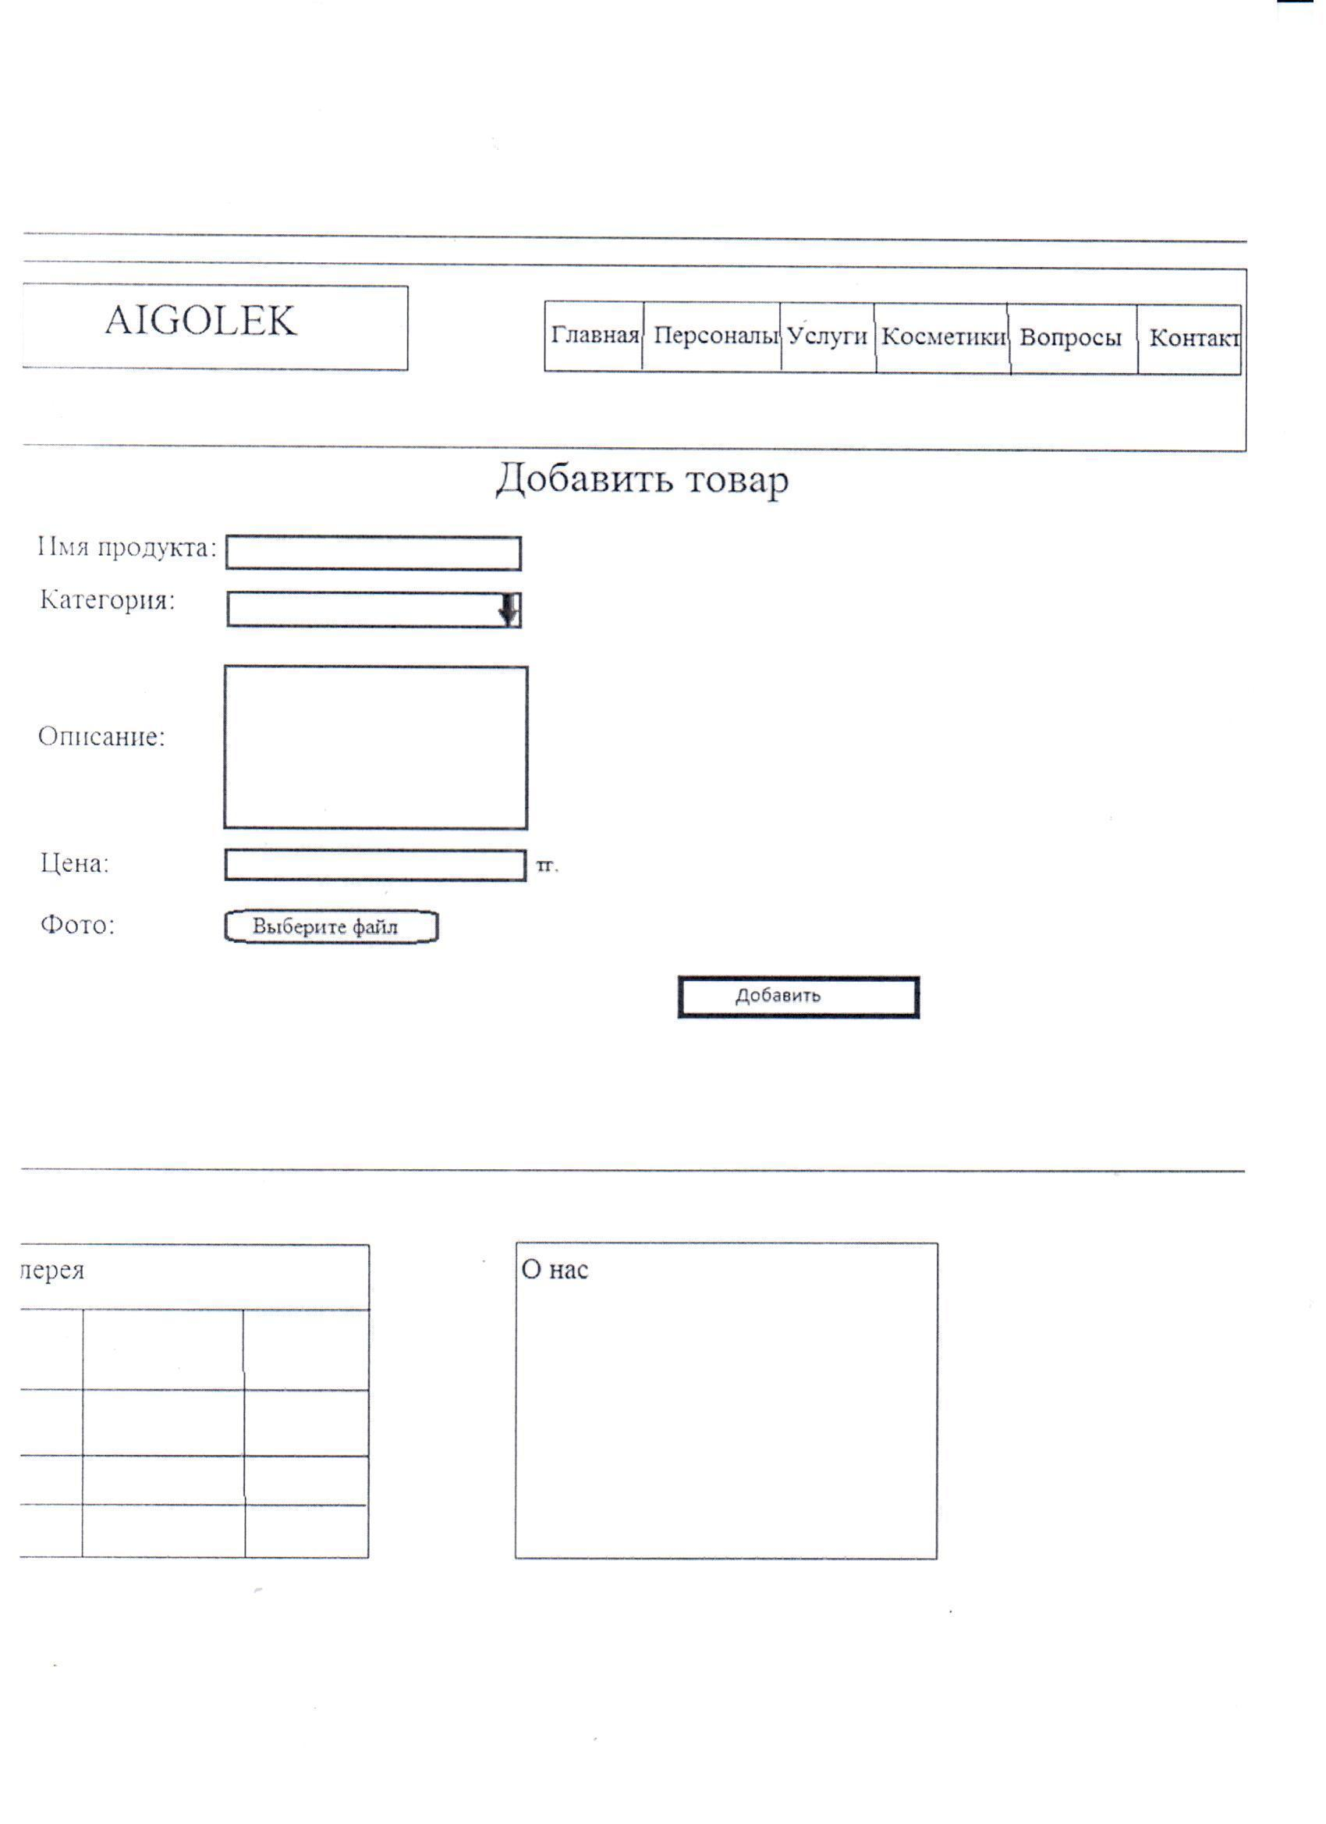

(Fig. №22)

This page is intended to add cosmetics, which is available only to the administrator. All added products are stored in a database and will be visible on the site.

(Fig. №14)

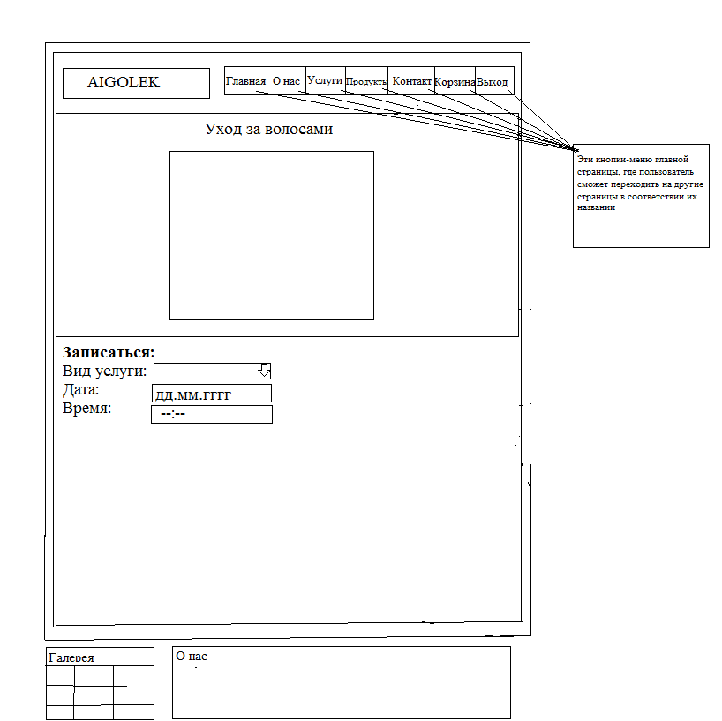

(Fig. №23)

The goal of this page is to record customers for hair related services. The client must choose the type of service (haircut, styling), time and date. The remaining data is automatically sent from the customer database to the database where the data of the recorded customers is located. (Fig. №23)

**Data output**

**All data output from the system is shown in the text area. According to the structure of the source system and the “object-relationship” diagram, I developed the following output forms with the consent of Mr. Abdramanov Marat Dosymbekovich. (Fig. №16)**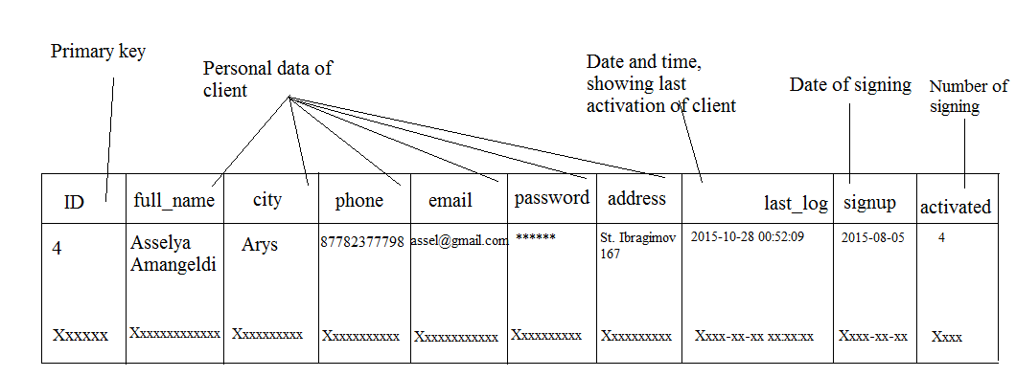

(Fig. №16)

***The purpose of this scheme is to show all users who have registered on the site. The administrator can see all information about the client and delete users.***

***Added items***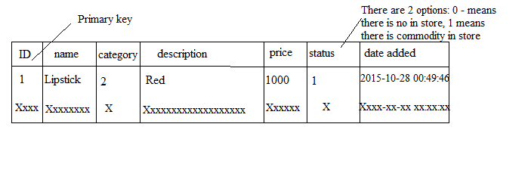

Fig. №24

This table will display all added products by the administrator. Also, the administrator can edit and delete products. (Fig. No. 24)

**Clients enrolled in services**

**The goal below is the scheme shown to show users recorded for different services. Shows the time and date of arrival of the client. Also, the phone number and e-mail address. (Fig. №25)**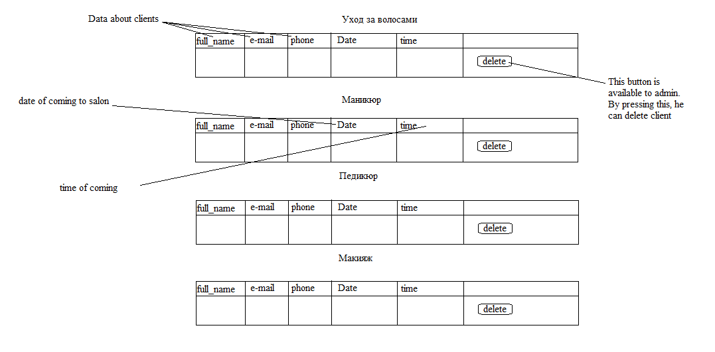

Fig. №25

|  |
| --- |
| **(Ii) Estimated Benefits**   * **➢ Convenient interface. It will be easier and more convenient for clients and administrator to use my site than to write data manually. Compared to the existing system, data entry, editing, deletion and all other operations are easily performed using the website. The user should only type data into the input data block. The user will not have access to the database directly.** * **➢ High speed of operation. A web site can reduce duplicate operations in the original method and use the program to increase the speed of searching, checking, data entry and many other operations. Therefore, my website can increase the efficiency of the company.** * **➢ Reducing the number of errors. The new system provides data verification and verification functions that reduce input errors. Also, the system provides automatic verification of duplication of primary keys (for example, a user ID), so the problem of two entries sharing primary keys is eliminated.** * **➢ Secure data storage. Since the original system was based on paper, the data could be corrupted due to damage to the paper. In the new system, all records are stored in the computer, and the user can make a backup of data on a removable disk, for example, on a USB flash drive.**   **(iii) Decision Range Frames**  Despite the fact that the website is allowed to alleviate some difficulties, there are several several disadvantages to this system:  1. The old method of order management was based on the papers, but the new system requires devices that allow you to order goods via the Internet. To do this, all customers must have equipment that would have access to the Internet. Therefore, we can not guarantee that every user has access to the Internet and they need to purchase equipment that has access to the Internet;  2. There are some limitations of a computerized system. For example, data may be lost due to a power outage, and attacks on a computer system may reduce data security. Therefore, the administrator should regularly back up data. |

|  |  |  |  |  |  |  |  |  |  |  |
| --- | --- | --- | --- | --- | --- | --- | --- | --- | --- | --- |
| **Table** | | **Fields** | **Example** | | | | **Maximum size (in bytes)** | | | **Table size (in bytes) * estimated number of records per year** |
| Customer table | | ID user | 5 | | | | 9 | | | 426*14600 |
| Full name | Nargiz Isina | | | | 255 | | |
| City | Almaty | | | | 100 | | |
| Telephone number | 87777777766 | | | | 15 | | |
| E-mail | isina.nargiz@gmail.com` | | | | 100 | | |
| Password | Qwerty123 | | | | 32 | | |
| Address | Street Ibragimova, 4 | | | | / | | |
| IP | 2 | | | | 15 | | |
| Service table (manicure) | | ID user | 3 | | | | 15 | | | 238*3650=868700 |
| Date | 25.06.2014 | | | | 115 | | |
| Time | 13:35:00 | | | | 100 | | |
| Mem_id | 4 | | | | 8 | | |
| Service table (makeup) | | ID user | 3 | | | | 15 | | | 238*3650=868700 |
| Date | 25.06.2014 | | | | 115 | | |
| Time | 13:35:00 | | | | 100 | | |
| Mem_id | 4 | | | | 8 | | |
| Service table (pedicure) | | ID user | 3 | | | | 15 | | | 238*3650=868700 |
| Date | 25.06.2014 | | | | 115 | | |
| Time | 13:35:00 | | | | 100 | | |
| Mem_id | 4 | | | | 8 | | |
| Service table (hair) | ID user | | | | 3 | | | 15 | 238*3650=868700 | |
| Date | | | | 25.06.2014 | | | 115 |
| Time | | | | 13:35:00 | | | 100 |
| Mem_id | | | | 4 | | | 8 |
| Message table | | ID user | 2 | | | | 7 | | | 747*125=93375 |
| Name of user | Asan Nursaule | | | | 100 | | |
| E-mail | assan@gmail.com | | | | 80 | | |
| Title | error | | | | 50 | | |
| Massage | Hello | | | | 500 | | |
| Date | 2015:05:04 | | | | 10 | | |
| Order  table (shopping) | | ID | 3 | | | | 10 | | | 43*3650=156950 |
| Mem_id | 25.06.2014 | | | | 10 | | |
| Cart | 23, 35, 42 | | | | 15 | | |
| total amount | 45000 | | | | 7 | | |
| Status | n | | | | 1 | | |  |
| Product table  Increase (+) overrun (10%) | | ID product | | 8 | | 7 | | | | 1007*2500=2517500 |
| Name | | Gel | | 500 | | | |
| Category | | For body | | 500 | | | |
| Description | | Very soft | | / | | | |
| Price | | 1000 | | 7 | | | |
| Status | | 1 | | / | | | |  |
| Date added | | 2015:11:04 16:00:00 | | / | | | |  |
| **Database size (in kbps)** | |  | | One year record | |  | | | | 782153.125 |
|  | | | | | | | | | | 782153 |
|  | | | | | | | | | | About |

Table №5

### (d) Software engineering, programming, testing and installation

**(i) Development:**

System development and program listing

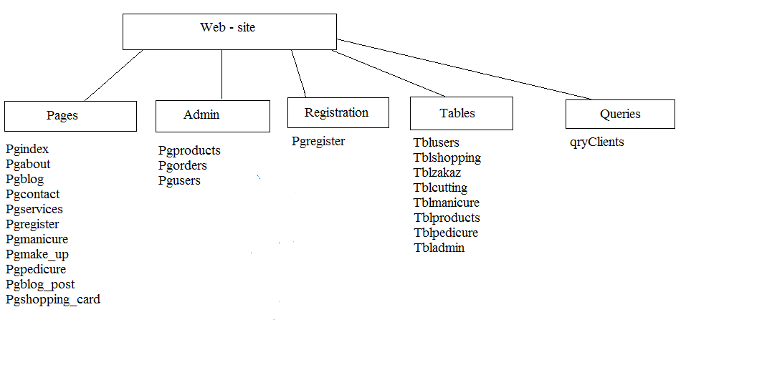

Fig. №26

**Program listing**

**In order to provide automatic storage and data management, I had to work with databases. Because data storage in the database is the most optimal method for storage. (Goal-3, page-10)**

Varchar -

variable length character string. To store data of this type, the number of bytes corresponding to the actual length of the string is allocated.

INTEGER or INT is an integer to store.

TEXT - can store no more than 65,535 characters.

DATETIME is a data type intended for time.

ENUM is the data type used to select.

**The form of the proposed table "Customers" ()**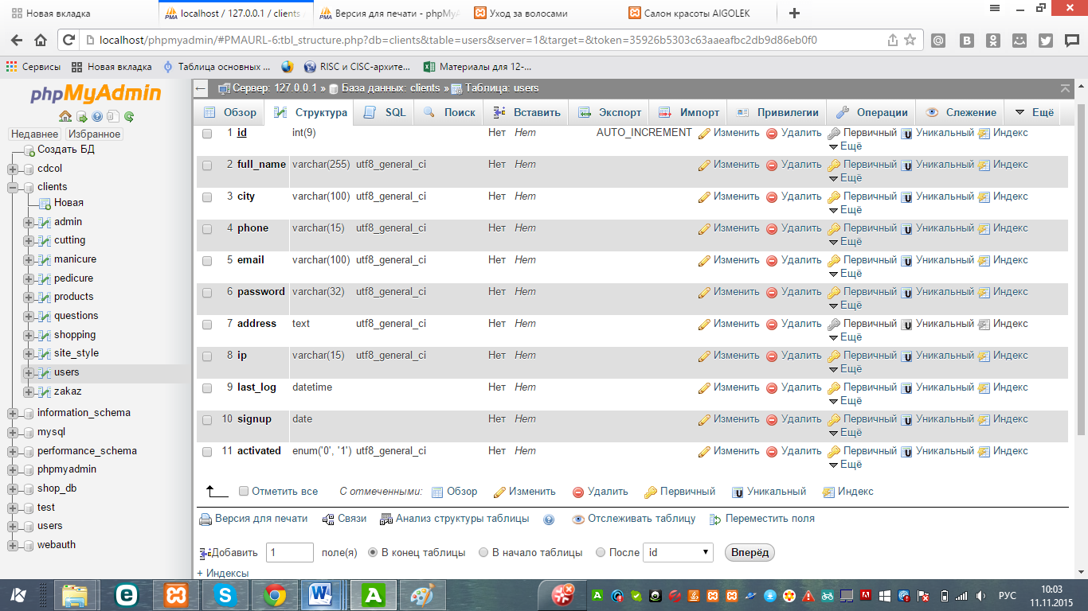

Fig. №27

“Users”

|  |  |  |
| --- | --- | --- |
| **Column** | **Type of** | **The size** |
| Id | int(9) | 9 |
| full_name | varchar(255) | 255 |
| City | varchar(100) | 100 |
| Phone | varchar(15) | 15 |
| Email | varchar(100) | 100 |
| Password | varchar(32) | 32 |
| Address | Text |  |
| Ip | varchar(15) | 15 |
| last_log | Datetime |  |
| Signup | Date |  |
| Activated | enum('0', '1') |  |

Table №6

|  |  |  |  |  |  |  |
| --- | --- | --- | --- | --- | --- | --- |
| **Index name** | **Type of** | **Unique** | **Packed** | **Column** | **Unique items** | **Comparison** |
| PRIMARY | BTREE | Yes | No | id | 3 | A |

**Index**

Table №7

**The form of the proposed table “Products”**

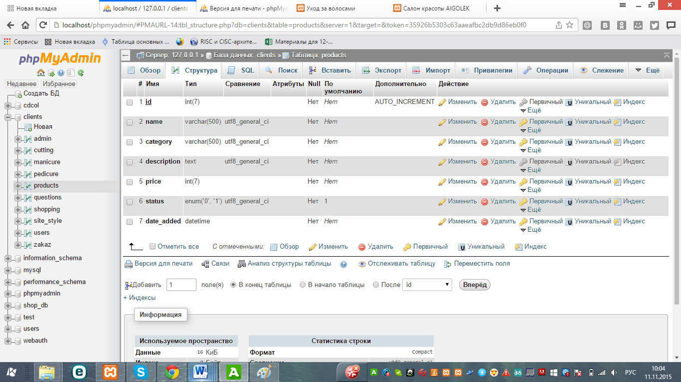

Fig. №28

|  |  |  |
| --- | --- | --- |
| **Column** | **Type of** | **Null** |
| Id | int(7) | No |
| Name | varchar(500) | No |
| Category | varchar(500) | No |
| Description | text | No |
| Price | int(7) | No |
| Status | enum('0', '1') | No |
| date_added | datetime | No |

Таблица №8

**Index**

|  |  |  |  |  |  |  |  |
| --- | --- | --- | --- | --- | --- | --- | --- |
| **Index name** | **Type of** | **Unique** | **Packed** | **Column** | **Unique items** | **Comparison** | **Null** |
| PRIMARY | BTREE | Yes | No | id | 0 | A | Нет |

Table №9

**The form of the proposed table “cutting”**

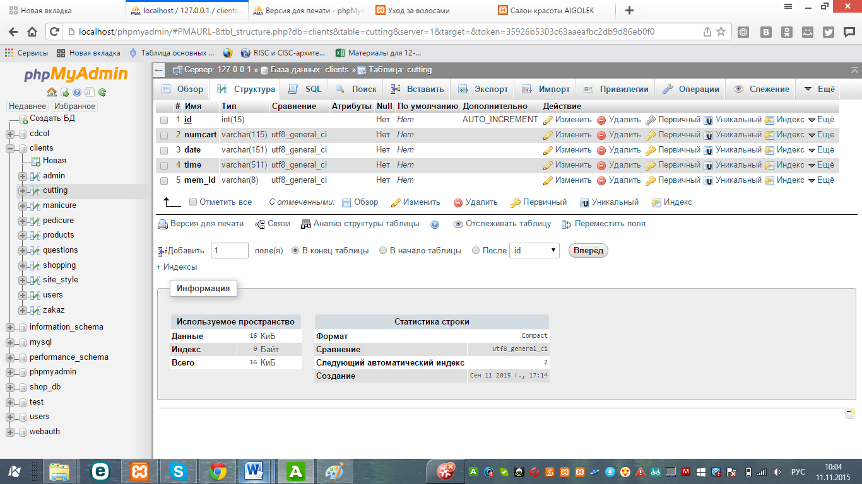

Fig. №29

|  |  |  |
| --- | --- | --- |
| **Column** | **Type of** | **Null** |
| Id | int(15) | No |
| Numcart | varchar(115) | No |
| Date | varchar(151) | No |
| Time | varchar(511) | No |
| mem_id | varchar(8) | No |

Table №10

### Index

|  |  |  |  |  |  |  |  |  |
| --- | --- | --- | --- | --- | --- | --- | --- | --- |
| **Index name** | **Type of** | **Unique** | **Packed** | **Column** | **Unique items** | **Comparison** | **Null** | **Comment** |
| PRIMARY | BTREE | Да | No | id | 0 | A | No |  |

Table №11

**The form of the proposed table “manicure”**

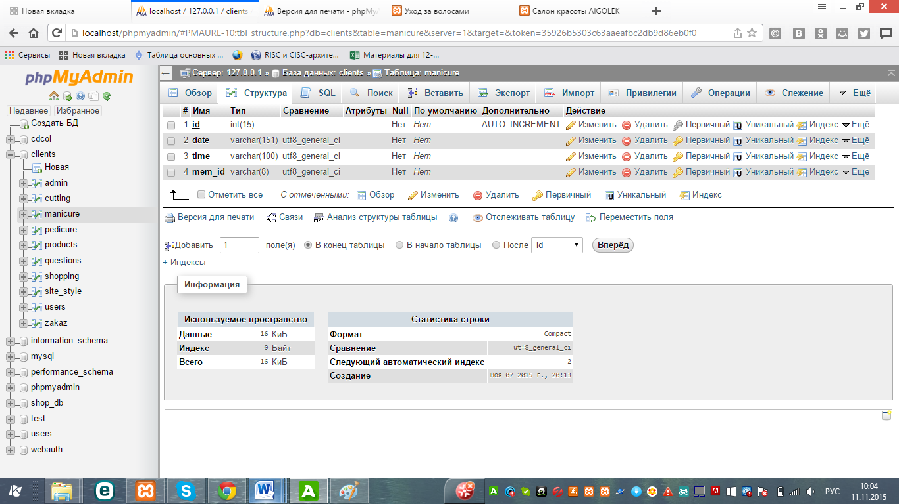

Fig. №30

|  |  |  |
| --- | --- | --- |
| **Column** | **Type of** | **Null** |
| Id | int(15) | No |
| Date | varchar(151) | No |
| Time | varchar(100) | No |
| mem_id | varchar(8) | No |

Table №12

**Index**

|  |  |  |  |  |  |  |  |  |
| --- | --- | --- | --- | --- | --- | --- | --- | --- |
| **Index name** | **Type** | **Unique** | **Packed** | **Column** | **Unique items** | **Comparison** | **Null** | **Comment** |
| PRIMARY | BTREE | Yes | No | id | 0 | A | No |  |

Table №13

**The form of the proposed table “pedicure”**

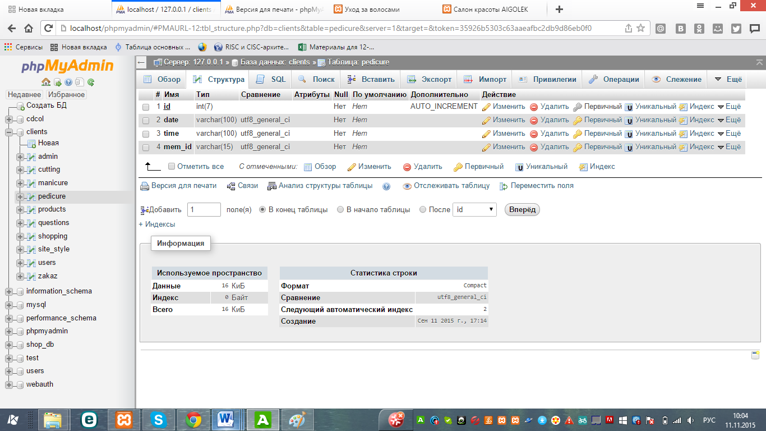

Fig. №32

|  |  |  |
| --- | --- | --- |
| **Column** | **Type of** | **Null** |
| Id | int(7) | No |
| Date | varchar(100) | No |
| Time | varchar(100) | No |
| mem_id | varchar(15) | No |

Table №14

**Index**

|  |  |  |  |  |  |  |  |  |
| --- | --- | --- | --- | --- | --- | --- | --- | --- |
| **Index name** | **Type of** | **Unique** | **Packed** | **Column** | **Unique items** | **Comparison** | **Null** | **Comment** |
| PRIMARY | BTREE | Yes | Yes | id | 0 | A | No |  |

Table №15

**The form of the proposed table “shopping”**

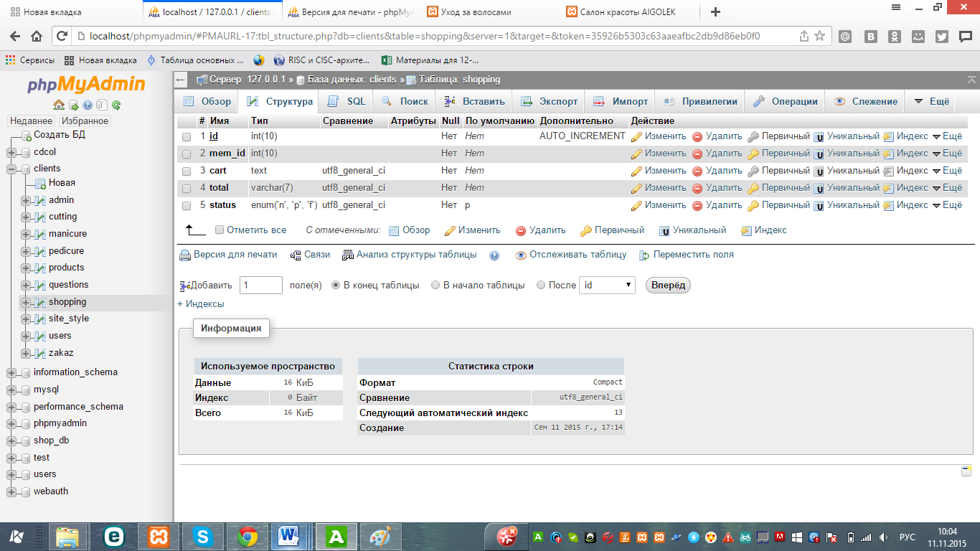

Fig. №3

|  |  |  |
| --- | --- | --- |
| **Column** | **Type of** | **Null** |
| Id | int(10) | No |
| mem_id | int(10) | No |
| Cart | text | No |
| Total | varchar(7) | No |
| Status | enum('n', 'p', 'f') | No |

Table №16

**Index**

|  |  |  |  |  |  |  |
| --- | --- | --- | --- | --- | --- | --- |
| **Index name** | **Type of** | **Unique** | **Packed** | **Column** | **Unique items** | **Comparison** |
| PRIMARY | BTREE | Yes | No | id | 4 | A |

Таблица №17

**The form of the proposed table “zakaz”**

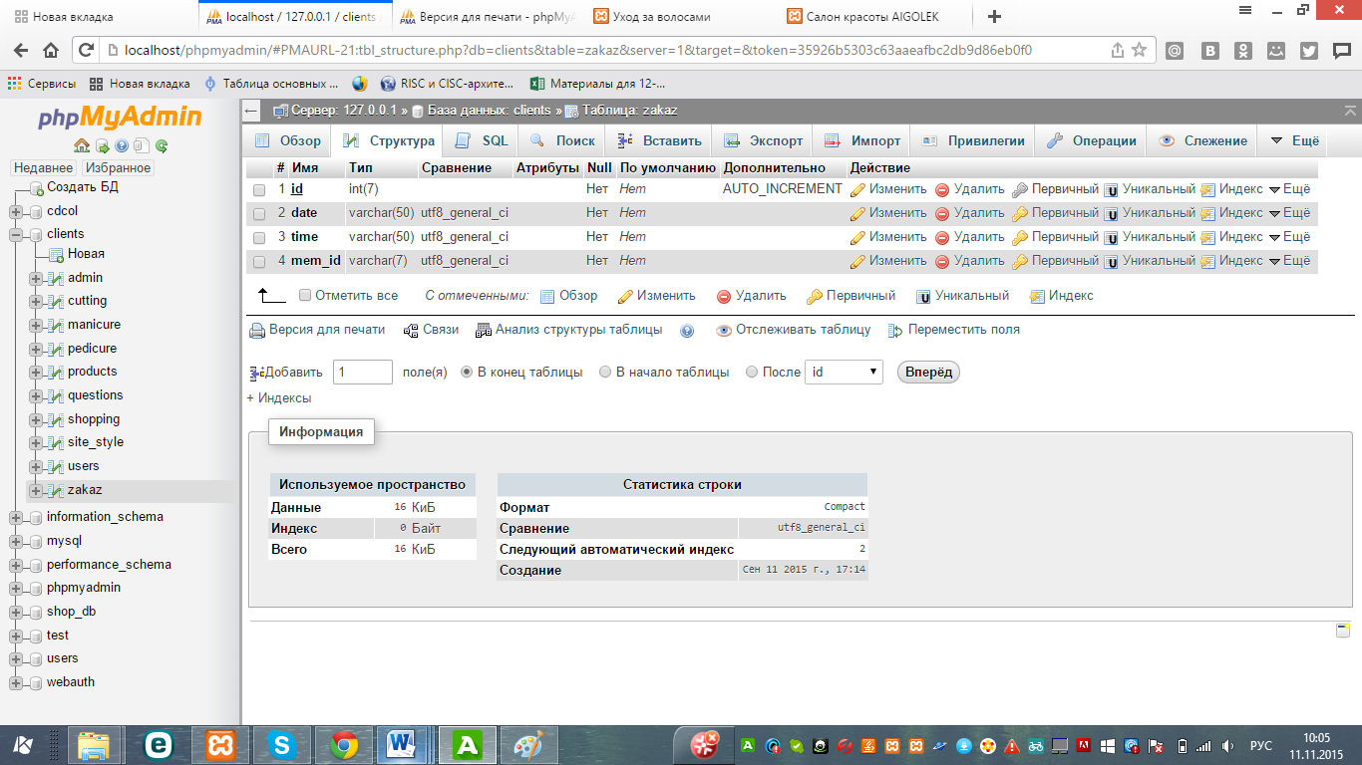

Fig. №33

|  |  |  |  |
| --- | --- | --- | --- |
| **Column** | **Type of** | **Null** | **Links to** |
| Id | int(7) | No | products -> id |
| Date | varchar(50) | No |  |
| Time | varchar(50) | No |  |
| mem_id | varchar(7) | No |  |

Table №18

**Index**

|  |  |  |  |  |  |
| --- | --- | --- | --- | --- | --- |
| **Index name** | **Type of** | **Unique** | **Column** | **Comparison** | **Null** |
| PRIMARY | BTREE | yes | id | A | No |

Table №19

**Database link table**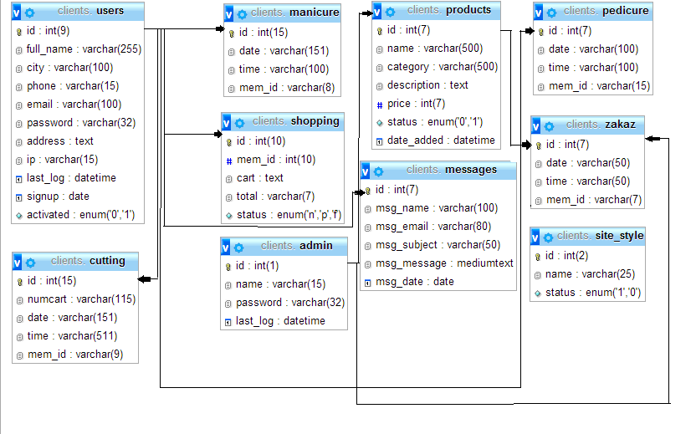

**(ii) Programming:**

To create the site I had to choose a suitable program designed for web programming. There were several software options for creating a site such as "Sublime Text 3", "Visual Studio Codet", "PsPad", "Dreamweaver" and so on. In the end, I chose Sublime Text 3. Sublime Text 3 (the former name of Macromedia Dreamweaver html-editor), by right, occupies a leading position in a wide range of programs for developing and creating websites.

To create a base for my site, I needed a server, so I decided to use Google Firebase. This service is very convenient for testing and viewing my site. In order to view the site from the browser, it was necessary to add .js files.

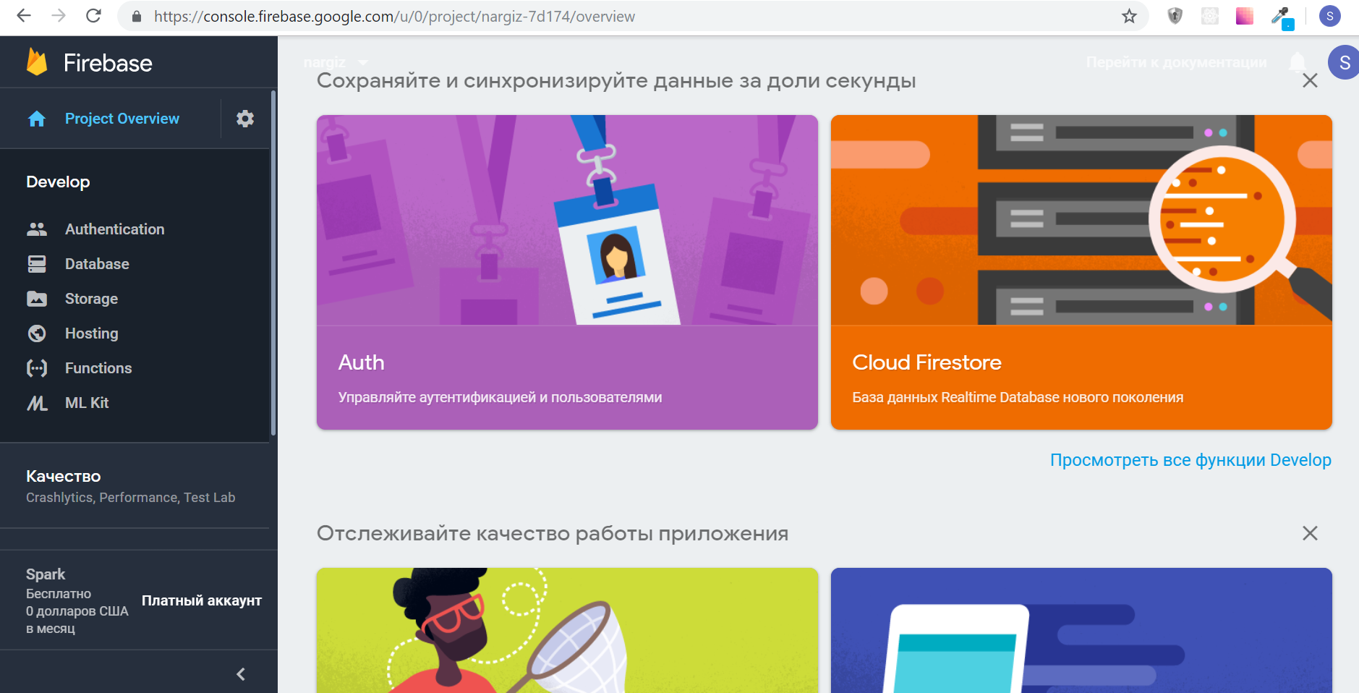

The site will consist of several pages. According to the first goals of the simulation (page 23), the interface of the new system will have an understandable functioning. Each page will have blocks for the menu, footer header, and login form. (goal-1, page 23, Figure No. 23) But here I had one problem concerning the blocks. The fact is that if I create a php file for each page, I will need to write in each file the form for the blocks. To prevent this problem, I created a separate file for the blocks and wrote the following scripts in each file:

<?phpinclude_once("templates/tmp_header.php"); ?>

<?phpinclude_once("templates/tmp_nav.php"); ?>

<?phpinclude_once("templates/tmp_left_aside.php"); ?>

<?phpinclude_once("templates/tmp_right_aside.php"); ?>

My site has pages for all users and the admin page: (Pic. №31):

**Homepage form for users**

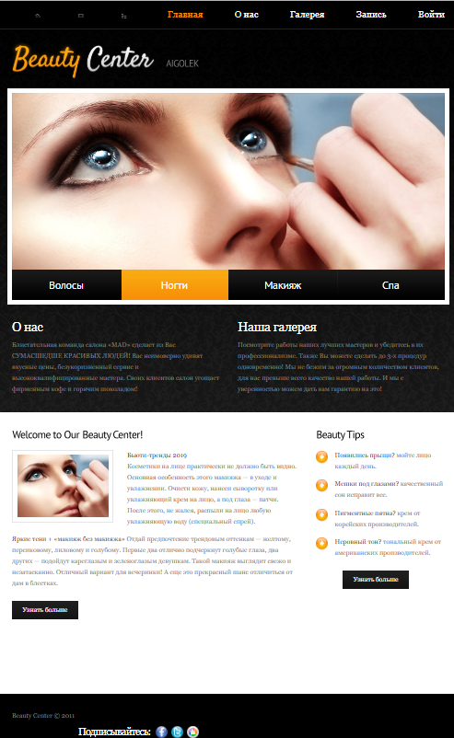

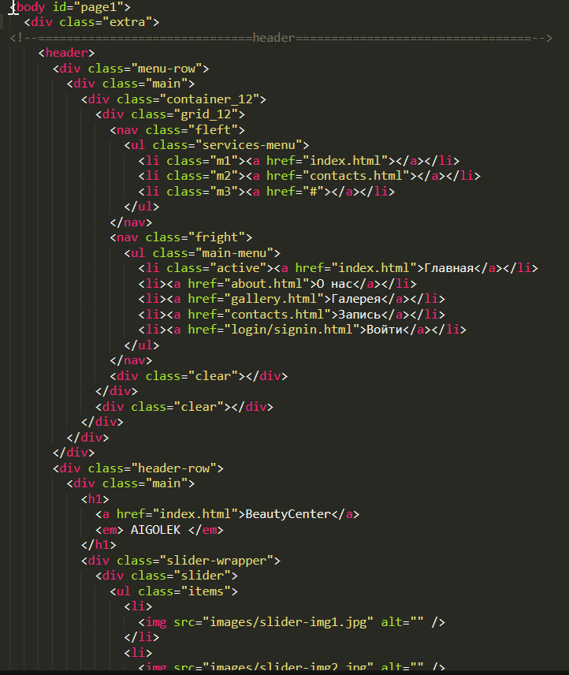

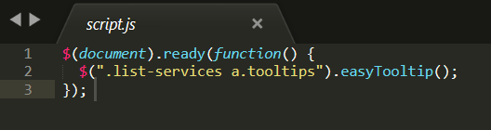

Script runs after all requests are sent and the document is downloaded, the function calls method easyToolTip to set styles of the elements as shown below:

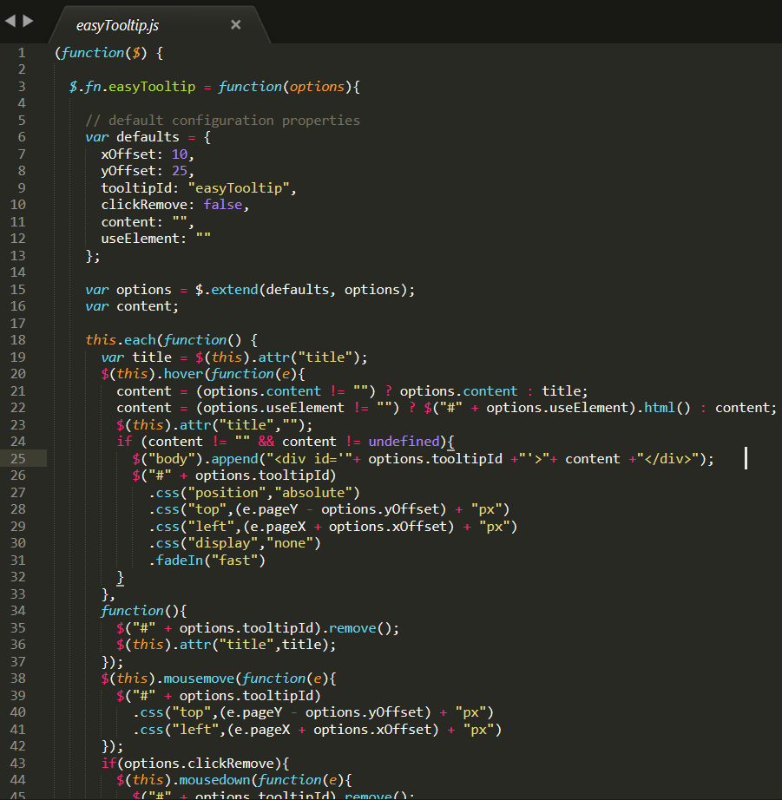

**About us page**

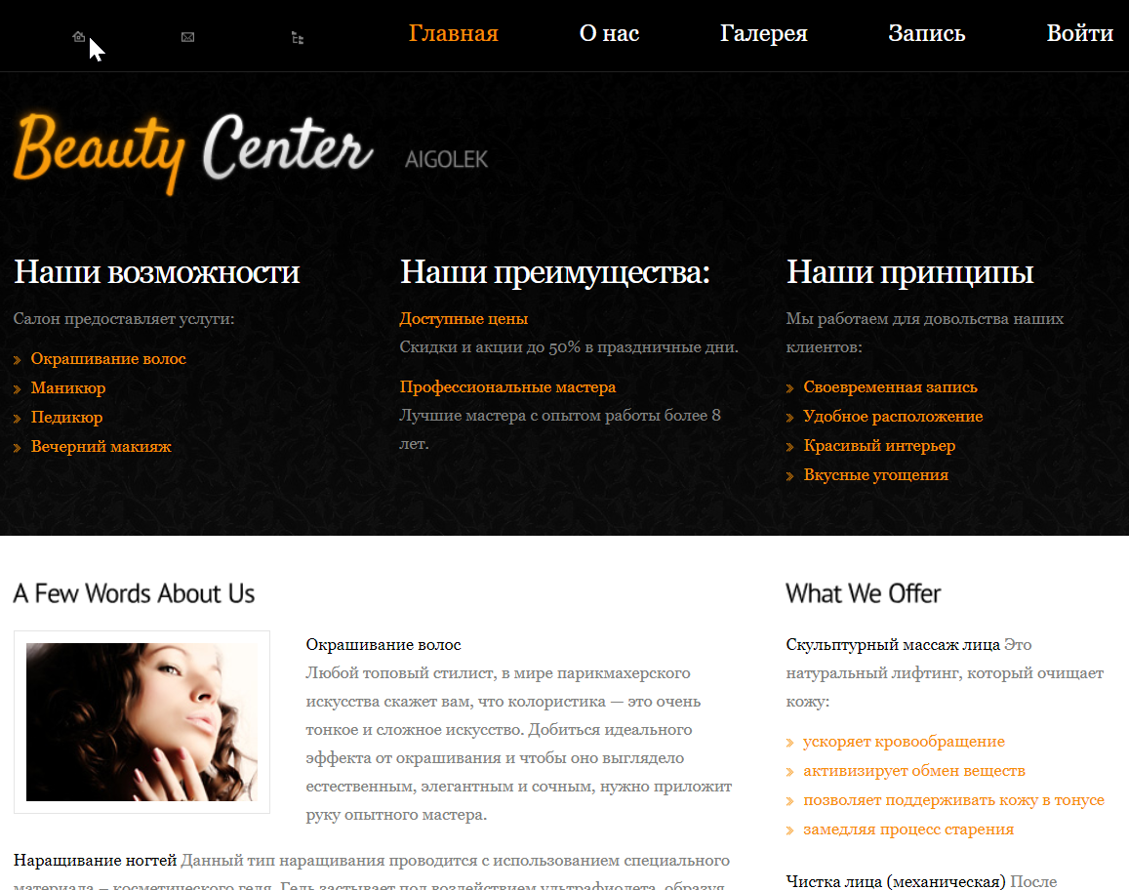

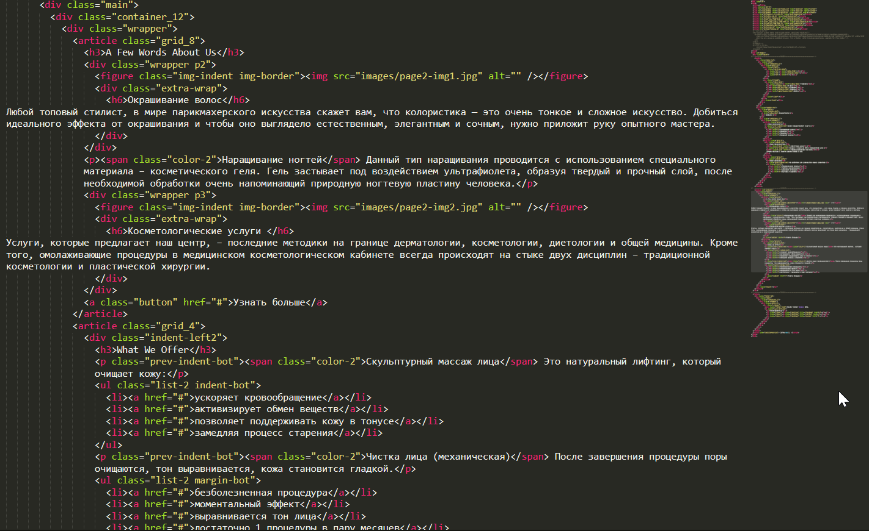

**Gallery page**

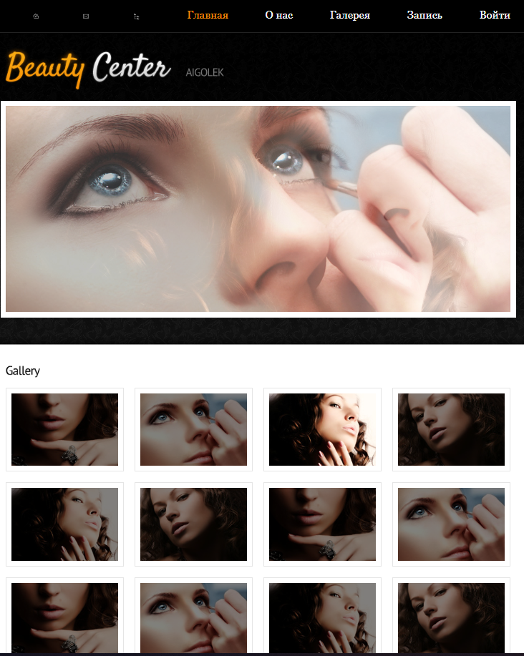

For this gallery I created js carousel plugin:

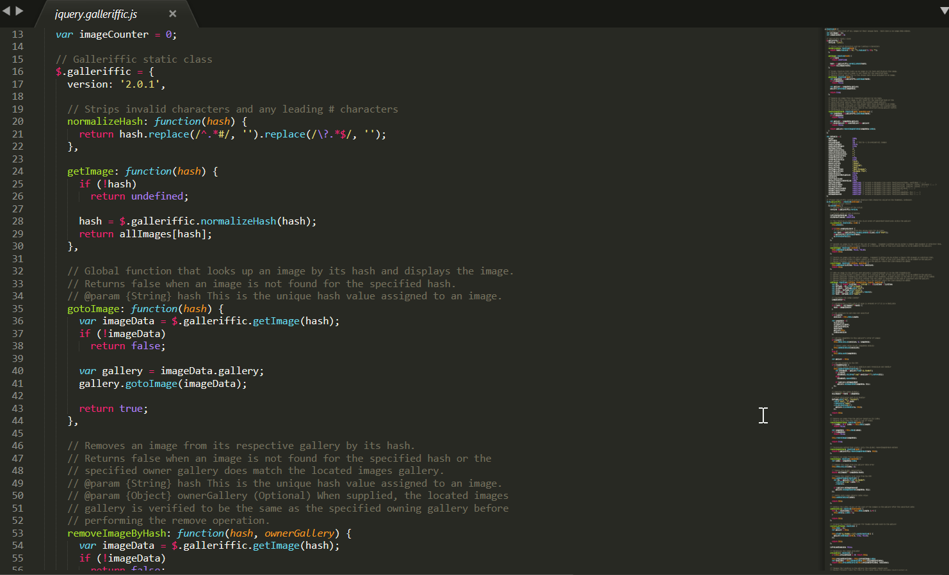

**Form page for ordering a service**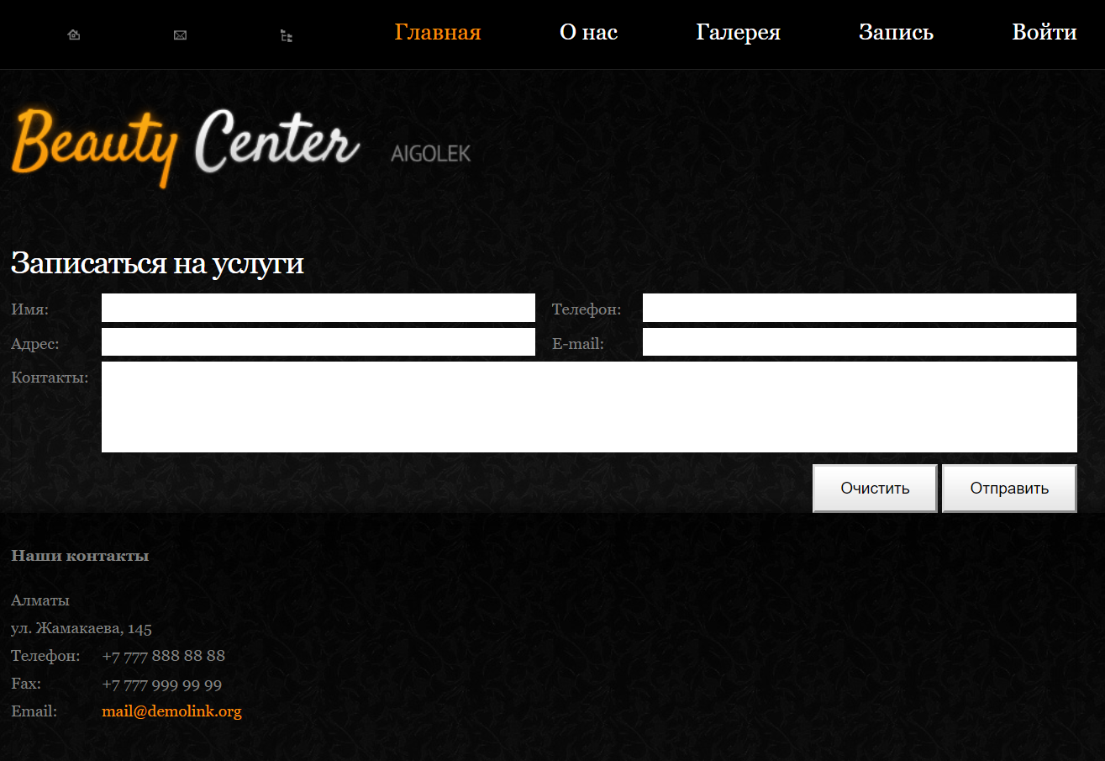

Fig. №37

Registration Code (Рис. №38-39):

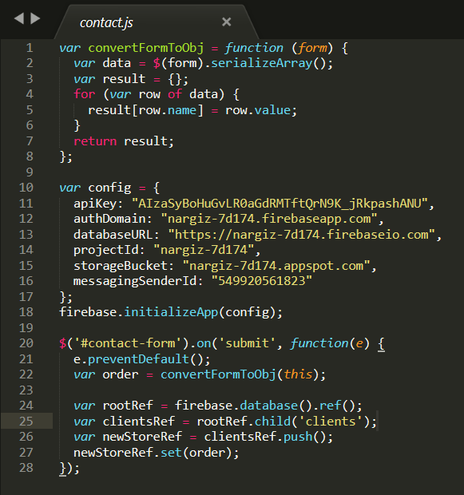

Fig. №38

(Fig. №39)

|  |  |  |
| --- | --- | --- |
| № | Variables | Destinations |
| 1 | $email | Customer email address, used as key element |
| 2 | $password | The password of the user who must match the email address |
| 3 | $data | Array of input data |
| 4 | $order | JSON of the $data |
| 5 | $rootRef | Base url to send object |
| 6 | $clientsRef | Clients table link |
| 7 | $result | objected data from input |
| 8 | $address | User Address |

**On this page, users do registration, and all data is sent to the users database. (Goal-2, Goal-4 Figure # 23) All data is first checked for uniqueness (key) and correctness (Figure # 39).**

**Form page for admin signup**

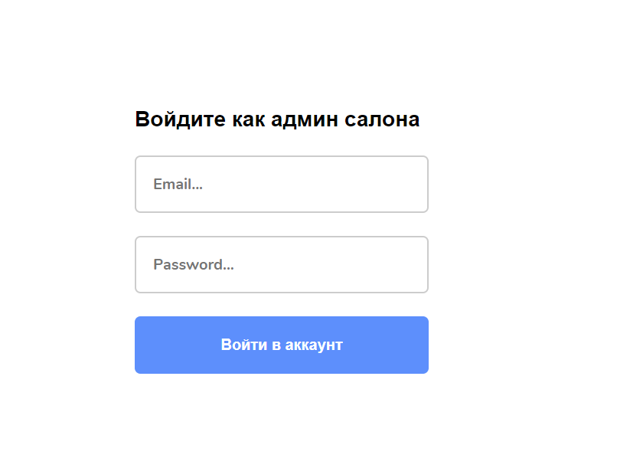

Coding of the admin signup page:

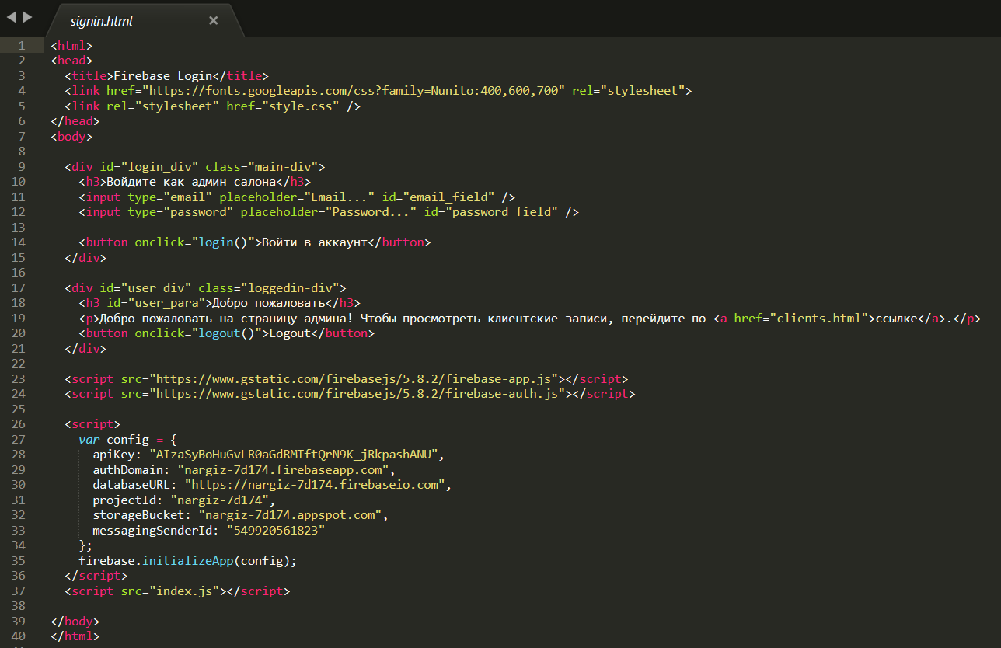

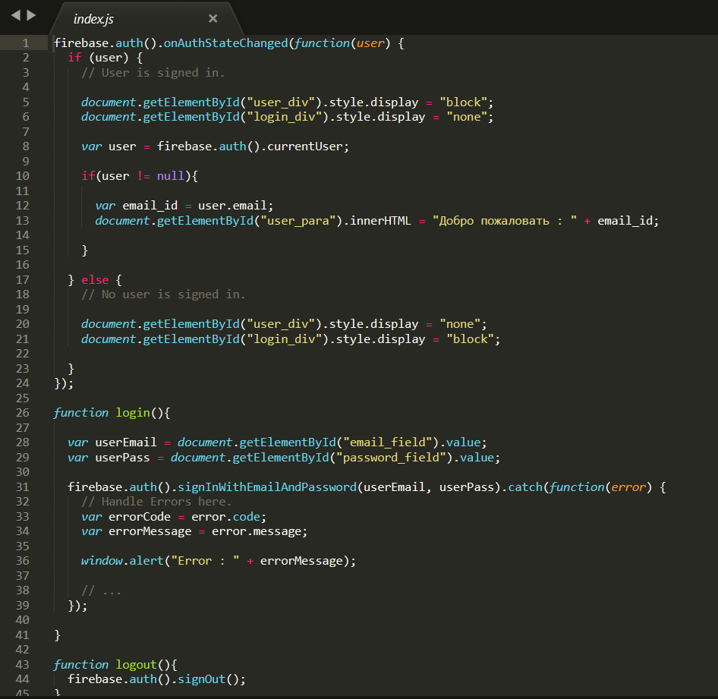

**Page to confirm admin profile sign in**

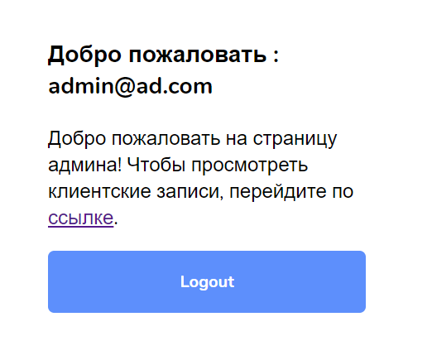

Admin page to see the orders:

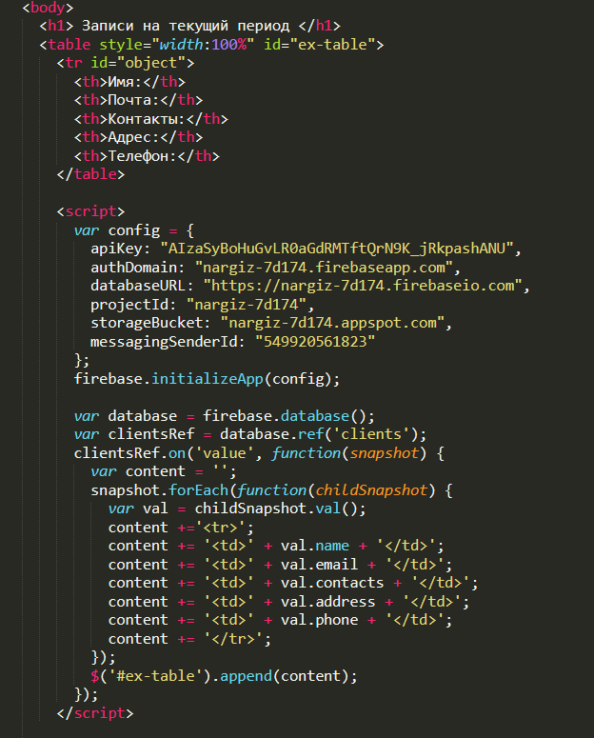

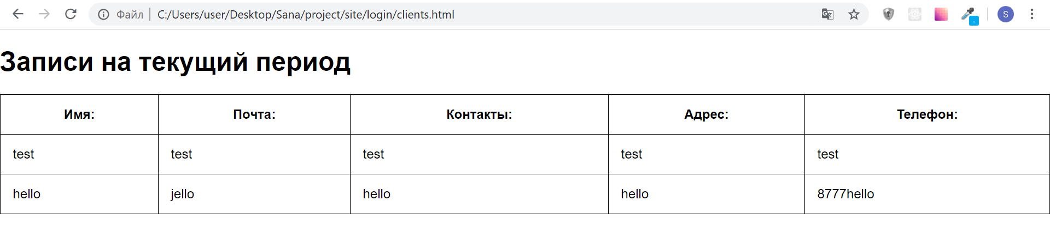

**Online real-time database with the data**

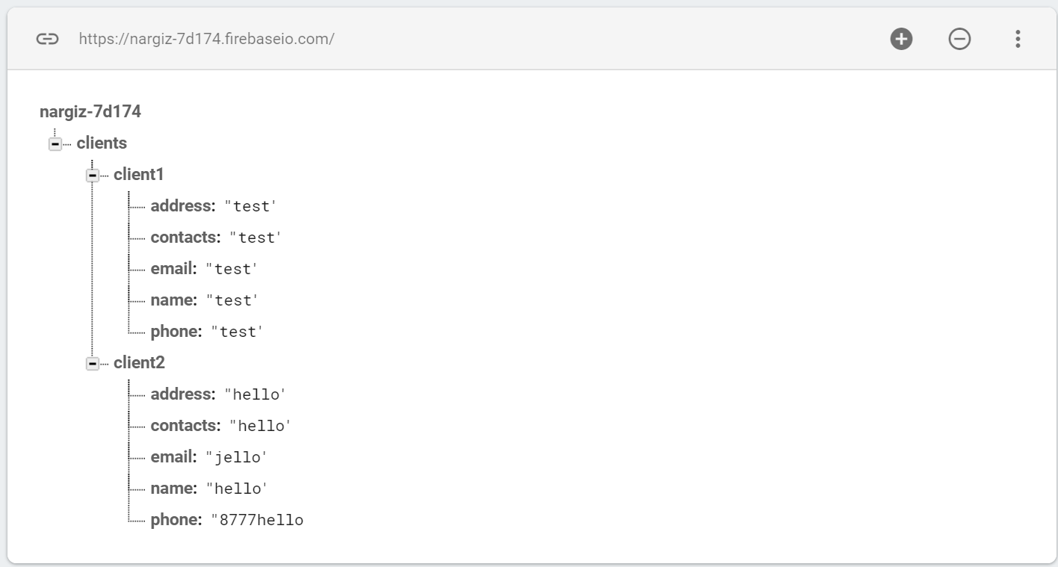

**Appearance of the website (styles.css)**

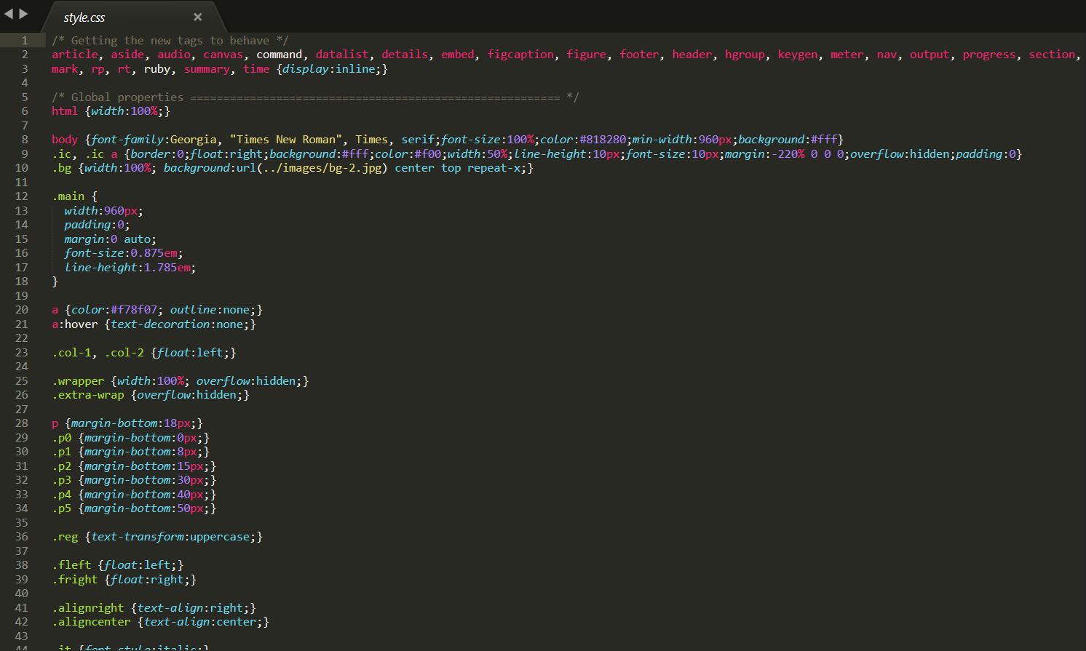

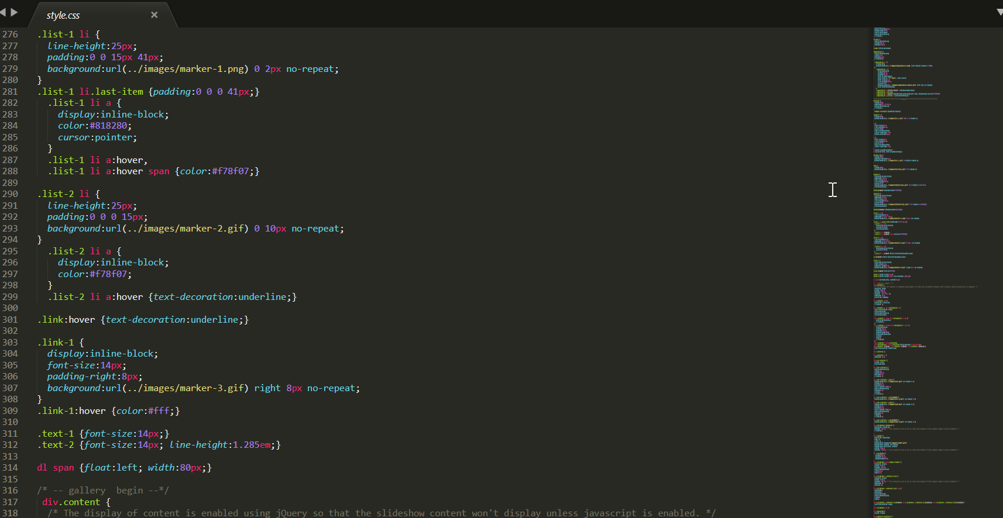

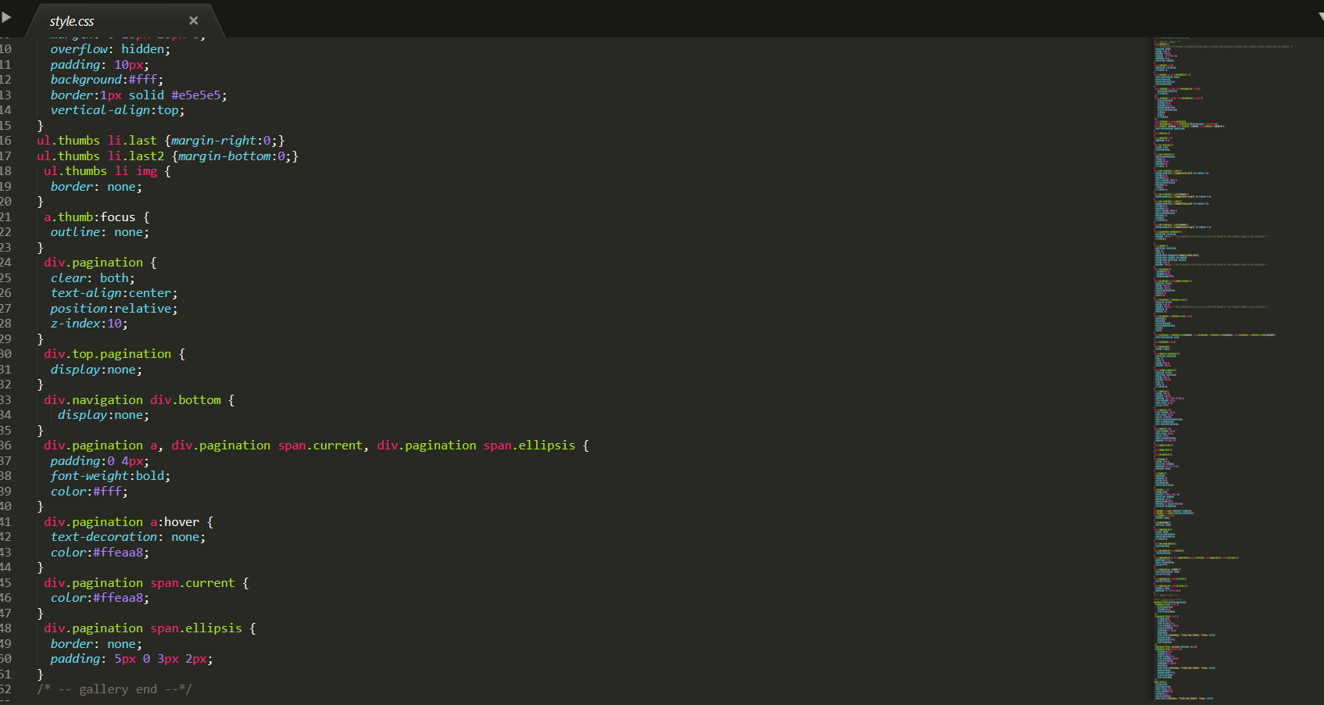

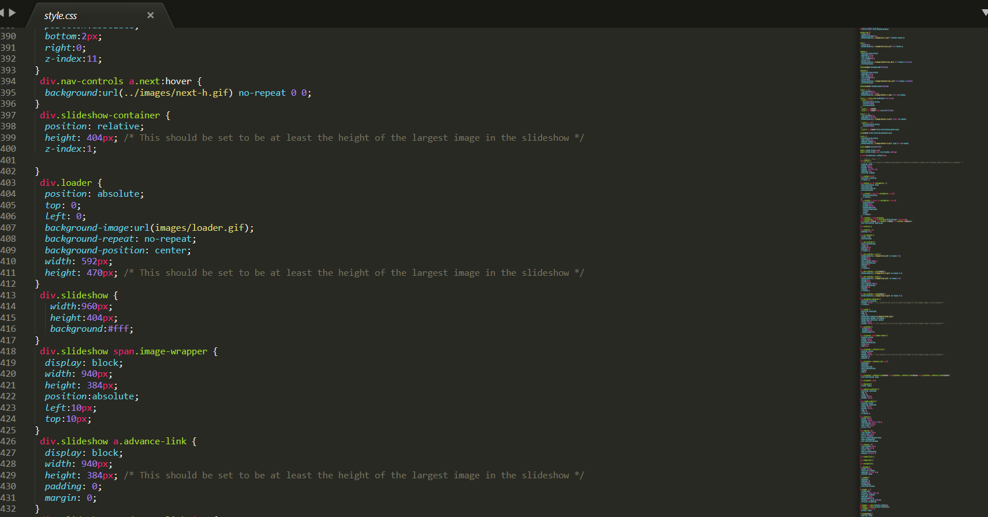

### (iii) Testing:

**Testing strategy**

**Like all sites on the Internet, my site may also have some errors. I decided to check out my site before it will be used by the salon and users. I use many different verification strategies to ensure that every possible error is considered. I will enter both normal and abnormal values to check my site. I hope that after testing I will be able to reduce the number of errors to zero.**

|  |  |  |  |  |  |  |  |  |
| --- | --- | --- | --- | --- | --- | --- | --- | --- |
| **Test number** | **Purpose of the test** | | **Test method** | **Use test data** | **Expected Result** | | **Actual result** | **Proof, page no** |
| 1 | Check the result if you leave the input field empty. For example: username | | Leave the username field blank and try to register on the site. | N/A | The system will warn the user that it cannot do this and tells the user to enter all the data. | | Successfully | Fig № 60-61 |
| 2 | Check if the email address is checked in the database | | Enter the email address that already exists in the database | isina.nargiz@gmail.com | The system will warn the user that there is already such a login. | | Successfully | Fig № 62-63 |
| 3 | Check if the password system works properly (this is very important) | | Enter correct and incorrect password | 123456/erbol2004 | The site should not allow to enter when the password is entered incorrectly. | | Successfully | Fig № 64-65 |
| 4 | Check if the password system for the administrator is working properly (this is very important) | Enter correct and incorrect password for admin | | nargiz/2004erbol | The site should not allow an administrator to log in when the password is entered incorrectly. | | Unsuccessfully, but solved | Fig № 66-67 |
| 5 | Check whether the system allows you to add a lot of products to the cart and displays the total amount | | Add 3-4 products to the cart |  | The site will add all products and displays the total amount | | Successfully | Fig № 68 |
| 6 | Check if one user can sign up for many services | | Try to sign up for 3 services by logging in from the same registered user | N/A | The system should allow to sign up for several services. | | Successfully | Fig № 69,70,71,72 |
| 7 | Check whether the product is added by the administrator and is shown on the website, is added to the database | | Add a product to the admin page and check it in the standard user site and in the database | N/A | The site should add the product and display on the product page in the database | | Successfully | Fig № 73,74,75,76 |
| 8 | Check basket operation | | Do not add any products and enter the cart | N/A | The site should warn that the user does not yet have a basket. | Successfully | | Fig № 77 |
| 9 | Check whether all orders are shown on the admin page and in the database | | Order goods on behalf of the user and check the admin page and database | N/A | On the admin page and in the database should be all customer orders | | Successfully | Fig № 78,79,80 |
| 10 | Check if the administrator can delete users, delete the record from the database | | Attempt to delete user | N/A | The “delete” function on the admin page should work | | Successfully | Fig № 81-82 |

(Table №20)

**Test number 1**

**All sites must register users with perfect data. I check the result when I enter all the data, but leave the Username empty, adding students to the database. A message appears on the screen: “Fill up all the data!” Similarly, other input fields will warn you with a message when the user leaves the field empty.**

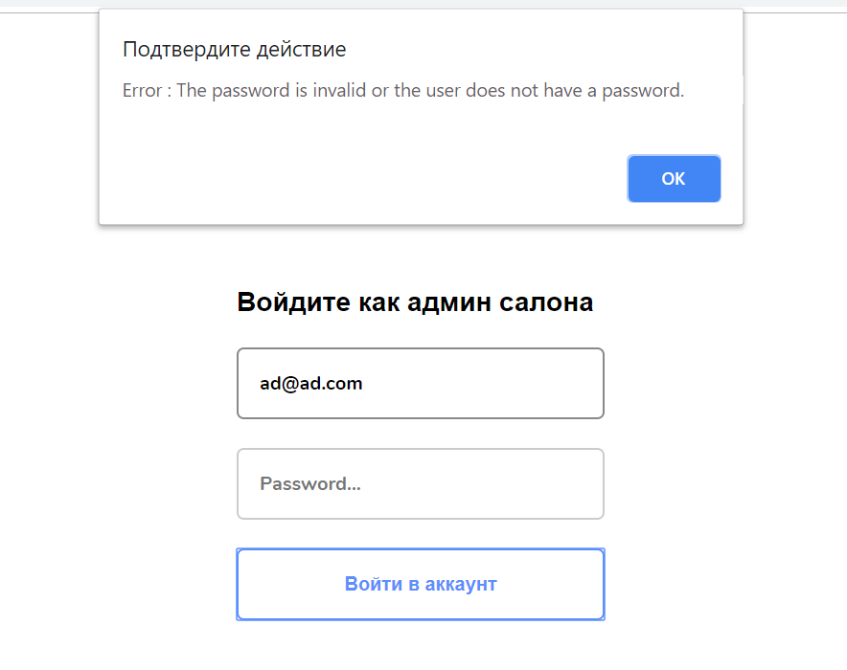

Fig. №60

If we enter all the data correctly, a message appears:

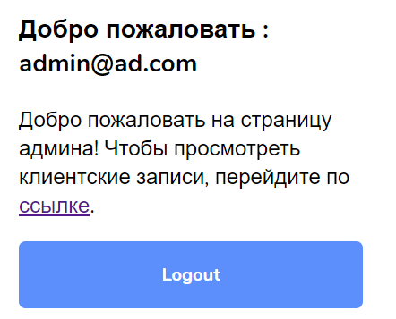

Fig. №61

**Test number 2**

**Each user must have a personal password and login. I check the uniqueness of the user's email address. Every time an existing database address is entered, the following message is always displayed:**

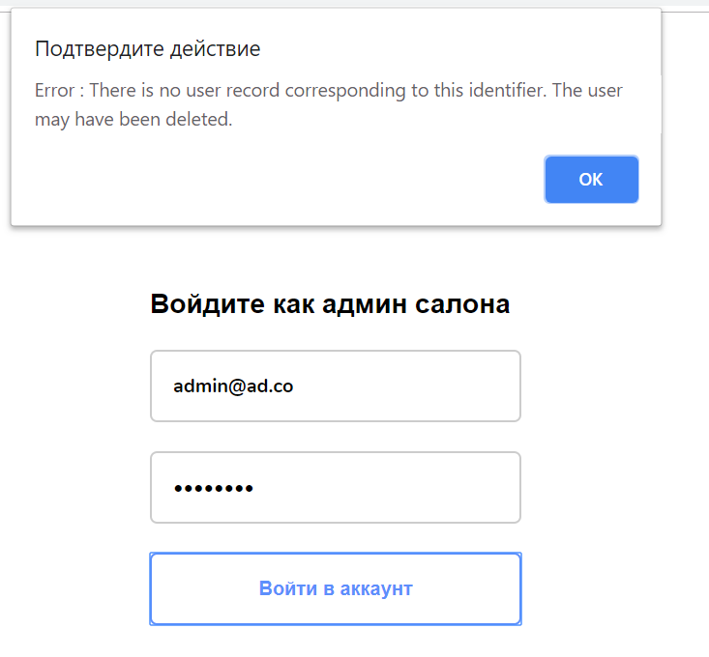

Fig №63

If everything is correct and there is no duplication, then the account is created successfully:



Fig. №64

**Test number 3**

**Each client must have a password and login and the site must verify the accuracy of this data. I entered the wrong password and checked this site system. I will try to enter the wrong password to the existing login. If you enter the wrong password, then the site is not accessed:**

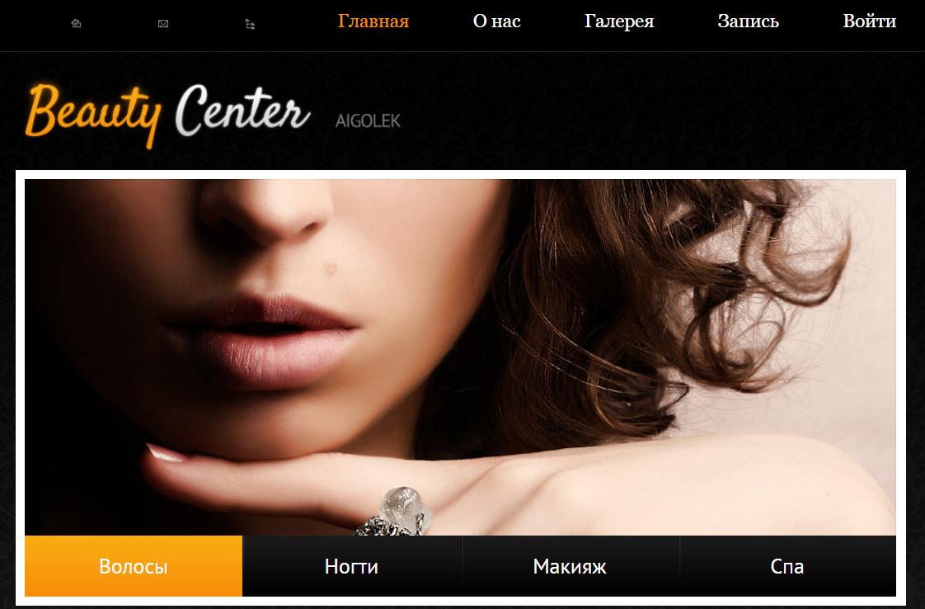

Fig. №64

Now I enter all the data correctly. If you enter the username and password correctly, then you enter the site:

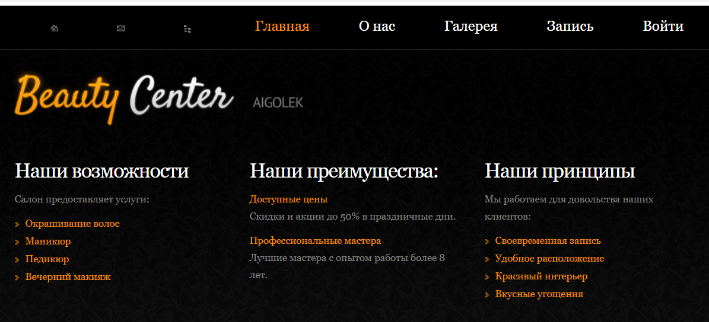

Fig. №65

**Test number 4**

**The administrator also has a personal password and login. I will enter the wrong password and check the site.**

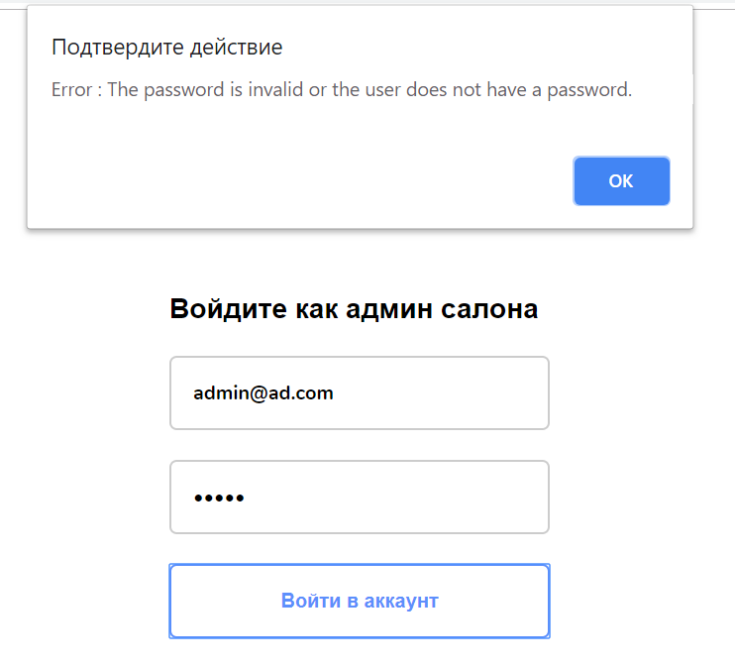

Fig №66

After pressing the “Enter!” Button, the message “Login or password is incorrect!” Appears, this means that the system is working correctly.

If you enter the correct username and password, the admin page opens:



Fig. №67

**Test number 5**

**My site has a function that reads the total amount of goods that have been added to the cart. I will add some products to the cart and check if the site considers the total amount. Some users want to order several products at once, in this situation this function plays a very important role.**

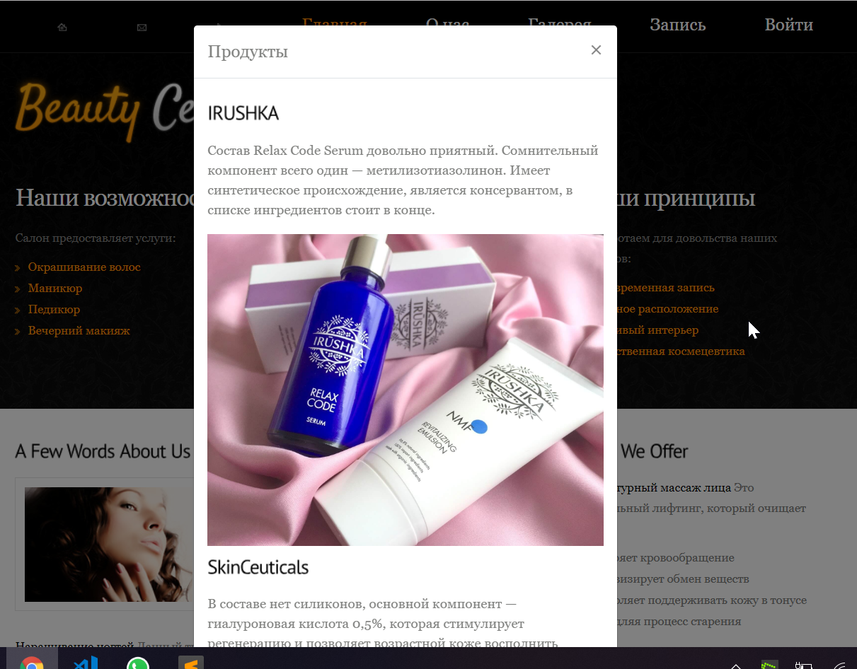

Fig. №68

The site displays the total amount of goods correctly, which means that the test was successful.**Тест №6**

There are cases when a client wants several services. I check this case when a client registers for several services. I enter the site and sign up for several services:

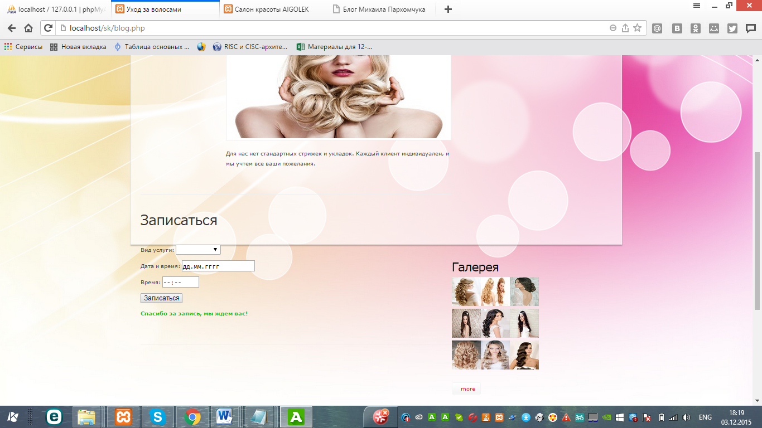

Fig. №69

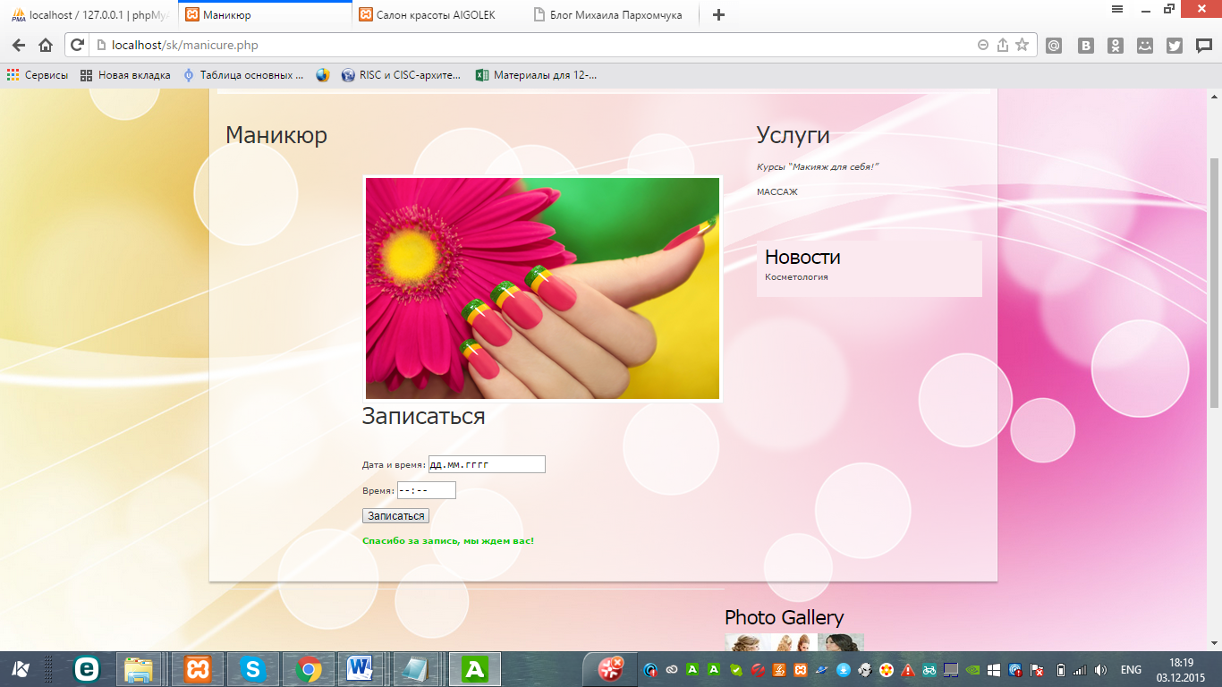

Fig. №70

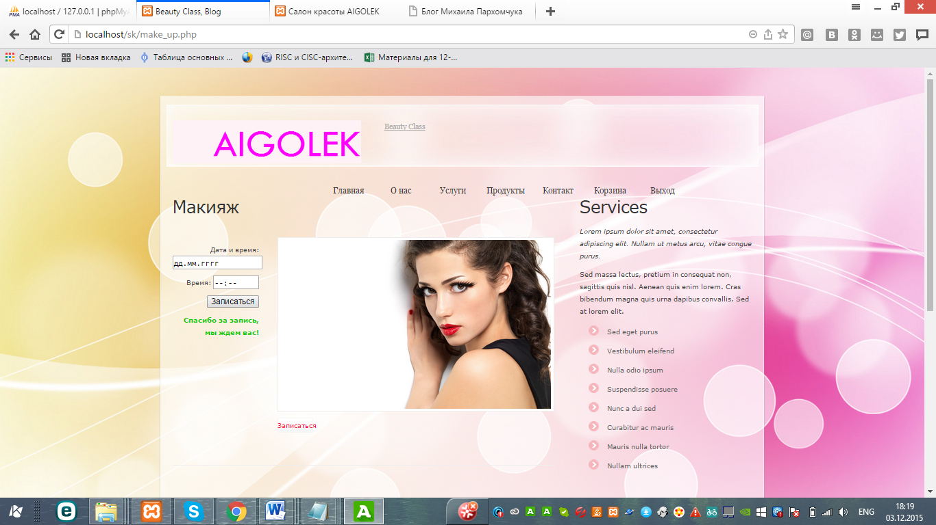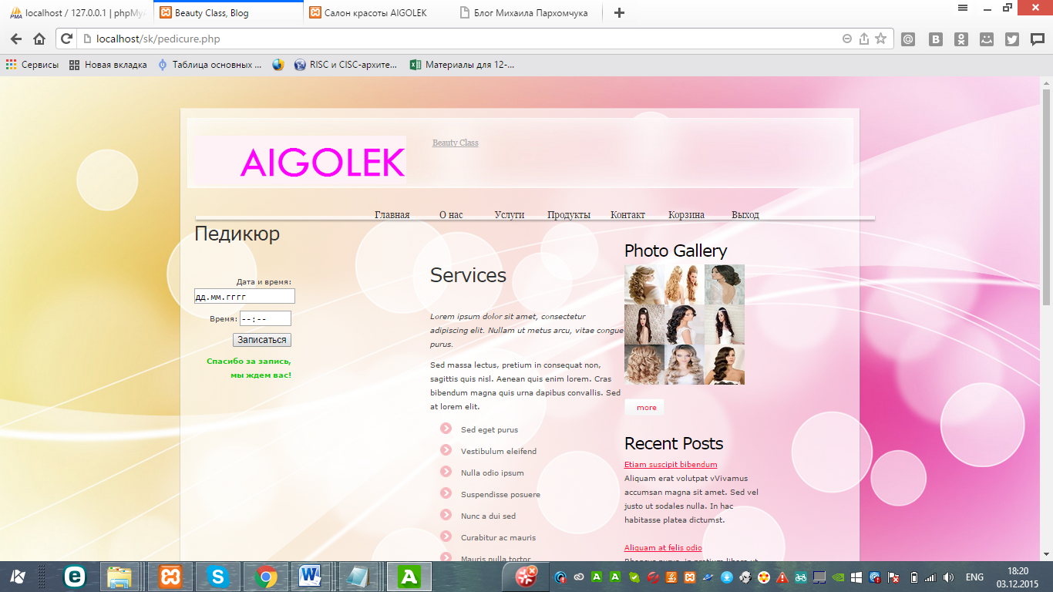

Fig. №71 Fig. №72

Now I go to the admin page and check the table of services recorded. User signed up for all services: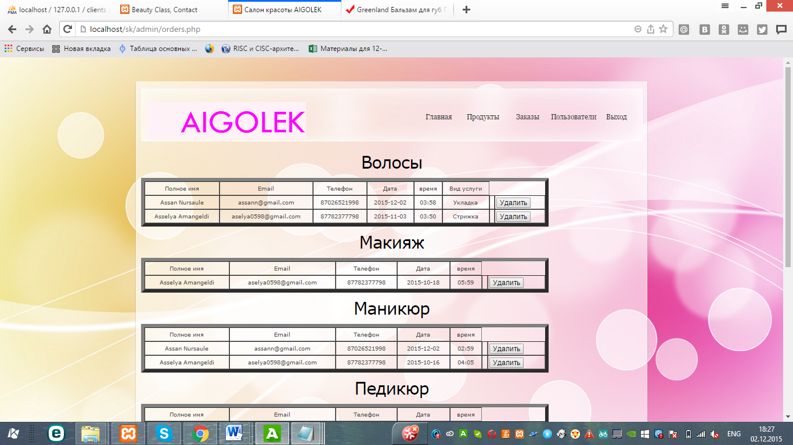

Fig. №73

In the table, which is located on the admin page, the name of the user who signed up for the service is revealed.

**Test number 7**

**My site allows the administrator to add products to the site and edit their data. I will check this process in the site. I add a new product to the site:**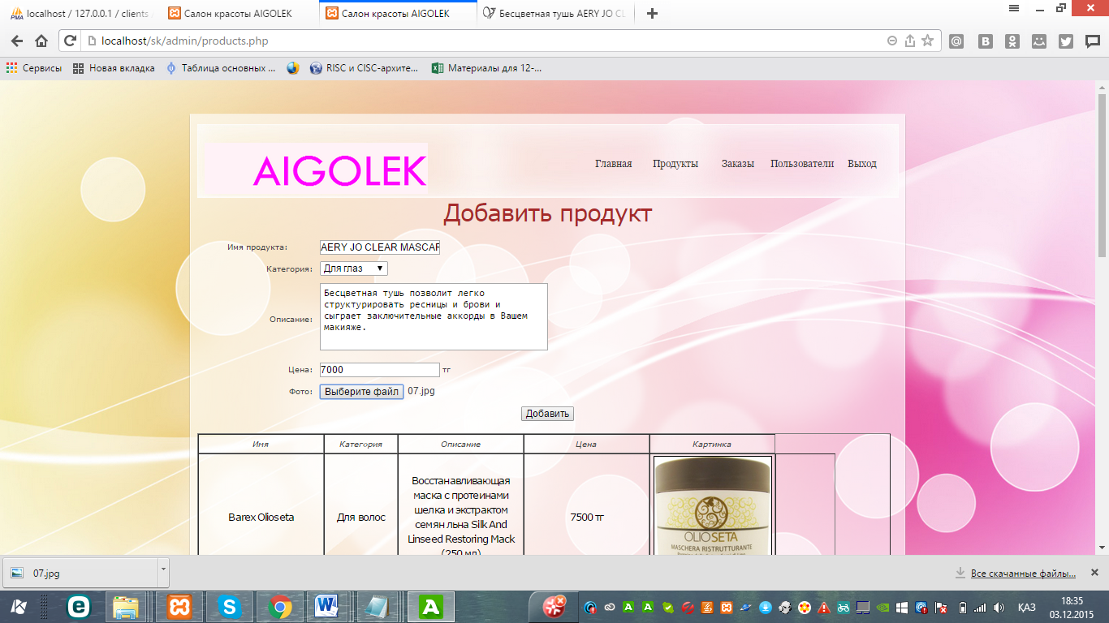

Fig. №73

The product has appeared on the admin page: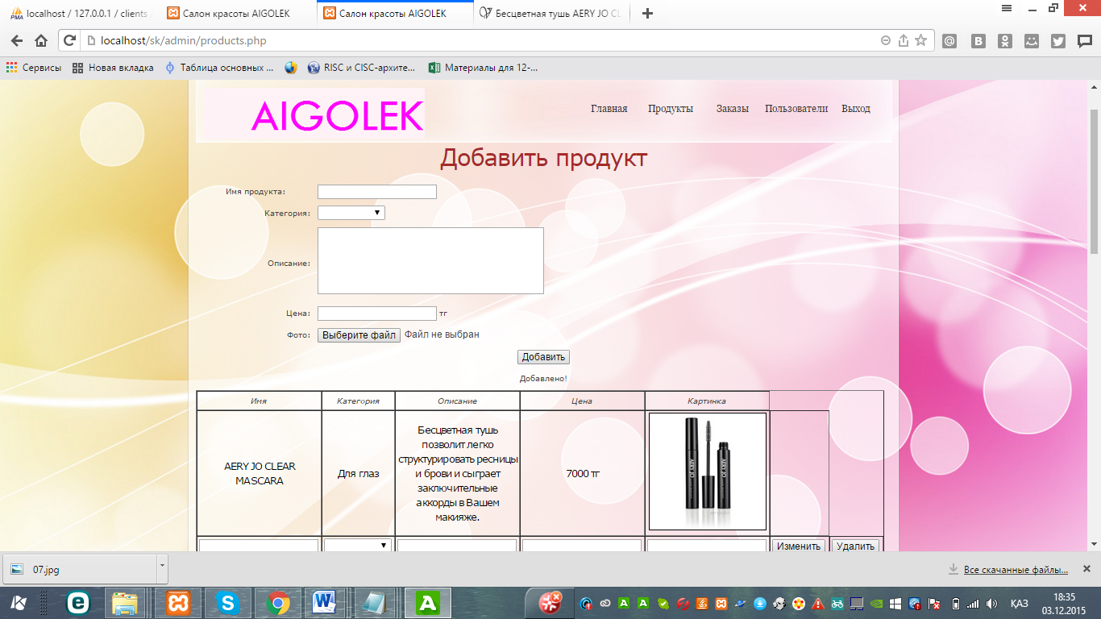

Fig. №74

Now I check this product on the site, it is located next to other products: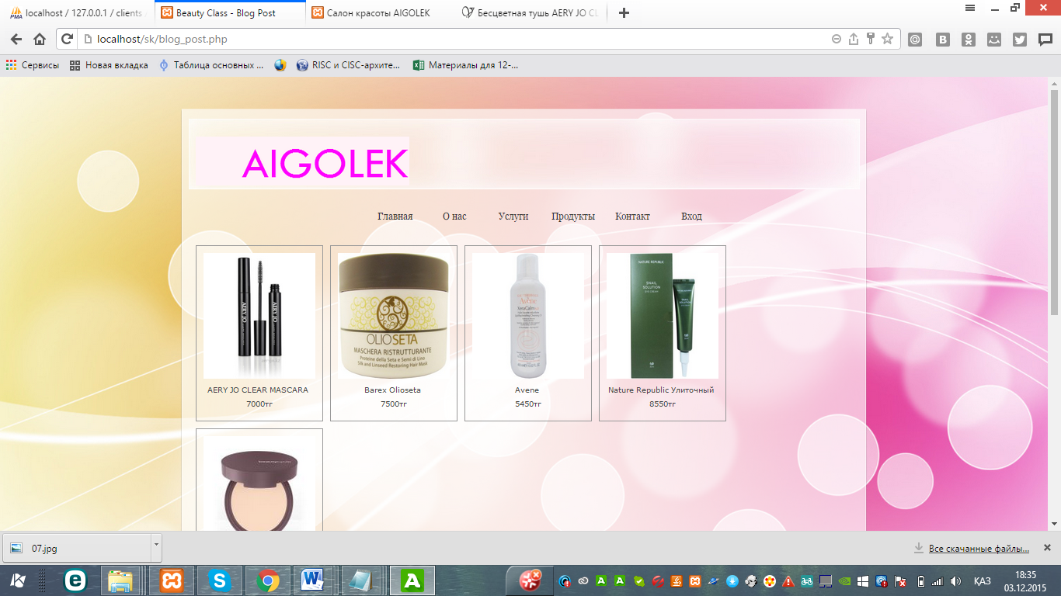

Fig. №75

Full Product Information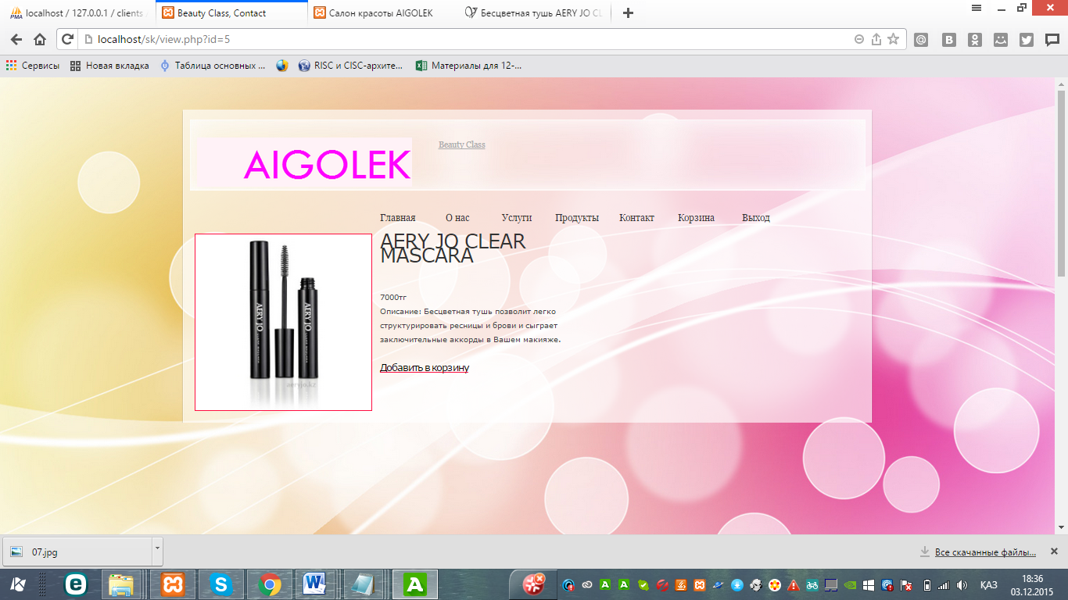

Fig. №76

**Test number 8**

**To check the basket, I will not add any products to the basket and open this page. Those who have not added products will receive the following message:**

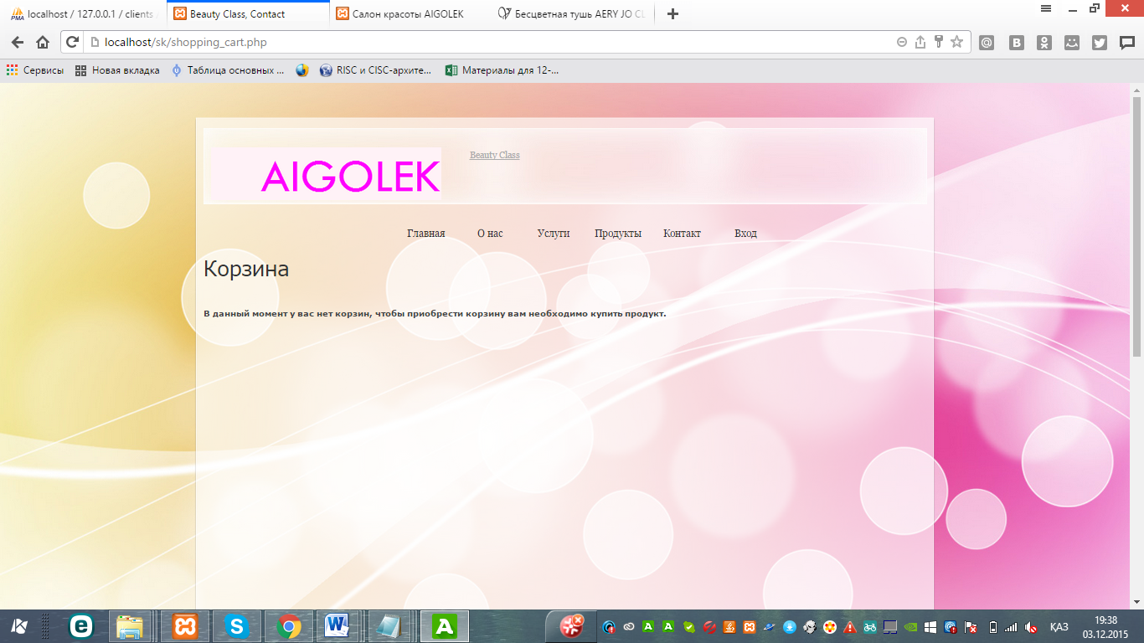

Fig. №77

**Test number 9**

**This test checks customer orders, and also checks whether orders are actually displayed on the admin page.**

**User orders products:**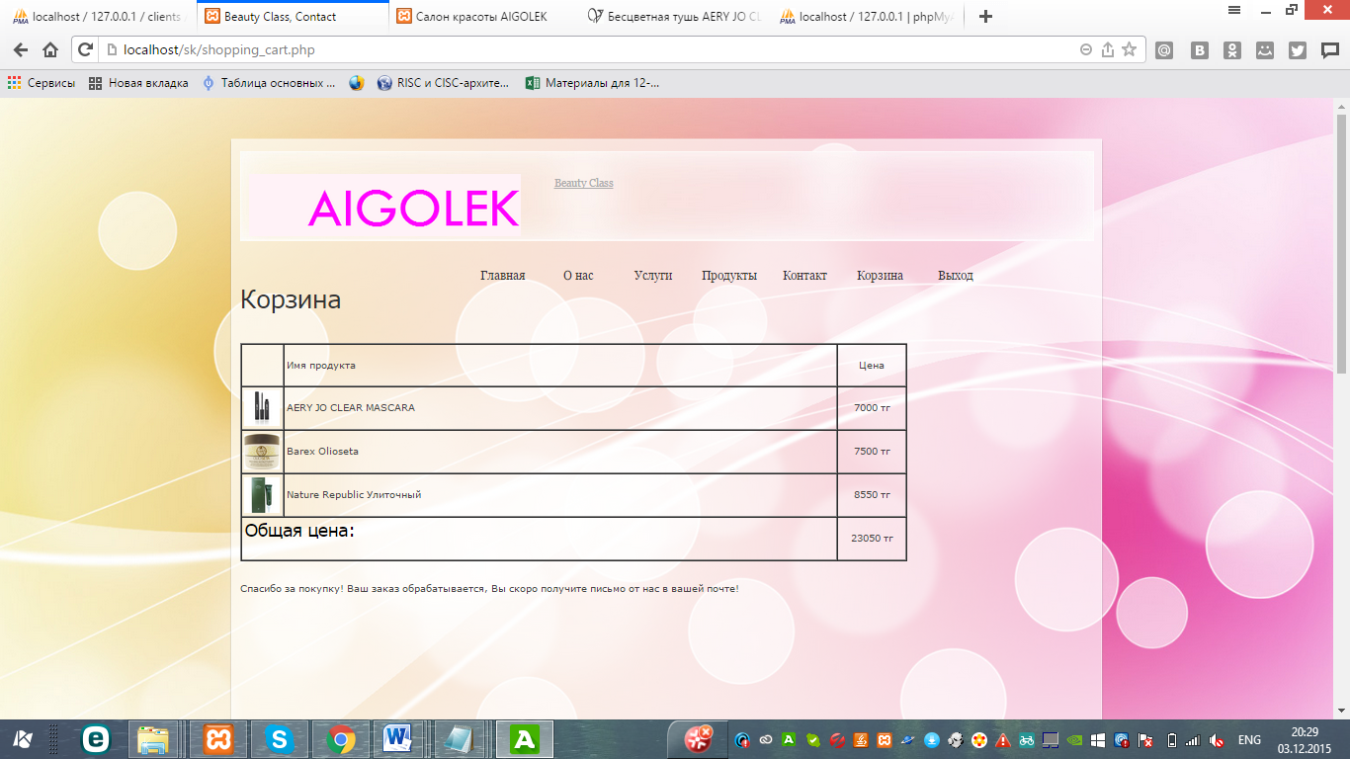

Fig. №78

Order data is sent to the admin page: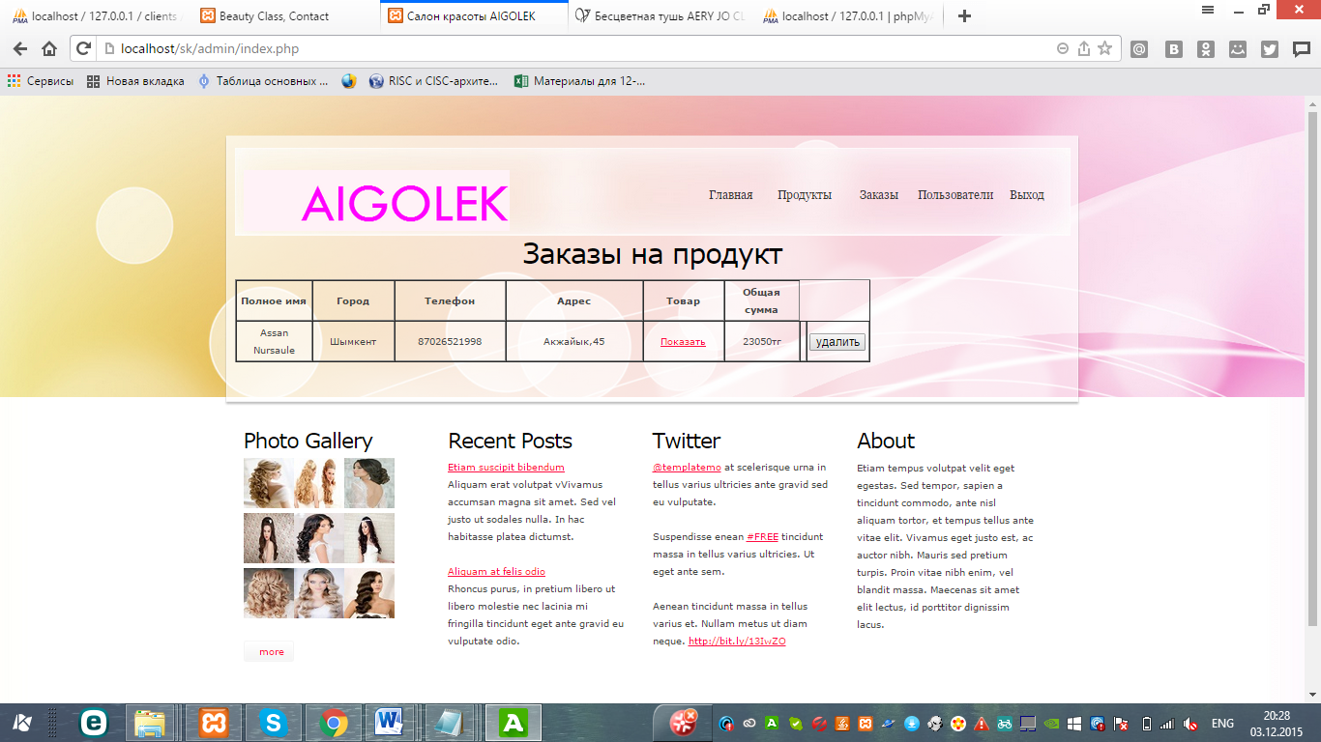

Fig. №79

Also, the data is sent to the database: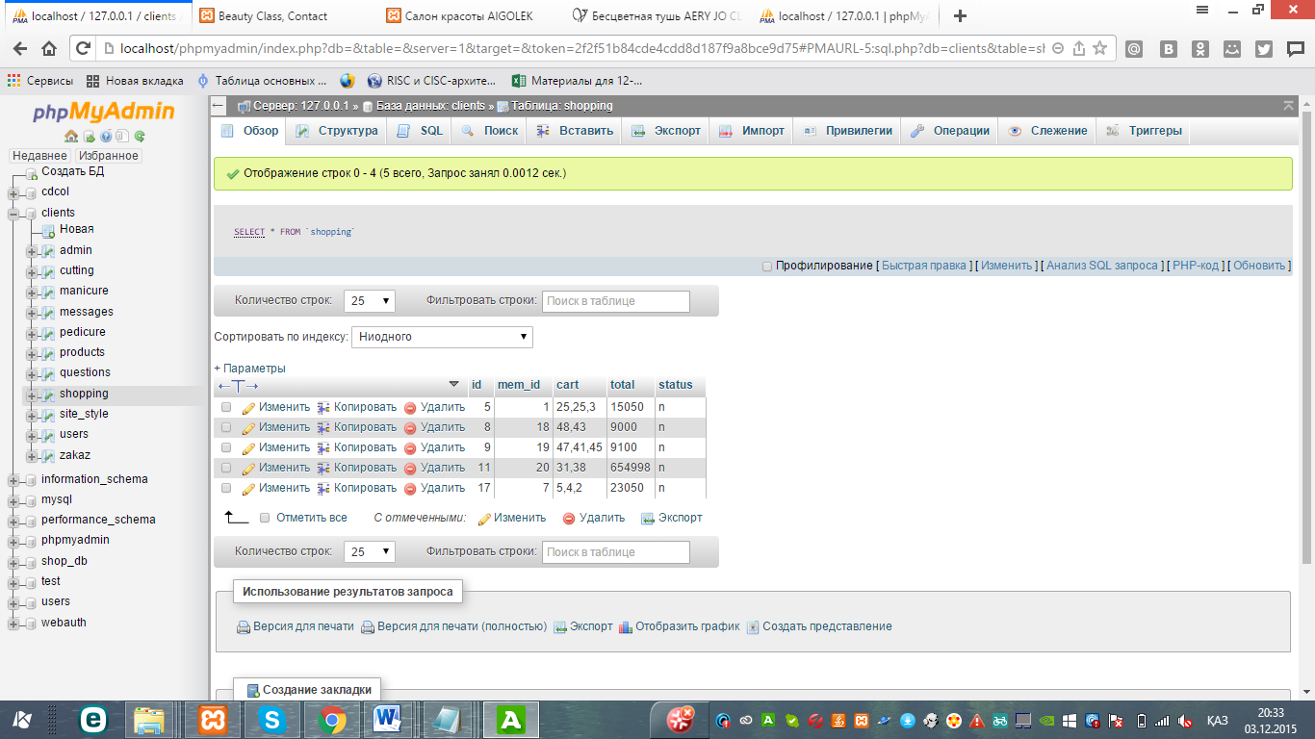

Fig. №80

**Test number 10**

**This test checks one of the many administrator functions that helps it remove users from the site. Open the admin page:**

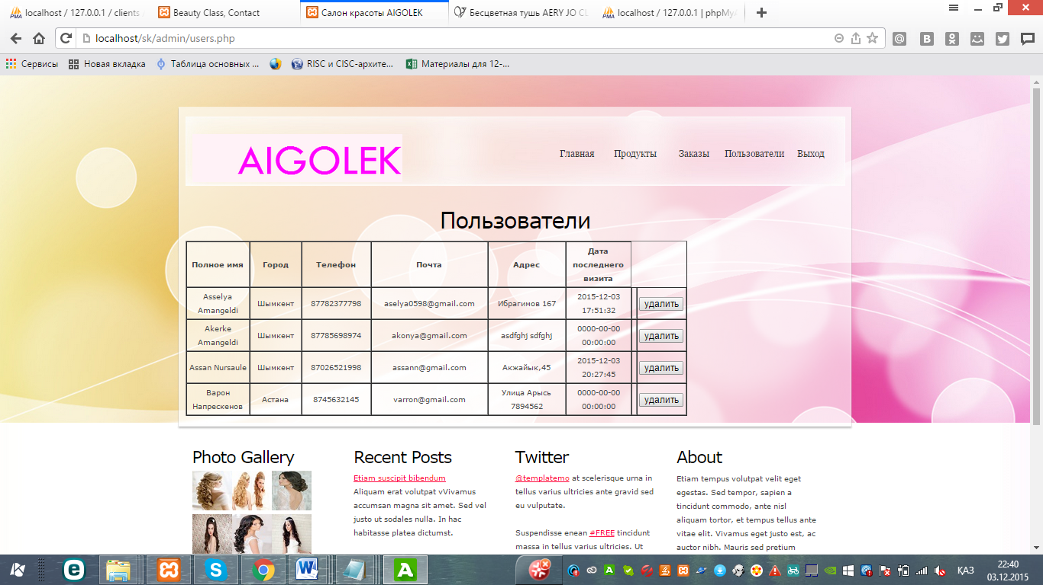

Fig. №81

I click the button “Delete” of the last user, then all data of this client is deleted:

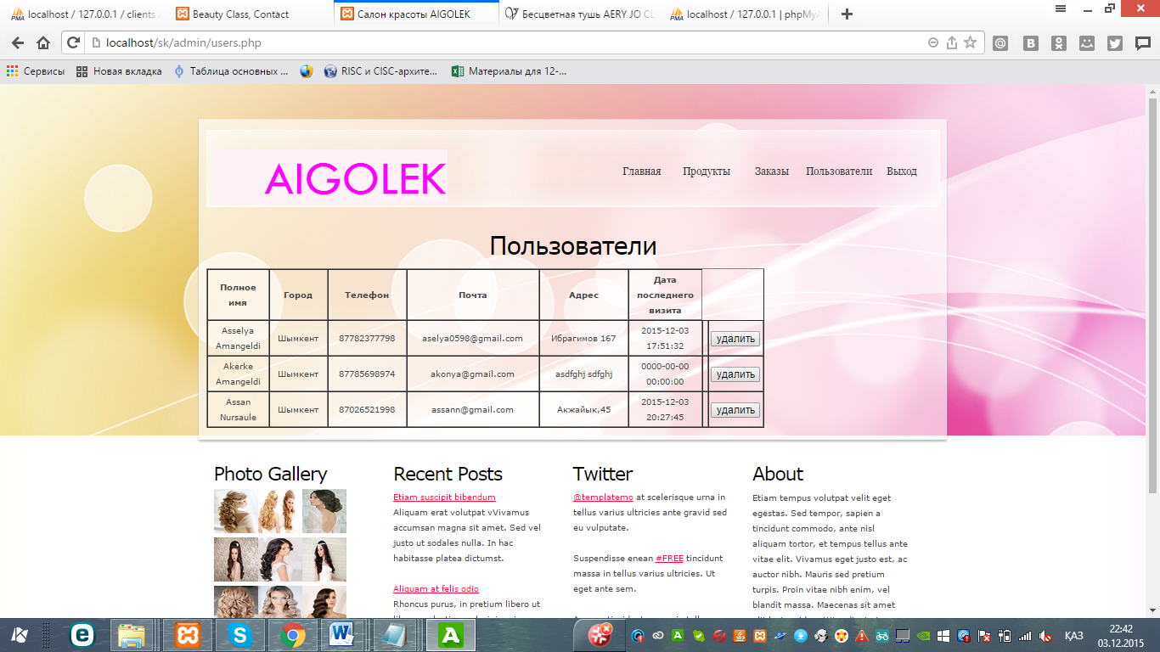

Fig. №82

**(iv) Installation**

**Installation plan**

**The installation plan was discussed and agreed upon at the meeting (Figure No. 84) with the client and the end user during the meeting.**

**1. Give the client and teacher to test my final project.**

**2. Pre-teaching staff how to use with the site. (add, change and delete products)**

**3. Use feedback to make any changes or correct any possible errors.**

**4. Explain how new users will inform about themselves when ordering products (see below)**

**5. Implement the system continuously using a consistent plan implementation system (see below)**

**6. Temporarily maintain the system before IT understands the system completely and will independently maintain it.**

**A meeting was held with the client to get permission to install the developed system:**

Fig. №83

**Training plan**

**Recommended study date: May 12-14, 2018**

**Reason: Firstly, in three days it will be possible to conduct training for all salon personnel. Secondly, in my study, these days (Saturday, Sunday, Monday) the least number of clients.**

**Estimated method of training: To train the administrator and each master separately and conduct practical training**

**Reasons: Individual training will be very effective, and besides, while one is studying, the other will be at work, i.e. a frame change will be provided.**

**System implementation plan (proof-Figure No. 85)**

**Implementation Method: Direct Implementation**

**Cause: The system has already been tested, so there is no need to wait. It should be put into operation as soon as possible, due to its simplicity and ease of use, direct implementation is the most effective method.**

**Suggested implementation date: May 19, 2018**

**Reason: The working day ends early, so it will be beneficial for both the client and the end user.**

**User Test Evidence: A meeting was made with the client and the end user to familiarize themselves with the final work. It was provided so that the user and the client could individually test the final version of the program. Also so that the client and the user could see the documents for training and the stages of implementation that were discussed earlier. The user and the client have passed questionnaires regarding any problems with the system. I asked the user to write a letter to confirm that she saw the system in operation and the installation plan and fully agrees with the documentation. The following document is proof of testing by the user. Figure number 84**

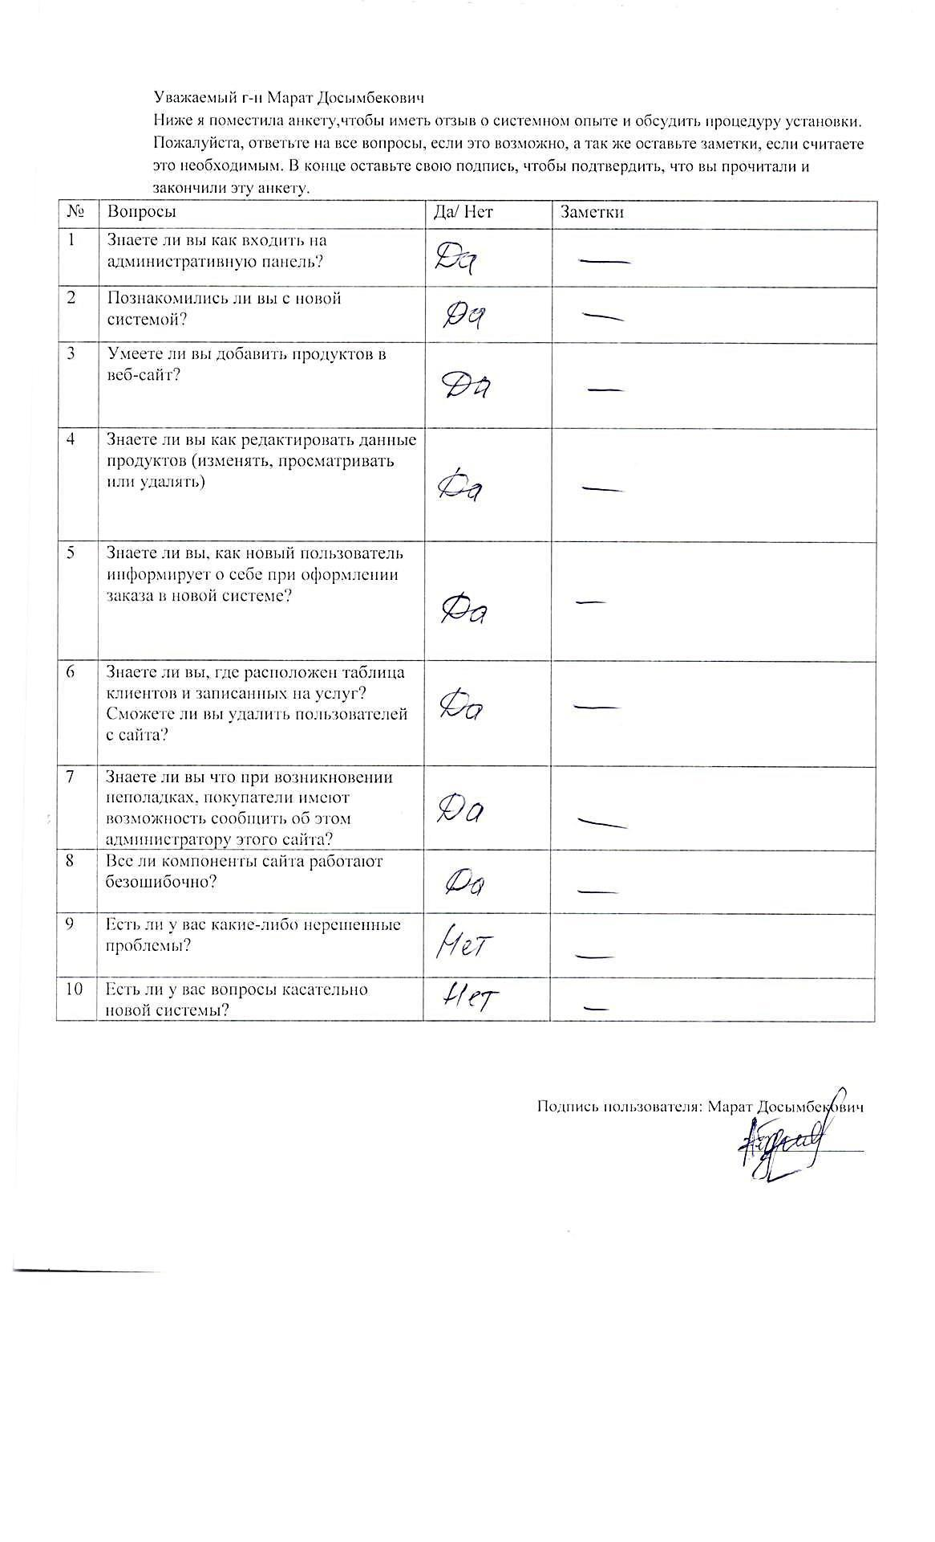

Fig. №84

## (e) Documentation

**(i) Operating system documentation:**

**Data dictionary**

**Web pages.**

|  |  |
| --- | --- |
| **Page title** | **Using** |
| the main | It has photos of the salon, promotions and news of the organization |
| About Us | Has a brief information about the organization. |
| Services | It has brief information about 4 salon services and a link to their pages: |
| Manicure | Allows users to sign up for a manicure |
| Pedicure | Allows users to register for a pedicure |
| Makeup | In this page, customers can sign up for makeup |
| Hair care | This page allows users to register for a pedicure. |
| Products | A complete list of products is located. On this page, customers choose a product. |
| Contact | The page that is intended to send the message and notification to the administrator. |
| Trash (if user is registered) | In this page, customers place an order for the product they have chosen. |
| Login or Register | This page is intended to register new users of this site or log in to the site. |
| **Admin pages** | **Using** |
| Orders | Contains a customer table with complete data that ordered goods. |
| Products | A page where the administrator can add new products with prices, descriptions, images and categories or edit those that already exist in the database. |
| Records | A page for viewing customers who have signed up for services. |
| Users | Page to view the data of all clients or delete their data from the database. |
| Messages | Page to view messages from customers. |

**Tables**

|  |  |
| --- | --- |
| **Table name** | **Use table** |
| Table of all users | Table of registered users. Acts as a central table that links all other tables to make the database normalized (user ID) |
| Product table | Assigns a unique ID for each item. Associates a product ID with a user ID. |
| Table of recorded clients for manicure | Displays all recorded users for a manicure. Binds user (mem_id) and IT services |
| Table of recorded clients for a pedicure | Displays all recorded users for a pedicure. Associates the user ID (mem_id) and service ID |
| Table of recorded clients for hair care | Displays all recorded users for a manicure. Binds user (mem_id) and ID of this service |
| A table of recorded clients for makeup | Displays all recorded users for a manicure. Binds user (mem_id) and ID of this service |
| Message table | Displays user messages, assigns a unique ID for each message, in order to display them on the admin page. |

**Table of all users**

|  |  |  |
| --- | --- | --- |
| **Name field** | **Data type** | **Using** |
| ID user | Automatic number | Assigns a unique ID for each user. |
| Username | Text | User's first and last name |
| City | Choose | Displays the client's city |
| Email | Text | Used as a unique key (user login) |
| Password | Text | Client code with which users log on to the site |
| IP | Number (integer) | Associates with the girth table |
| last visit | date and time | Logs the last visit to each user's site. |
| Date of registration | date and time | Shows the date of registration |
| Activations | Number (integer) | Shows how many times a user has visited a site. |

**Message table**

|  |  |  |
| --- | --- | --- |
| **Name field** | **Data type** | **Using** |
| Message ID | Automatic number | Assigns a unique ID for each Date / Supplier message. |
| Message subject | Text | Displays the subject of the message. |
| Message text | Text | Message text |
| departure date | Data | Shows date |

**Product table**

|  |  |  |
| --- | --- | --- |
| **Name field** | **Data type** | **Using** |
| Product id | Automatic number | Assigns a unique ID to each item. |
| Product name | Text | Displays the name of the product |
| Product category | Selection | Product category |
| Description | Text | Product description |
| Price | Number (integer) |  |
| Status | Number (0 or 1) |  |
| Add time | Data | Shows time |

**Basket table**

|  |  |  |
| --- | --- | --- |
| **Name field** | **Data type** | **Использование** |
| ID product | Automatic number | Присваивает уникальный ID каждому продукту |
| ID user | Number (integer) | Associates all users with the table “users” |
| Cart | Number (integer) | Shows the ID of the added products. |
| Total |  |  |

**Forms**

|  |  |
| --- | --- |
| Title | Purpose |
| User registration form on the site (input form) (Fig. 37) | This form is needed to register a new user in the user table (Fig. 30) |
| Login form (input form) (Fig. 36) | It is a user login window where you can verify your identity. |
| The main form of data output (admin page-fig38) | All admin pages contain output forms. |
| User list page (Fig. 40) | Displays a list of users contained in the database |
| Form of new products (Figure 42) | Contains images and other product data added by the administrator. |
| Table of customer records for services (Fig. 43) | Contains information about user records for services (Fig. 43) |
| Login form for the administrator (input form) (Figure 44) | It is an administrator login window where you can verify your identity. |
| The form of viewing the table of orders (Fig. 45) | Contains information about the orders of goods by users (Fig. 45) |
| The form of adding a new product (input form) (Figure 46) | Contains text fields, when filling out, you can add a book to the database |

Forms of the main objects of registration

|  |  |  |
| --- | --- | --- |
| **name of the property** | **Type of** | **Using** |
| Full name text | Text field | Displays the user's first and last name. Source: user |
| Button city | Select button | Displays the city of the user. Source: user |
| Text phone | Text field | Displays the user's phone number. Source: user |
| Text e-mail (login) | Text field | Displays the user's email address. Source: user |
| Password text | Text field | Displays the password for the user login. Source: user |
| Text address | Text field | Displays the exact address of the user. Source: user |
| Create button | Command button | Checks information and adds to database |

**Forms of the main objects for adding a product**

|  |  |  |
| --- | --- | --- |
| **name of the property** | **Type** | **Using** |
| Text product name | Text field | Displays the name of the product to be added by the administrator. Source: admin |
| Category button | Select button | Reflects the category of product to be added by the administrator. Source: admin |
| Text Description | Text field | Displays a description of the product to be added by the administrator. Source: admin |
| Текст цена | Text field | Displays the price of the product to be added by the administrator. Source: admin |
| “Select File” button | Text field | Helps you select a file from your computer for product photos |
| Add button | Command button | Checks information and adds to database |

**Section notes**

**Most of the sections required to maintain the documentation system have already been met in this document:**

|  |  |
| --- | --- |
| Section | Page |
| Data flow chart | 30 |
| Required hardware and software | 19 |
| Relationship object diagram | 22 |
| Menu and modular design | 31 |
| Block diagram | 32-33 |
| Annotated program listing | 35 |
| Full information and examples of data in tables | 22-24 |

**(ii) Administrator’s Guide**

1. Enter the administrator's login and password in the appropriate fields (Fig. No. 53)

Since the administrator is one, he will have a fixed login and password to access the site.

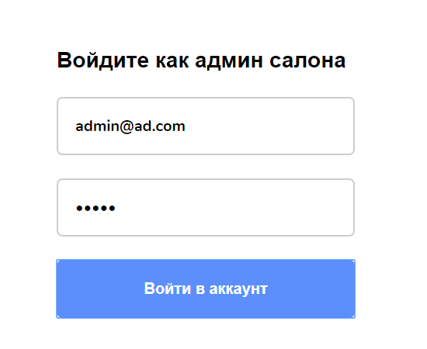

Fig. №85

2. You will see a page for the administrator, where you can edit the site data. First, the orders page will open (Fig. No. 54). This page shows the data of users who ordered goods. You will be able to remove some orders in case you cancel the order. Here you can navigate to other pages like Products, Recordings, Users, Messages and Logout.

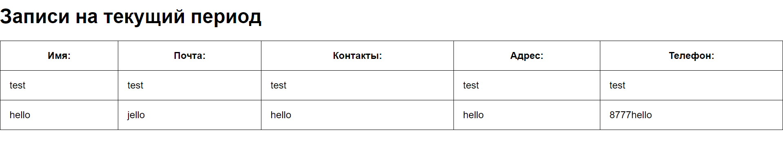

(Fig. №86, main page of the administrative part)

3. In the “Products” page you can add a new product or edit the data of goods that already exist in the database.

1. Enter product name

2. Select a product category

3. Write a full description.

4. Enter the price

5. Select file for image

Once you fill up all the fields, you can add a product by clicking the Add button. (Fig. No. 54)

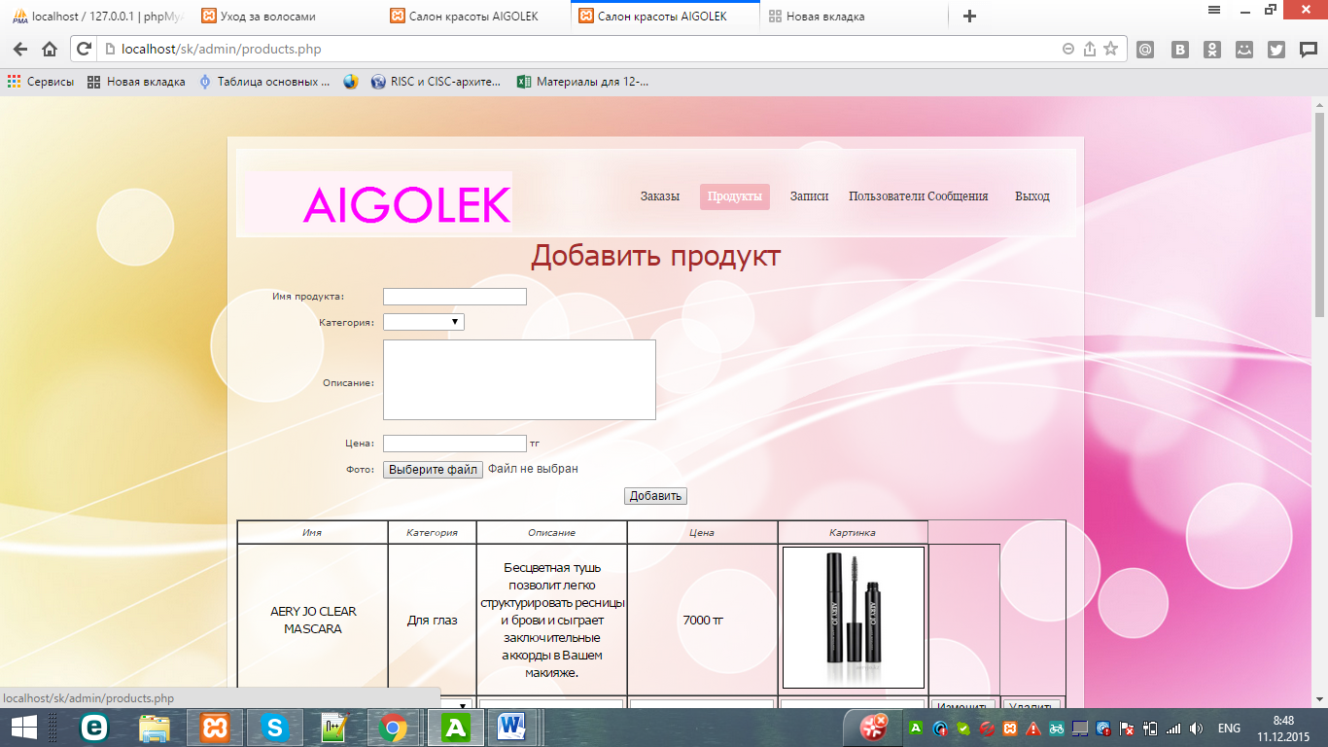

Gif. №87

4. The “Records” page shows the data of users who signed up for salon services (Fig. №88):

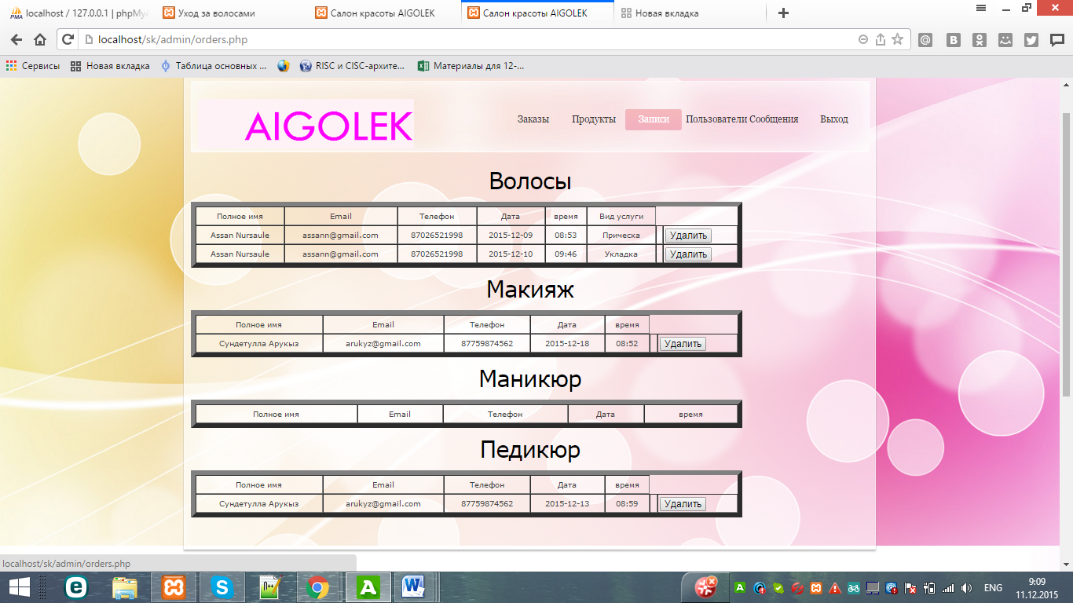

Fig. №88

5. The “Users” page displays the data of all users who have registered on the site. (Fig. №56) Also, you can delete users from the site.

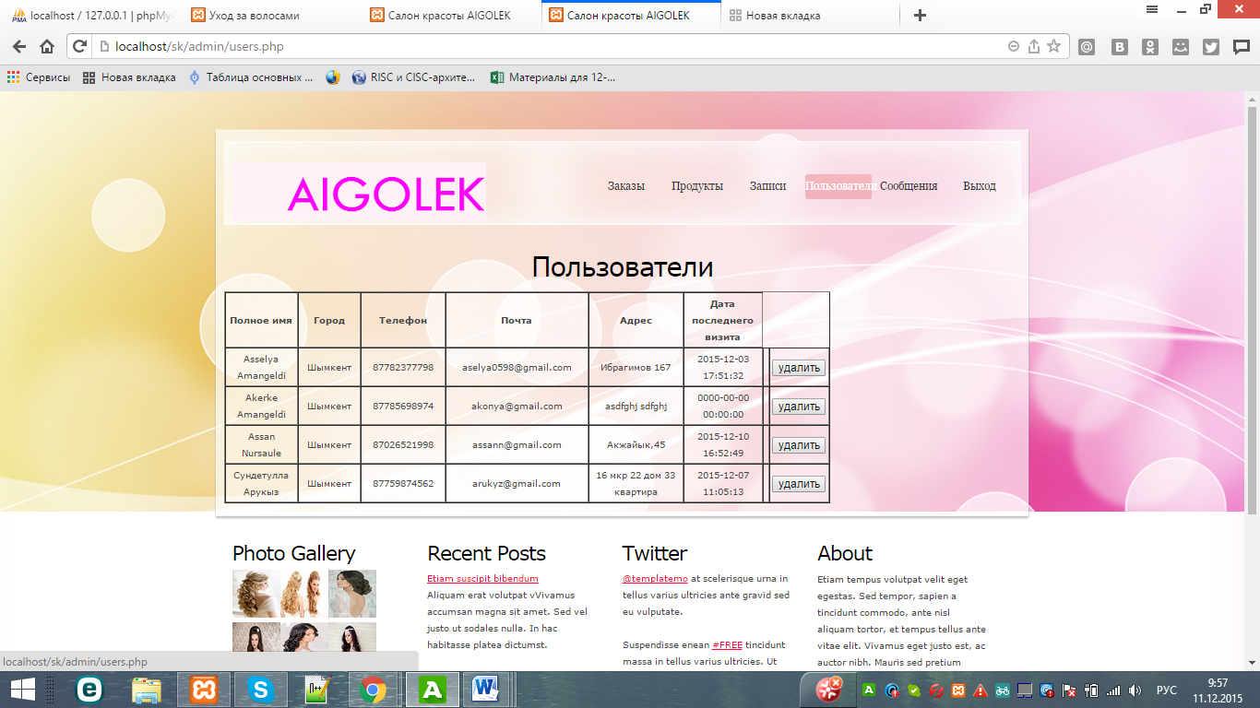

Fig. №89

6. In this page, you can read the messages of users and get acquainted with the problems that users have. (Fig. №90)

Fig. №90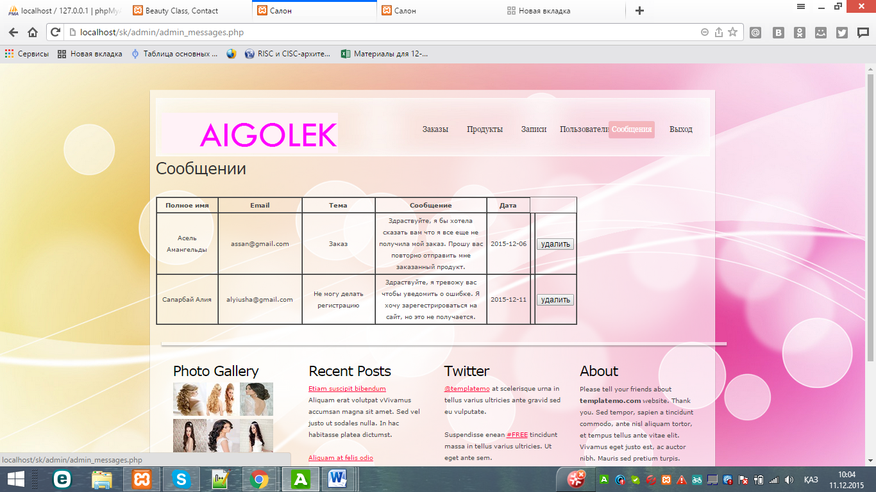

7. If you want to check if the product was added to the database or if the data was deleted, you can open PhPMyadmin by the link (http: // localhost / phpmyadmin / # PMAURL-1: db_structure.php? Db = clients & table = & server = 1 & target = & token = 441964a350d76f836633c319fee7cae7) and view the database. (Fig. №59)

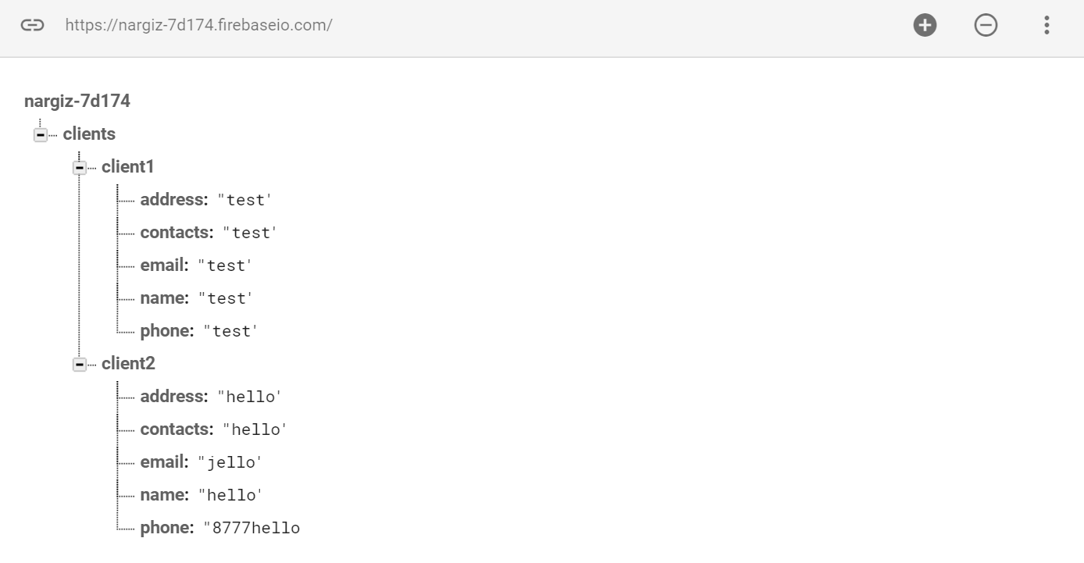

Fig. №91

8. After clicking “Exit” button (Fig. №93), you leave the admin page and the main page for all users opens. (Fig. No. 60)

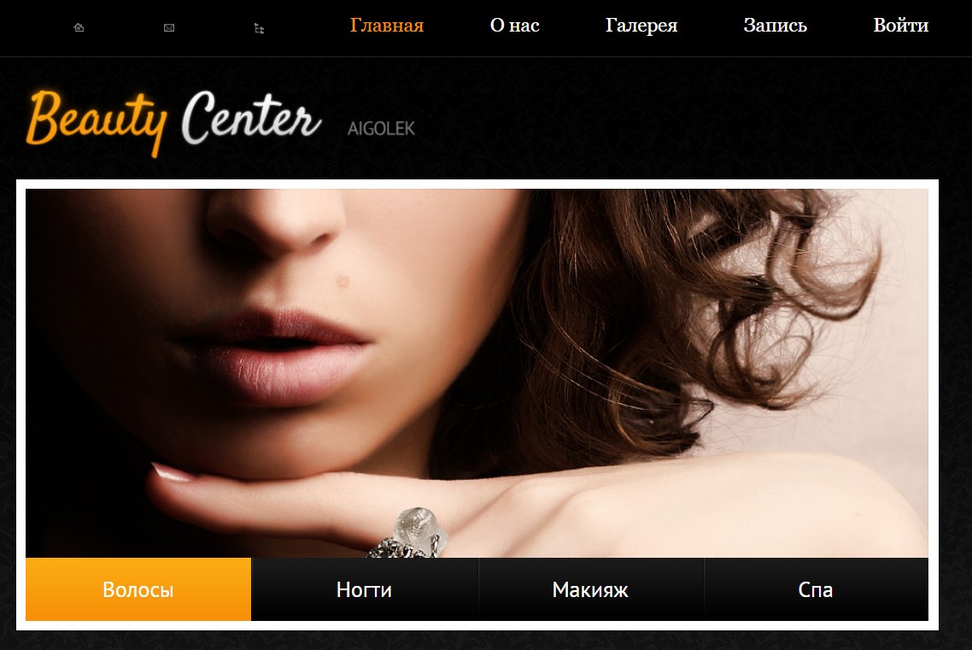

Fig. №92

Fig №93

### (iii) User Guide

1. First login or register. To do this, click on the "Register" button, if you have your account, then enter your username and password in the appropriate fields.

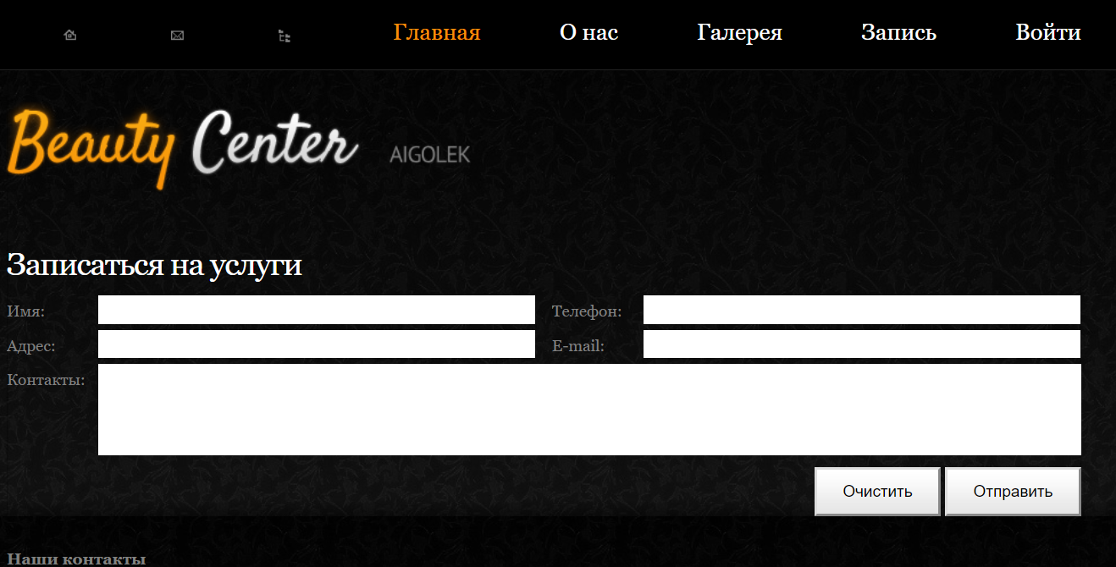

Fig. №93

1. If you clicked on the "Register" button, you are displayed the page where the registration form is located. You should fill in all the fields, and click on the "Create" button.

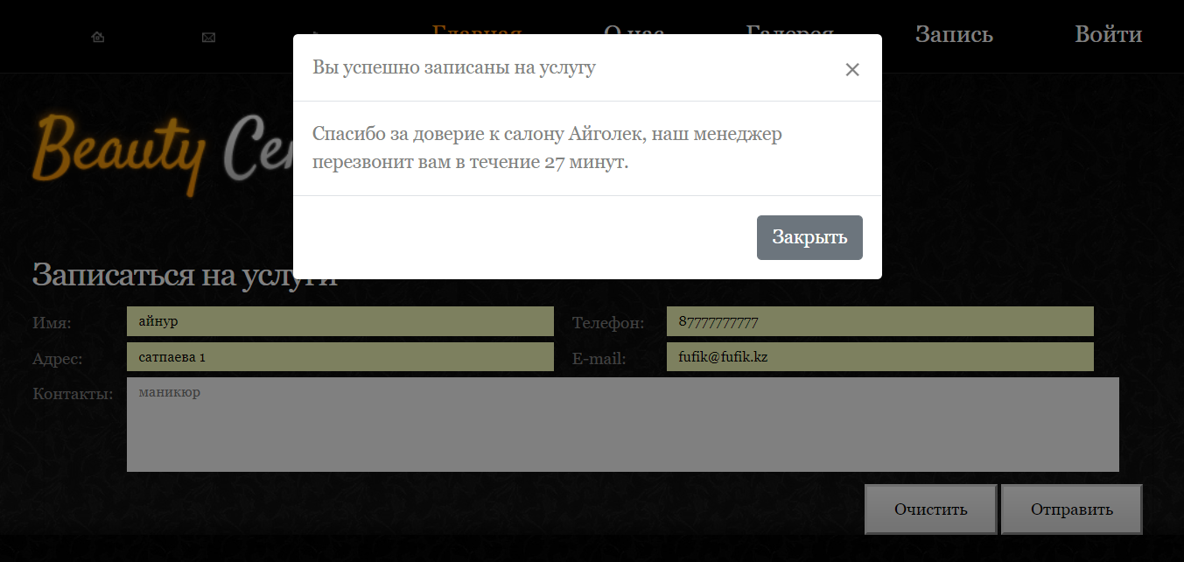

Fig. №95

1. After you have logged in, you have the opportunity to sign up for services and order products. If you want to order a product, then click on the "Products" button in the menu. You can choose one or several products.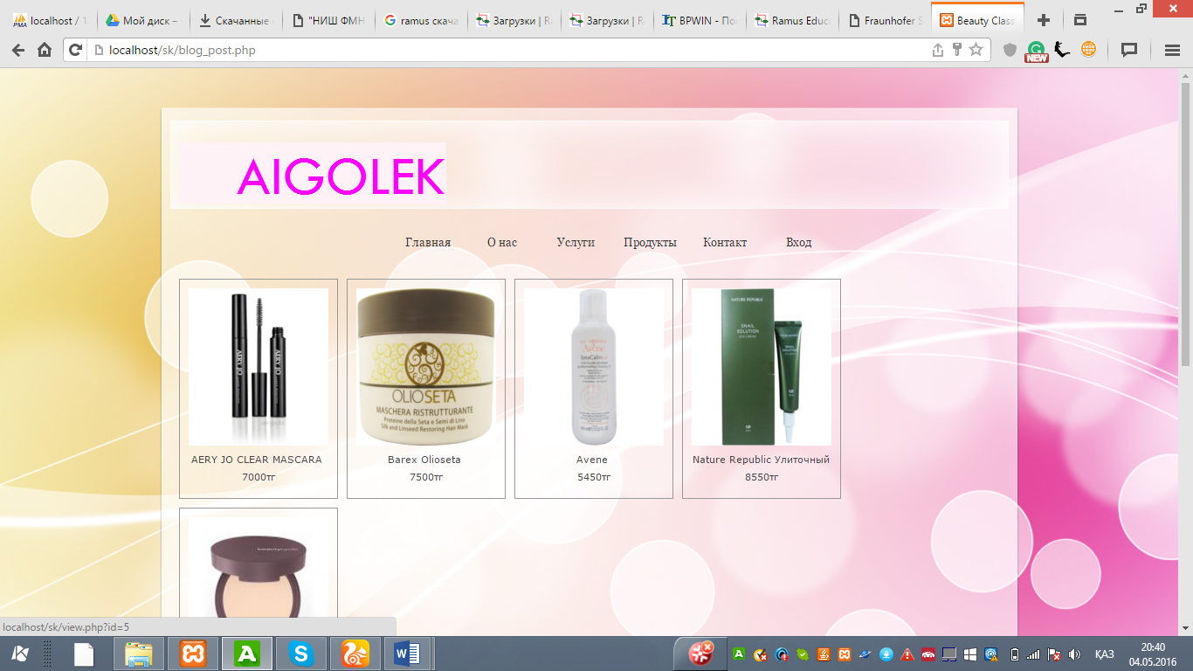

Fig. №96

1. You can add the item to the cart, and then order this item: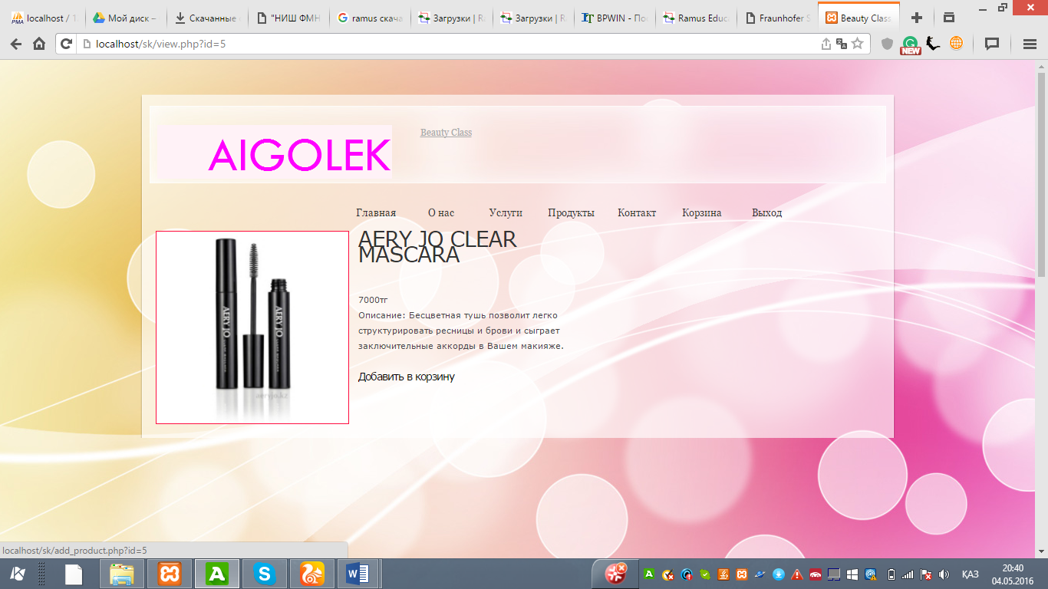

Fig. №97

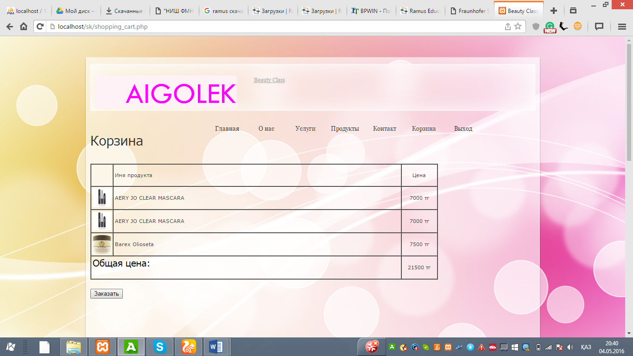

Fig. №98

1. You can also sign up for various services by clicking on the Services button and choosing the necessary service: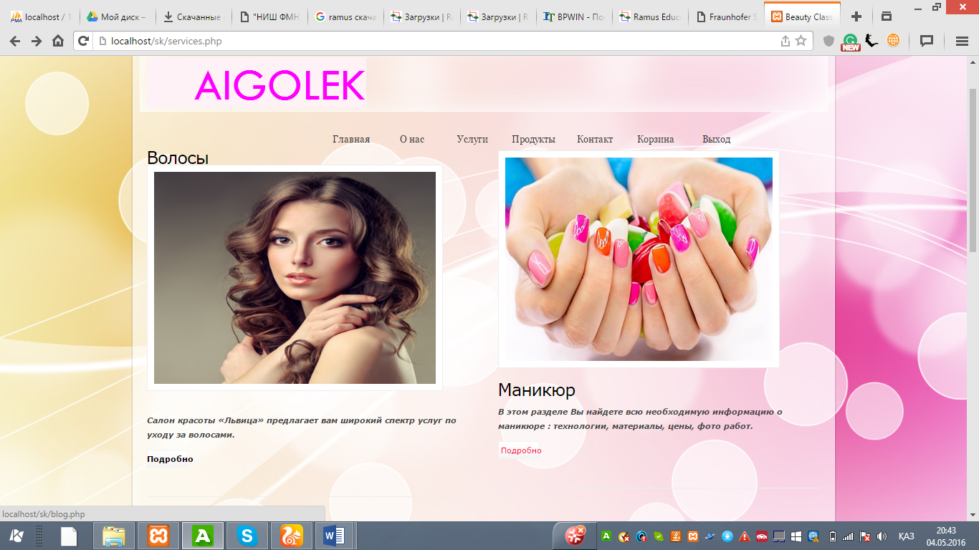

Fig. №99

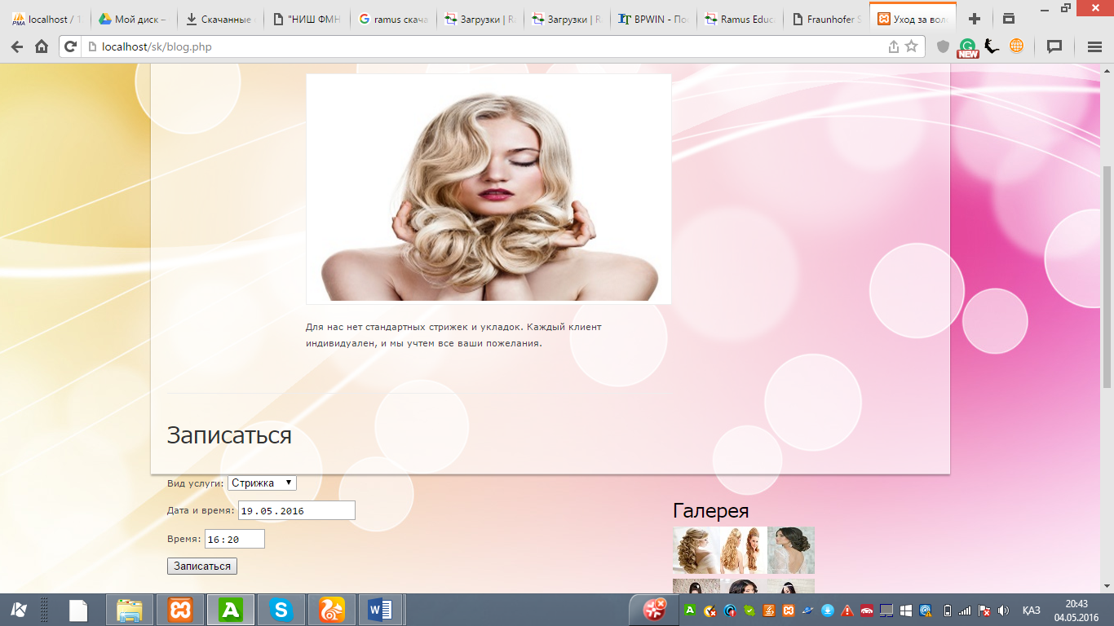

Fig. №100

1. If you have questions to the administrator or have a problem, you can write a message:

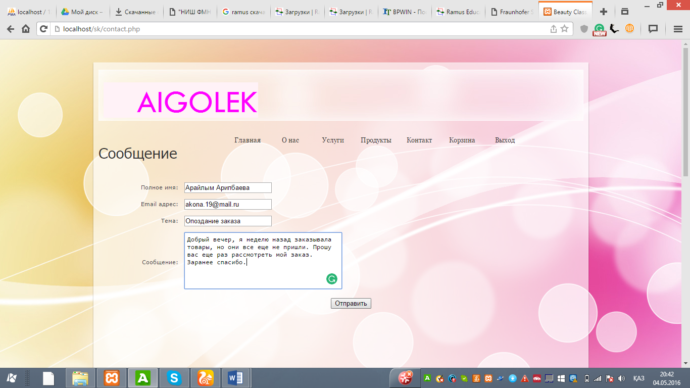

Fig. №101

|  |  |  |  |  |  |  |  |  |  |  |  |  |  |  |  |  |  |  |  |  |  |  |  |  |
| --- | --- | --- | --- | --- | --- | --- | --- | --- | --- | --- | --- | --- | --- | --- | --- | --- | --- | --- | --- | --- | --- | --- | --- | --- |
| **Common Mistakes Guide**   |  |  |  | | --- | --- | --- | | **Error** | **Cause** | **Decision** | | Message: "Fill in all the data" | Typo, all data entered | Re-enter, contact the administrator | | Message: “Login or password is wrong!” | A typo, the password does not exist or is not entered in the user text field. | Re-enter, contact administrator or enter password | | Does not display a list of entries for services | Error in the program code or the wrong path to add | Refresh the page or contact your system administrator or programmer. | | Product not added | Data entered is not correct | Enter and recheck data again | | There is no message about the successful addition of the product | Many possible reasons | Go to the MySQL database and check if you have recently added a product | | The site does not display data | Many possible reasons | Contact your system administrator. | | The site has stopped responding | Many possible reasons | Refresh the page or contact your system administrator. |   **Glossary:**  **DBMS - Database Management System**  **Default: parameters or values ​​set in case the program is configured**  **Form: a graphical interface that allows the user to control components and use displayed objects.**  **Hardware: A peripheral device that is used by a computer to allow input or to simplify its operation.**  **Website: information and data of any organization having an IP address (place) on the Internet.**  **AWP: a program to automate the work.**  **Query: method of displaying the specified fields in the system database using the selected parameters**  **Record: data structure that is used to organize data**  **Software: a set of functions and procedures necessary for using a computer**  **Backup program**  **The system administrator is responsible for order fulfillment. All product and order data is stored in my website. All data is stored in a database to which only the salon administrator has access.** |

### (f) Evaluation

**(i) Examining the likelihood of a successful outcome for compliance with the original objectives:**

List of user objectives contained in section

C) (i)****

Fig. №102

Evaluation

The following table estimates the user's tasks that were discussed in section C) i) and gives examples of where evidence can be found.

|  |  |  |
| --- | --- | --- |
|  | **Evaluation** | **Evidence** |
| 1 | The site was created clear and competent, at the same time enjoyable for users. Each user can easily find the input form and registration page. Also, the administrator has his own personal page, which has many functions and is very convenient to use. | Design p.31, 33  User Documentation  pp. 93-97 |
| 2 | Were developed 10 tables that make up the database. All of them are working properly, and the expert user will be able to add, delete and edit data. EC works on the basis of these databases, requesting input data on these databases. | Entry p. 84-88 |
| 3 | All tables in the database can handle a large amount of data. The tables are created in such a way that the database is normalized to the 3rd form. All data is displayed in an organized manner and can be easily navigated using the navigation buttons. | Tables p.84-88 |
| 4 | Using the adminstrator page, the administrator can easily edit the displayed data, which changes in the source tables, thus editing the source data. Using the delete command button, the user can easily delete the selected entry in the admin page by removing it from the source tables. It can also edit and delete product data. | Administrator Guide pp. 88-93 |
| 5 | During client registration, the program will not allow duplication of data. E-mail user is used as user login and the site automatically checks its uniqueness in the database. | Figure number 40, page 53 |
| 6 | Frequently used I replicated inputs have been identified for the required entries. These records were entered into the combined field in the input form input form. The list for each combined field is filled with data that is stored in the table. All data is automatically checked. Thus, all data is added to the database without errors.. | Input using the combined field p. 50-60 |
| 7 | Only registered users can order products. Using different encodings, the site checks whether a user is registered in the site. | Search page  Navigation  pp. 89-98 |
| 8 | Only registered users can sign up for services. Using different encodings, the site checks whether a user is registered in the site. | Page 59, Fig. No. 50 |
| 9 | The site conducts instant diagnostics, regardless of the input data. The system performs all functions automatically. The system does not hang and crashes. | Page 59, Fig. No. 50 |
| 10 | The new system performs work faster and more efficiently, connecting several processes. Thus, the original method was simplified. | page 48 |
| 11 | The main menu has a form to enter the site, where there is a link to the registration page. | page 48-49 . Fig №36 |
| 12 | In the page for the user's basket, the site automatically summarizes the total price of the goods, which makes it easier for the client and the salon. | Page 65, Fig. №58 |

**(ii) System evaluation by client and user**

**Degree of success**

From the assessment and the evidence presented, it can be concluded that all requirements are fully satisfied.

Fic. №103

**Analysis of customer response.**

**Before submitting the site, everything was once again checked for compliance with the requirements (section c (i), fig. 11) and the objectives of the project (section c (i), fig. 13). The site program was given to the client several days before asking for a reflection on the operational test, so the program was fully tested in use, the user could get used to the system and formulate his opinion on the functionality and suitability of the site. After the client used the system for several days, he was asked about the first impression and what needs to be changed in it in order to improve.**

**The client responded that all functions work fine and do not want any changes.**

**He wrote an e-mail (Fig. 103), indicating that the program was successfully tested and ready for use. The client indicated that he was fully satisfied with the website and would like to work with it in the future.**

**As can be seen from the email (Figure # 103):**

**● The client indicates that “the system works very well”**

**● The client confirms that the admin page is working fine: “The administrator already uses the page for the administrator and tried several times to add products and edit their data.”**

**● The client liked the design that meets the requirements and goals: “The design of the website satisfies all my requirements: it is both modest and attractive.”**

**● In general, the client liked the new system with all the input and output data.**